April 2020

A ‘Tasti’ solution
Food manufacturer opts for Kaeser to deliver a fully networked compressed air system for complete control and optimum efficiency

New Zealand food manufacturer Tasti Foods recently invested in a complete Kaeser compressed air system. This was selected to not only meet the compressed air demands of its new wholefoods manufacturing hall, but also to reliably and efficiently deliver compressed air to all other required areas of the manufacturing facility. For maximum efficiency, complete control and connectivity of all components within the compressed air station, a Sigma Air Manager 4.0 master controller was installed.

From baked bars, nut bars, muesli/granola and cereal style bars, to raw fruit and nut snack packs, dried fruits, nuts and baking products - on most supermarket shelves throughout New Zealand and Australia, you will find products manufactured by Tasti Foods.
Now in its third generation, Tasti Foods remains proudly New Zealand owned and operated. The company began life back in the 1930’s when two friends decided to start producing crystalised ginger. Fast forward over 80 years and now a workforce of over 250 produce a whole range of food products including co-manufacturing for a number of internationally recognised brands. They also supply nearly every supermarket chain in New Zealand and Australia with private label snack bars.

Operating an efficient manufacturing facility
Tasti has always manufactured in New Zealand and has been in its current purpose built facility on the Te Atatu Peninsula for almost 50 years. In that time the factory has been extended and re-fitted several times as the company has grown. This modern facility is fully automated and designed to deliver the highest quality products, and Tasti continue to invest heavily in the required plant and facilities to ensure they can operate efficiently and to the highest quality standards.

Compressed air is mainly used for the automation of equipment in the manufacturing process. Some of the most sensitive pieces of equipment that compressed air powers at Tasti are the sophisticated and robotic packing machines. Here, compressed air powers cylinders that perform a number of critical tasks from; picking and making boxes, placing the products in the boxes, to then sealing the boxes up ready for dispatch. The equipment operates very quickly – it is able to pack over 800 products a minute – however, to do this it relies on a constant supply of high quality and dry compressed air.

The existing compressed air system was struggling to reliably and efficiently meet the compressed air requirements at Tasti. Reoccurring failures in the compressed air line were creating downtime in some areas of production. At the same time as these issues were occurring, Tasti had begun planning the expansion of its manufacturing facility to include a new hall specifically to manufacture its burgeoning wholefoods ‘free from’ product range.

As Tasti started the planning process for the new build, elevated electricity bills had additionally led them to invite Energy NZ to conduct an audit on the existing manufacturing facility. One area the audit highlighted was that cost savings could be made by investing in compressors that were connected through a controller to each other, and were well staged. As the manufacturing facility had developed over the years so had the compressed air system grown and changed. The existing compressors were therefore not linked together and so they had no control around staging. There was also no ring main connecting all compressed air applications in the facility together to one compressed air source.

All of these factors together led Matthew Barber, the Maintenance Engineering and Environmental Manager at Tasti, to take the new build – which would require compressed air - as an opportunity to address the entire compressed air system for the manufacturing facility. As Barber explains: ‘We saw the expansion as the ideal opportunity to find one solution that would not only solve the issues we were having with the existing compressor system, but would also allow us to get the whole plant set up on a ring main from one central compressor room. In addition we were keen to digitalise the compressed air system - linking all of the compressed air equipment together for optimum efficiency and system control.’

Meeting the criteria
Barber invited a number of compressed air providers to review their requirements and recommend a solution. Working closely with the Procurement Manager, he developed a selection criteria by which they could measure not only the overall suitability of the recommended compressed air equipment – including design, quality, digitalisation and efficiency – but also other key factors to Tasti, such as after sales support, service, backup and training.

Kaeser Compressors was invited to tender for the project and was successful in meeting Tasti’s criteria. As a result a complete Kaeser compressed air system was recently installed. A ring main was also installed which now connects all of the compressed air applications throughout the manufacturing facility to the new compressed air system.
The compressed air system comprises of three ASD series rotary screw compressors alongside a complete compressed air treatment package which includes two TD series refrigeration dryers. For total control and digitalisation, the entire compressed air system is controlled and managed by a Sigma Air Manager 4.0 master controller.

Industrie 4.0-ready compressed air technology
The latest generation of ASD series rotary screw compressors from Kaeser once again push the boundaries of compressed air efficiency. Not only do they deliver more compressed air for less energy, but they also combine ease of use and maintenance with exceptional versatility and environmentally responsible design.

At the heart of every ASD compressor lies a premium quality screw compressor block featuring Kaeser’s Sigma Profile rotors. Flow-optimised for impressive performance, these advanced rotors help Kaeser ASD compressors set the highest standards for efficiency. In fact, they achieve power savings of up to 15 percent compared with conventional screw compressor block rotor profiles. In addition maximum performance and energy efficiency are assured thanks to the inclusion of a super-premium efficiency IE4 motor.
Furthermore, the inclusion of the innovative Electronic Thermo Management (ETM) system dynamically regulates fluid temperature. This not only reliably prevents condensate formation and associated moisture damage but saves additional energy.

For Tasti, incorporating the Sigma Air Manager 4.0 master controller was the final piece of the puzzle to ensure they had complete control of the entire compressed air system. A key technology for Industrie 4.0, the Sigma Air Manager 4.0 utilises adaptive 3-D^{advanced} control to make air generation and treatment even more intelligent, reliable and efficient. By predictively calculating and comparing various operating scenarios, it selects the most efficient to suit Tasti’s specific needs at any one time. Compressor flow rate and energy consumption are therefore always optimally matched according to actual compressed air demand. In combination with the integrated multi-core processor industrial PC, the adaptive 3-D^{advanced} Control is able to ensure optimised performance for Tasti at all times.

Delivering compressed air when and where required
Now up and running the new Kaeser compressed air system is delivering a reliable, efficient and high quality source of dry compressed air throughout the manufacturing facility - exactly where and when it is needed.

Barber concluded: ‘The new Kaeser compressed air system has helped us solve a number of issues. The SAM 4.0 in particular has allowed us to develop a fully connected compressed air system, giving us a lot of control over for example our energy usage.’
The standard ASD series rotary screw compressor models from Kaeser are available with drive powers of 18.5 to 30 kW and produce flow rates from 2.58 to 5.53 m³/min, designed for pressures 7.5 to 15 bar. The Sigma Air Manager 4.0 master controller can control up to 16 compressors within a compressed air station. For more information visit au.kaeser.com or phone 1800 640 611.
-END- Free for publication, copy appreciated
Editors Notes
From 0.18 to 515 kW, Kaeser Compressors manufactures a wide range of compressors and associated auxiliary equipment that meet the varying requirements of a diverse range of industries and applications.

One of the world’s largest manufacturers of rotary screw compressors, Kaeser Compressors is represented globally in over 100 countries through a dedicated network of branches, subsidiary companies and authorised partners.

Kaeser Compressors Australia provides comprehensive sales and service from its 30,000 ft² purpose built factory in Dandenong, Victoria alongside an extensive network of sales and service centres and authorised partners that cover Australia and New Caledonia.

For editorial and advertising enquiries contact: Beth Wood, Marketing Manager
Press office: +61 3 9791 5999 Fax: +61 3 9791 5733
E-mail: beth.wood@kaeser.com

KAESER COMPRESSORS Australia Pty Ltd
45 Zenith Road, Dandenong, VIC 3175, Australia
Phone: +61 3 9791 5999 Email: info.australia@kaeser.com
au.kaeser.com
Kaeser photo(s) – free for publication, credits appreciated.

File: Q-Tasti-Foods-Case-Study-aus
Approved for publication, copy acknowledgement appreciated
Images: Contact our press office to request high res versions of the images found below

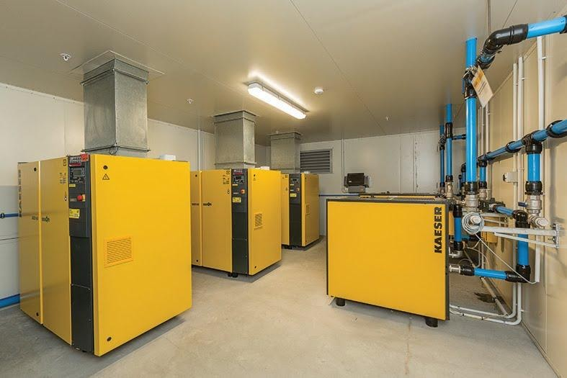
Caption: The complete Kaeser compressed air system that was recently installed at Tasti Foods.

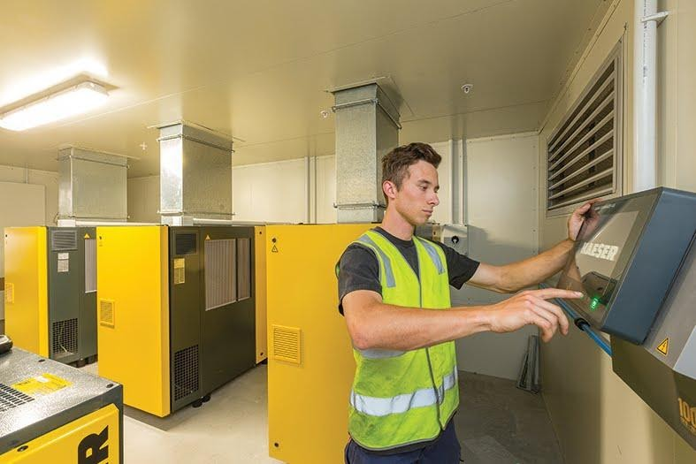
Caption: For maximum efficiency, complete control and connectivity of all components within the compressed air station, a SAM 4.0 master controller was installed.

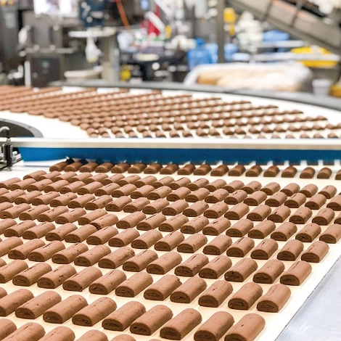
Caption: Tasti Foods’ modern facility is fully automated and designed to deliver the highest quality products.

Caption: Tasti Foods produces a whole range of food products including nut bars.

Kaeser photo(s) – free for publication.

