Kaeser keeps the wheels turning at All Mag Wheel Repairs
All Mag Wheel Repairs, a mag wheel repair and refurbishment expert based in NSW, recently chose to install two Kaeser Aircenter SM 12 compressed air systems to meet their requirement for a high quality and reliable supply of compressed air.
For any of us who own a car with alloy wheels we may well have felt the pain of damage caused to our alloys over the years. Whether it be from changing a tyre to chips, kerb damage or gutter rash, finding a replacement can be a timely and expensive exercise. Luckily companies like All Mag Wheel Repairs in Ingleburn, NSW offer a quality repair and refurbishment service for all makes and models of mag wheels.
Each mag wheel that comes through All Mag is hand refurbished by one of the teams experienced technicians, who use compressed air extensively in the repair and refurbishment process; from inflating tyres to powering pneumatic tools and paint spraying.
Established over 17 years ago, when the company recently expanded and moved into a larger facility, they recognised that there was a need to invest in a new compressed air system. Priding themselves on delivering a professional service to its customers with a quality repair guarantee, it is no surprise then that when the Owner of All Mag - Milan Stovic - came to invest in a new compressed air system, he wanted to source a high quality solution.
After considering a number of options, All Mag chose to install two Kaeser Aircenter SM12 compressed air systems along with a Sigma Air Manager compressed air controller.
Perfect for collision and automotive finishing shops, the Aircenter from Kaeser is an all-in-one compressed air system. Incorporating a high efficiency rotary screw compressor, refrigeration dryer and air receiver all in one compact package, the Aircenter is ideal where space is at a premium.
At the heart of every SM series compressor lies a premium quality Kaeser rotary screw compressor block featuring the flow-optimised and energy saving ‘Sigma Profile’ rotors. Designed for maximum energy efficiency, the Kaeser Sigma Profile can achieve power savings of up to 15 percent compared to conventional screw compressor block rotor profiles. In addition, all SM series rotary screw compressors are equipped with a premium efficiency IE3 class drive motor which complies with and exceeds prevailing Australian GEMS regulations for 3 phase electric motors. For the end user this translates into more compressed air for less energy consumption.
All models feature a built-in Sigma Control 2 industrial PC-based compressor controller that is responsible for dynamically adjusting the flow rate to match actual compressed air demand thereby assuring further energy savings. Relevant information can be viewed at a glance from the easy to read display.
Ideal at point of use, the sound absorbing compressor enclosure keeps operational sound levels to a minimum ensuring a pleasantly quiet work environment.
The Aircenter from Kaeser has also been designed to be service friendly, with all service points easy to access from one side of the compressor.
For optimum efficiency and connectivity of both Aircenter SM12 compressed air systems, All Mag chose to install a Sigma Air Manager (SAM).
A key technology in the advanced world of Industrie 4.0, SAM is a cutting-edge compressed air controller and the central mastermind that controls the entire compressed air supply system to ensure maximum availability and optimised service costs.
Installed almost 2 years ago, the Kaeser compressed air system at All Mag has proven to be reliable and efficient. Stovic said: ‘Our team of wheel specialists are very experienced in repairing mag wheels back to their original form. To deliver on our customer guarantee of repair quality we rely on the quality and performance of the equipment we use. The Kaeser compressed air equipment has proven to be dependable in meeting our compressed air requirements. Situated near point of use it has also shown to be very quiet in operation.’
The standard Kaeser Aircenter SM series of all-in-one compressed air systems are available with drive powers up to 9 kW, a working pressure 5.5, 7.5 or 9 bar and with free air deliveries from 0.56 to 1.50 m³/min.

File: Q-Allmag-aus
Approved for publication, copy acknowledgement appreciated
Images: (contact the press office for high res copies of the following images)

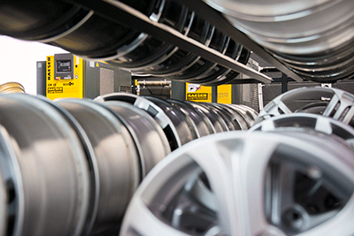
Caption: All Mag chose to install two Kaeser Aircenter SM12 compressed air systems
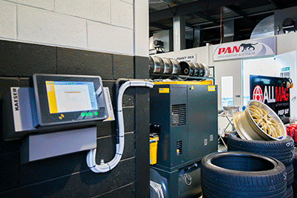
Caption: For optimum efficiency and connectivity, All Mag chose to install a Sigma Air Manager (SAM)

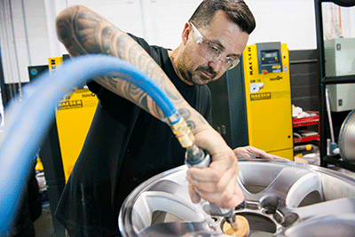
Caption: Compressed air extensively in the repair and refurbishment process; here powering a pneumatic tool
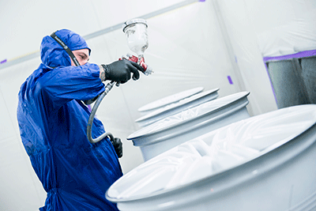
Caption: Compressed air is used for paint spraying at All Mag Wheel Repairs

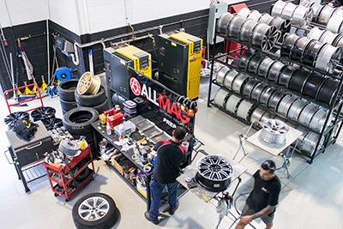
Caption: All Mag Wheel Repairs is a mag wheel repair and refurbishment expert based in NSW

