Boxing Clever:
Oji Fibre Solutions opts for energy efficient Kaeser compressed air system
Oji Fibre Solutions, a leading producer of market pulp, paper and fibre based packaging, opted for an energy efficient Kaeser compressed air system in the development of its new green-star rated corrugated cardboard packaging manufacturing facility in Yatala, QLD.
From fresh fruit and produce, meat, poultry, seafood and beverages to reseller and industrial manufacturing – the wide range of industries that Oji Fibre Solutions has been supplying innovative corrugated cardboard packaging solutions to, in Australia and New Zealand is immense.
Oji Fibre Solutions is part of the pulp and paper division of Oji Holdings Corporation - the fifth largest pulp and paper company in the world. As part of the company’s expansion to its packaging business in Australasia, Oji recently invested into the development of a new 5.8 hectare Greenfield site in Yatala, Queensland. Complementing the company’s existing manufacturing plants in Melbourne and Sydney, the Yatala site houses a newly constructed 2.4 hectare green-star rated manufacturing facility. From here Oji manufactures and supplies innovative corrugated cardboard packaging solutions to its customers throughout Queensland, northern New South Wales and the Northern Territory.
As part of Oji’s commitment to delivering innovative and environmentally sustainable products, the new facility operates to a green-star rating system. From daylight sensors and a lighting control system to a rainwater harvesting system, Oji implemented a number of initiatives that would assist them in reducing emissions and increasing energy efficiency throughout the operation. It is no surprise then that in designing and building the new manufacturing facility, they also chose to invest in the latest and most energy efficient manufacturing technology.
Energy efficiency was therefore a key criteria for Peter Henley, the Engineering Manager at Oji, when selecting the compressed air system for the new facility. From material handling to the conveyor systems, pre feeders and corrugator, compressed air would be a key utility required throughout the manufacturing process.
After considering a number of vendor packages, Oji chose to invest in a Kaeser compressed air system, consisting of a Kaeser CSD 85 series fixed speed rotary screw compressor, a CSD 125 SFC Sigma frequency controlled rotary screw compressor, in addition to a comprehensive compressed air treatment package.
The CSD series of rotary screw compressors from Kaeser push the boundaries when it comes to compressed air efficiency in a number of ways;
Developed by Kaeser and continuously enhanced ever since, all CSD series models include the low speed Sigma Profile rotary screw compressor block. Equipped with flow-optimised rotors, this achieves power savings of up to 15 percent compared with conventional screw compressor block rotor profiles.
Energy efficiency is further maximised with the inclusion of an IE3 drive motor - which complies with and exceeds prevailing Australian GEMS regulations for 3 phase electric motors.
In addition, the 1:1 drive design eliminates the transmission losses associated with gear or V-belt driven systems, as the motor directly drives the screw compressor block. The inclusion of the Sigma Control 2 compressor controller also enables compressor performance to be precisely matched to actual air demand thereby allowing additional energy savings.
In order to meet the fluctuating demands for compressed air of the new manufacturing facility in the most efficient way possible, a frequency controlled rotary screw compressor was selected as part of the compressed air package. As the lead compressor, it is responsible for supplying the sites initial requirements for compressed air.
In any compressed air installation where a frequency controlled compressor is installed, this will be the compressor that operates longer than any other unit within the system. The Kaeser CSD SFC series models were therefore built with maximum efficiency in mind and are designed to avoid extreme high speed operation. This saves energy, maximises service life and enhances reliability.
Operating pressure can be consistently maintained with +0.1 bar. In turn, the consequent ability to reduce maximum system pressure also reduces energy costs. The relationship between pressure consistency and speed can be viewed directly on the Sigma Control 2 display.
The soft rise in motor starting current from zero to full load without current spikes lead to an almost unlimited motor starting frequency (the number of possible motor starts within a given time period without overheating occurring). The continuously variable acceleration and deceleration significantly reduces component stress.
All Kaeser SFC packages are equipped with Siemens frequency converters. They provide seamless communication between the SFC control cabinet and the compressor controller, thereby ensuring maximum efficiency at all times.
The additional fixed speed Kaeser CSD 85 series rotary screw compressor at Oji, therefore acts as the lag compressor. This means that it only starts up and produces compressed air when the demand exceeds that which the CSD 125 can produce alone. This therefore ensures that the fixed speed unit is not operating in a loaded state for extended periods of time. The result of this configuration for Oji is optimum energy efficiency, reducing power costs, by only producing the precise amount of compressed air required at any one time.
Peter Henley commented; ‘We have been using Kaeser compressors for some time now on our other sites and they have proven to suit our application and be reliable and efficient in meeting our compressed air requirements. We have also found that they are well suited to operating in the Australian climate.’
The CSD series of rotary screw compressors from Kaeser are available with working pressures 7.5 to 13 bar, motor power 45 to 75 kW and free air deliveries 5.50 to 12.02 m³/min with the fixed speed units, and 1.07 - 12.00 m³/min with the frequency controlled units.

File: Q-Oji-Fibre-Solutions-aus
Approved for publication, copy acknowledgement appreciated
Images: (contact the press office for high res copies of the following images)

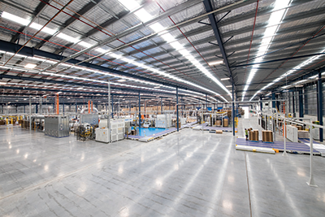
Caption: Oji Fibre Solution’s Yatala site houses a newly constructed 2.4 hectare green-star rated manufacturing facility

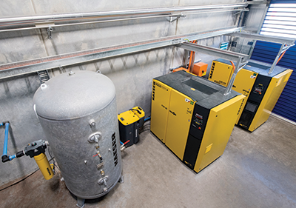
Caption: Oji Fibre Solutions chose to invest in a complete turn-key compressed air system from Kaeser
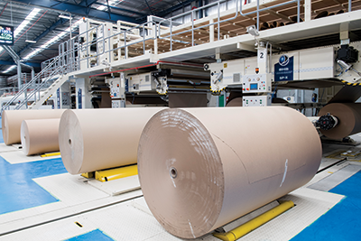
Caption: Raw material ready for processing at Oji Fibre Solutions

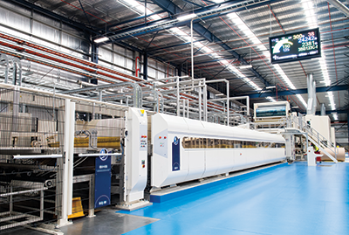
Caption: Compressed air is required for the corrugator at Oji Fibre Solutions
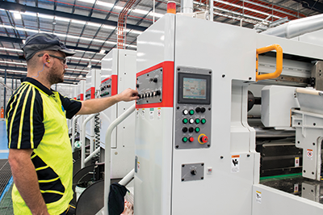
Caption: Compressed air is required for the corrugated board box making machines at Oji Fibre Solutions

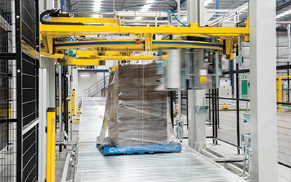
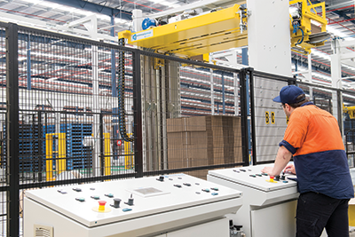
Caption: Compressed air is required for the materials handling equipment at Oji Fibre Solutions

