Kaeser Australia celebrates 25 year anniversary
Kaeser Compressors is currently celebrating its 25th anniversary in Australia. Over the past 25 years the company's presence has grown considerably throughout the region. Whilst the business landscape has continued to change in that time, the company's focus on developing innovative air system solutions has remained, and its latest generation of products are ready to take full advantage of the future-orientated benefits that Industry 4.0 has to offer.
Kaeser Compressors Australia has grown significantly since it was established in1990. From modest beginnings with just two employees, the company now boasts an extensive network of sales and service centres as well as dedicated partners that provide comprehensive coverage to compressed air users throughout Australia, New Zealand and New Caledonia.
The Company has seen a number of changes to the business landscape over the past 25 years. From the development of the internet to the instant communication capabilities of electronic mail and SMS, the revolutionary growth in information and communication technologies have had a profound effect on the; control, monitoring, communication and inter-connective abilities of air compressor technologies.
The dawn of Industry 4.0 is now once again changing this landscape. A term which encapsulates a number of technologies and concepts, Industry 4.0 represents the fourth industrial revolution, whereby the real and virtual worlds are brought together via cyber-physical systems in order to optimise a company's manufacturing processes and entire value chains.
Capable of seamless integration into an overall system and communicating with one another, all Kaeser products are ready to take advantage of the future-orientated benefits of Industry 4.0. All elements of a Kaeser compressed air system can be networked together from; production planning to implementation and predictive maintenance, enabling intelligent control, which allows for the automatic delivery of the compressed air volume and quality required by each specific user. This strategy helps to maintain availability and efficiency, and keeps lifecycle costs to a minimum.

File: o-25-years-aus
Approved for publication, copy acknowledgement appreciated
Image:

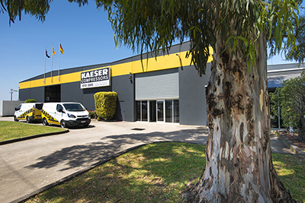
Kaeser Australia's 30,000 ft² purpose built head office in Dandenong South, Victoria.

