Bosisto's relies on Kaeser to deliver high quality and dry compressed air
An independent Australian owned and operated pharmaceutical company, FGB Natural Products (FGB) specialises in manufacturing natural; over the counter pharmaceuticals, nutritional supplements, household products, personal care products and medical devices which can be found in pharmacies and supermarkets throughout Australia.
The largest fully integrated producer and manufacturer of eucalyptus oil and eucalyptus oil based products, FGB manufactures such well-known and much loved Aussie brands as; Bosisto's 'Parrot' brand Eucalyptus and Euky Bear range, from its modern facility in Oakleigh South, Victoria. Compressed air is used to power a number of functions across the facility from; the automatic capping to the high speed labeller and shrink wrapping machines.
Larry Michaud, the Maintenance Officer at FGB recently called upon KAESER Compressors to replace their ageing compressed air system. Requiring reliable, high quality and dry compressed air, FGB chose to install a KAESER CSD 105 rotary screw compressor along with a 1000 litre air receiver and DC108E desiccant dryer.
The CSD series rotary screw compressors from KAESER deliver premium quality compressed air and superior efficiency. At the heart of every CSD rotary screw compressor lies a low-speed Sigma Profile screw compressor block equipped with flow optimised rotors. Developed by KAESER, the Sigma Profile achieves power savings of up to 15 percent compared with conventional screw compressor block rotor profiles for a highly energy efficient solution. In addition, all KAESER rotary screw compressor blocks are powered by premium efficiency IE3-rated drive motors (that comply with, and exceed, prevailing Australian MEPS regulations for 3 phase electric motors), for maximum performance and reliability.
The internal component layout in the CSD series rotary screw compressors, not only ensures even greater efficiency, but is also allows direct access to all service and maintenance points from the front of the unit. This saves both time and money when it comes to servicing. A long service life is also achievable thanks to the inclusion of only high quality components.
Producing exceptionally dry compressed air is paramount for FGB in the manufacturing process, where any moisture contamination to the compressed air supply could cause product spoilage.
As a result FGB chose to install a KAESER DC108E heatless dessicant dryer with Eco Control. This desiccant filled air dryer has an exceptionally high adsorption capacity and its regeneration capability provides sustained low pressure dew point performance with minimal pressure and energy loss. For maximum energy savings, the DC E models are equipped with "Eco Control" an intelligent control system which features a highly effective purge air savings mode.
Robust, compact and reliable the DC series desiccant dryers from KAESER, incorporate a meticulous design and high quality durable components for minimal operating and service costs.
Installed and operating for over 12 months, Michaud commented: 'We are very happy with the performance of the KAESER equipment which has proven to be very reliable in operation. We are also impressed with the long service life of the equipment which has created cost savings for us.'
The CSD/CSDX series rotary screw compressors from KAESER, are available with fixed or variable speed drive and with an integrated refrigeration dryer. Drive power 45 to 90 kW, working pressure 5.5 to 15 bar with free air deliveries from 1.07 to 16.16 m³/min.

File: Q-Bosistos-aus
Approved for publication, copy acknowledgement appreciated
Images: (contact the press office for high res copies of the following images)

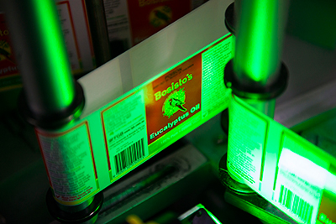
Caption: Kaeser compressed air is used to power the high speed labeller at FGB

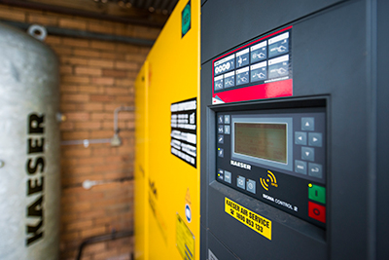
Caption: FGB chose to install a Kaeser CSD 105 rotary screw compressor along with a 1000 litre air receiver and DC108E dessicant dryer

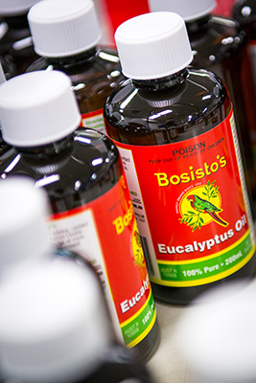
Caption: FGB manufactures the renowned Bosisto's 'Parrot' brand Eucalyptus Oil

