Exceptional energy efficiency for smaller compressed air users from Kaeser
Compressed air users that require smaller volumes of air can now benefit from all of the advantages that modern compressed air technology has to offer with the Kaeser ASD series of rotary screw compressors.
With free air deliveries from 3.16 to 5.53 m³/min at 8.5 bar, and capable of 15 bar maximum operating pressure, the Kaeser ASD series of rotary screw compressors are the perfect choice for users that require smaller volumes of compressed air.
At the heart of every ASD compressor is a high performance Kaeser rotary screw compressor block equipped with flow-optimised 'Sigma Profile' rotors. The 'D' in ASD stands for Direct Drive, which means that the compressor block and the drive motor are directly coupled and turn at exactly the same speed. The drive power is transmitted from the motor to the compressor block without the losses incurred by gearing or drive belts. The use of premium efficiency IE3 electrical motors, which comply with and exceed prevailing Australian GEMS regulations for 3 phase electric motors, also contributes to additional energy savings.
Another important efficiency-enhancing component is the new "Sigma Control 2" internal controller. This advanced system not only enables demand-oriented performance matching and dependable monitoring, but ensures even greater flexibility through its numerous interfaces and innovative plug-in communication modules. Connection to energy-saving master control systems, computer networks and / or remote diagnostics and monitoring systems couldn't be easier. The addition of an integrated RFID reader ensures service continuity, increases security and significantly raises service quality.
'Sigma Control 2' equipped ASD series rotary screw compressors from Kaeser, can also be connected to a second machine of the same specification to provide co-ordinated base load operation - a master control system is therefore not required. One of the units assumes the 'Master' role and thereby precisely co-ordinates performance of both compressors to suit specific compressed air demand. It also ensures that both machines are evenly loaded.
Featuring a radial fan and optimised cooling-air flow, a clever cooling system ensures low compressed air outlet temperatures. The fan's power reserve is sufficient for long lengths of ducting and, as a result, eliminates the need for installation of an additional exhaust fan. Moreover, it consumes less power than a comparable axial fan. In conjunction with exceptional sound insulation, the high performance ventilation system enables low sound levels of only 65 to max. 69 dB(A), depending on model.
The Kaeser ASD series of rotary screw compressors are optionally available with an integrated refrigeration dryer and / or frequency control module. This versatile modular design allows the compressor system to be precisely tailored to meet the user's exact requirements.
Models featuring an integrated compressed air dryer are also equipped with a centrifugal separator and an electronic "Eco Drain" condensate drain as standard. This consequently ensures efficient condensate separation and drainage, and further aids effective operation of the downstream refrigeration dryer.
As a result, users who require smaller volumes of compressed air can now benefit from all the advantages that modern compressed air technology has to offer! The standard ASD series rotary screw compressors are available with drive power 18.5 to 30 kW, max working pressure 8.5 to 15 bar and free air delivery 2.63 to 5.53 m³/min.

File: A-asd-aus
Approved for publication, copy acknowledgement appreciated
Image:

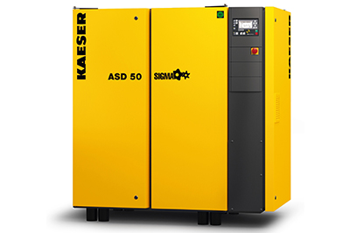
Kaeser ASD series rotary screw compressors ensure efficient compressed air production and treatment with a minimal space requirement.

