Mobilair 50 portable compressor from Kaeser now includes a robust new PE enclosure
The Mobilair 50 portable compressor from Kaeser Compressors now features a new highly durable, corrosion- and scratch resistant, double-skinned polyethylene sound enclosure, providing maximum protection from even the toughest of conditions. Beneath this new enclosure remains a number of user benefits including impressive performance and energy efficiency as well as a user-friendly and environmentally-friendly operation.
Delivering enough compressed air power for three breakers, or one 'heavy duty' tool, this 5 m³ class portable compressor is exceptionally lightweight and combines outstanding flexibility with environmentally-friendly operation. Moreover, it uses trusted technology to ensure unrivalled dependability.
The Mobilair 50 portable compressor from Kaeser is powered by a proven, water-cooled, four-cylinder turbo-diesel engine, which directly drives the flow-optimised Sigma Profile airend. Direct drive eliminates the transmission losses associated with other systems, consequently providing more air for less fuel.
Service life and efficiency are enhanced through low motor and airend speed, this additionally assists in keeping noise emissions to an absolute minimum. In fact the Mobilair 50 is one of the quietest models in its class! The Mobilair 50 is therefore the perfect choice for simultaneously powering up to three breakers and is equally suited to impact borer applications.
The Mobilair 50 is surprisingly lightweight with an operational weight of less than 750 kg. This makes these portable compressor units one of the most manoeuvrable in its class.
Fitted as standard, and improving reliability still further, the Kaeser "Anti-frost Control" is particularly useful at times of the year when ambient temperatures are lower, protecting air tools against freezing, corrosion and potential damage.
All metallic body components are zinc-primed and powder coated to ensure long-term protection from the elements. Operation is made simple via a single control switch and user-friendly icons, whilst excellent component access greatly simplifies servicing and maintenance tasks. Built to Kaeser's renowned high quality standards, this versatile portable compressor is designed to provide many years of dependable service.
Manufactured at Kaeser's state-of-the-art production facility located in Coburg, Germany, the Mobilair 50 portable compressor features a 32.5 kW drive motor, standard working pressure 7 bar and with free air delivery 5.0 m³/min.

File: c-Mobilair 50_PE-aus
Approved for publication, copy acknowledgement appreciated
Image:

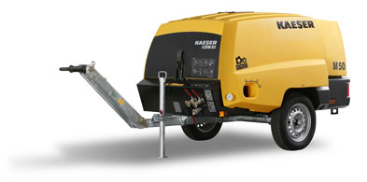
Exceptional performance characteristics hide beneath the Mobilair 50's new corrosion- and scratch-resistant PE sound enclosure.

