February 2022

Efficient and cost effective clean compressed air:
Kaeser launches next gen filters

Kaeser Compressors has just announced the launch of its latest generation of compressed air filters that provide highly efficient filtration for flow rates from 0.6 to 32.0 m³/min. Thanks to a number of sophisticated design features, Kaeser filters can create significant reductions in costs and CO₂ emissions.

The efficiency of a compressed air filter depends most on pressure loss, and with every 1 bar of pressure loss increasing an end user’s energy cost by 6 percent per m³/min of compressed air, the choice of compressed air filtration will therefore be significant. Kaeser Filter products deliver a 50 percent lower pressure loss in comparison to other filters on the market - and this is a value that remains constant throughout the entire service life of the filter element. As a result significant cost reductions and CO₂ emissions are made possible. This is thanks to a number of design features:

Kaeser Filter products use filter elements with flow-optimised element heads. The filter inlet is offset towards the air inlet. This increases the flow cross-section at the air discharge side and contributes to outstanding filter efficiency with minimal pressure loss. Generously dimensioned connection flanges furthermore help to keep pressure losses to a minimum.
High filtering efficiency with minimal pressure loss is also achieved thanks to the element head of the Kaeser Filter units which is optimised for best possible air flow. Its tapered internal structure channels the compressed air towards the centre of the element interior for an even charging of the filter media.
In addition, deep pleated Kaeser particulate and coalescence filter elements feature exceptionally large filter surfaces. This increases efficiency which significantly reduces operating costs compared to conventional filter designs. And, unlike conventional filters, Kaeser activated carbon filters with high-efficiency carbon matting prevent channeling whilst also ensuring reduced differential pressure.

Kaeser Filter products demonstrate a lower pressure loss right from the outset compared to other filters typically available on the market. Moreover, the pressure loss remains low for much longer, thanks to the high contaminant retention capacity. The result: low operating costs over the long term. The annual maintenance of particulate and coalescence filters also mitigates age-related risks and ensures maximum compressed air purity.

Kaeser Filter products are the key components for supplying compressed air of all purity classes as per the ISO 8573-1 standard. Available in four different filter grades and twelve housing sizes, they provide efficient filtration covering flow rates from 0.6 to 32.0 m³/min. For more information visit au.kaeser.com or phone 1800 640 611.
-END- Free for publication, copy appreciated
Editors Notes
From 0.18 to 515 kW, Kaeser Compressors manufactures a wide range of compressors and associated auxiliary equipment that meet the varying requirements of a diverse range of industries and applications.
One of the world’s largest manufacturers of compressors, blowers and compressed air systems, Kaeser Compressors is represented throughout the world by a comprehensive network of branches, subsidiaries and authorised distribution partners in over 140 countries.

Kaeser Compressors Australia provides comprehensive sales and service from its purpose built factory in Dandenong, Victoria alongside an extensive network of sales and service centres and authorised partners that cover Australia and New Caledonia.

For editorial and advertising enquiries contact: Beth Wood, Marketing Manager
Press office: +61 3 9791 5999 E-mail: beth.wood@kaeser.com

KAESER COMPRESSORS Australia Pty Ltd
45 Zenith Road, Dandenong, VIC 3175, Australia
Phone: +61 3 9791 5999 Email: info.australia@kaeser.com
au.kaeser.com
File: D-Filters-2022-aus
Approved for publication, copy acknowledgement appreciated
Images:
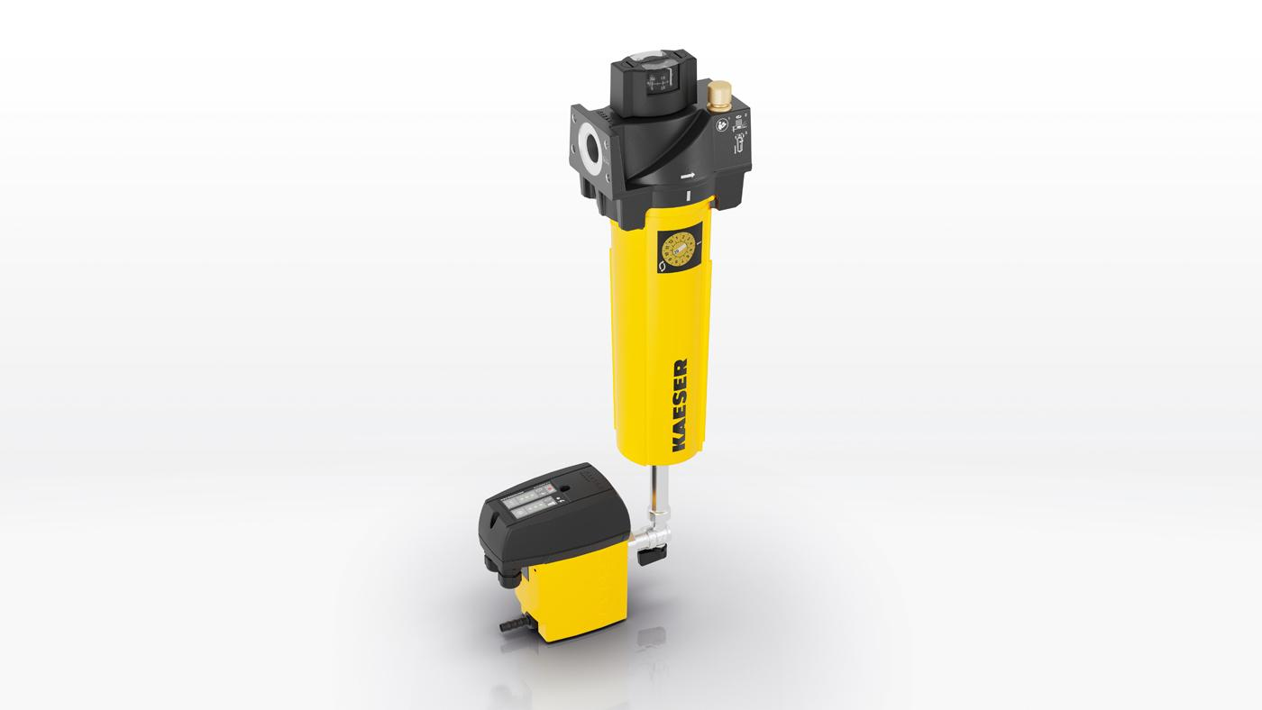
Caption: Kaeser Filter products can create significant reductions in costs and CO₂ emissions.

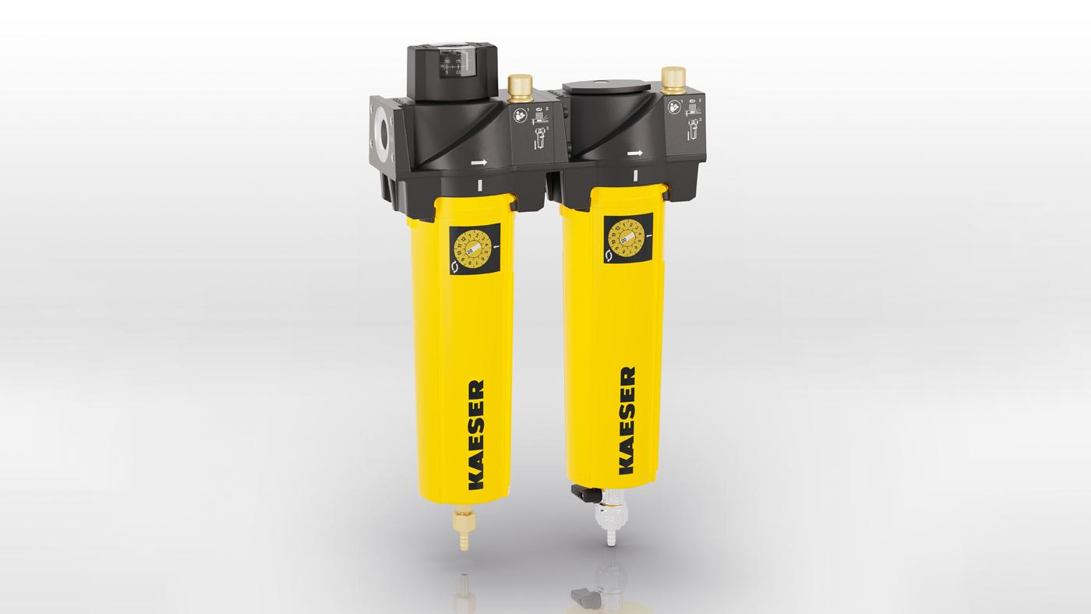
Caption: Generously dimensioned connection flanges are just one feature of Kaeser Filter products that help keep pressure losses to a minimum
((Kaeser photo – free for publication))

