The redesigned SX rotary screw compressor range from Kaeser Compressors
Quiet, compact and efficient
Applications requiring smaller volumes of compressed air can take advantage of reliable, efficient and ultra-quiet production of quality compressed air better than ever before with Kaeser’s redesigned SX series.
The new generation SX 3, 4, 6 and 8 models look set to continue the legacy of their predecessors with enhanced performance and exceptional efficiency; specific power has been improved by up to 9 percent compared with previous models. Designed for continuous operation with ultra-low sound levels of only 60 to 64 dB (A), these models cover air deliveries from 0.33 to 0.8 m³/min at 8 bar and range in power from 2.2 to 5.5 kW. Moreover, these versatile units require even less space: The SX 8, for example, produces an impressive free air delivery of 0.8 m³/min (at 8 bar), yet has a footprint of only 0.37 m².
At the heart of each unit lies a Kaeser rotary screw compressor featuring a specially designed airend with flow-optimised Sigma Profile rotors, which deliver more compressed air for less energy consumption. The efficiency of the airend is complimented by a highly effective cooling system featuring a new dual-flow fan. Its innovative design not only enhances cooling performance, but also minimises sound emissions. Furthermore, separate intake of motor-cooling air and air for compression from the ambient surroundings ensures optimum motor cooling and increased compression performance. The internal “Sigma Control Basic” controller provides automatic system monitoring and precisely adjusts compressor performance to match actual compressed air demand. Models are also optionally available equipped with the “Sigma Control”, which allows connection to compressed air management systems.
These units are also exceptionally service-friendly: The housing cover on the left of each unit is easy to remove and allows excellent component accessibility, whilst the new maintenance-free drive belt between the motor and airend eliminates the need for intermittent belt tensioning and adjustment. This both guarantees optimum power transmission and reduces service costs.
Integrated refrigeration dryer and 'Aircenter' (screw compressor, refrigeration dryer and 200-litre capacity air receiver) versions are also available. The dryers in both designs are thermally shielded to prevent exposure to heat from the compressor package. So, with this wide range of options there's always an appropriate SX configuration to suit even the most specific compressed air needs.

File: A-SX-aus
Approved for publication, copy acknowledgement appreciated
Image:

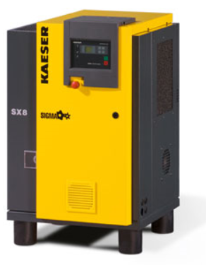
The new SX rotary screw compressors from Kaeser (SX 8 model pictured) ensure reliable, efficient and ultra-quiet production of quality compressed air. They require minimal installation space and maintenance. The wide range of package options includes integrated refrigeration dryer models (T-versions) and 'Aircenter' versions (refrigeration dryer and air receiver).

