KCT: Efficient & versatile ‘dry-running’ reciprocating compressors
High Quality Compressed Air

Modern reciprocating compressors can provide a reliable and efficient source of quality compressed air for a wide range of applications in environmental engineering. This especially applies to processes that require an intermittent supply of smaller volumes of compressed air. Kaeser’s KCT series compressors not only produce quality compressed air, but also save space and provide significant energy savings at the same time. The range covers air deliveries from 110 to 840 l/min with drive powers between 0.75 and 4 kW.
All KCT units are state-of-the-art ‘dry-running’ reciprocating compressors that feature high performance valves, low piston speeds and generously sized bearings to ensure long service life and low maintenance requirement. Precision machined, coated cylinders safeguard against corrosion and guarantee minimal wear, making a so-called ‘run-in period’ unnecessary. All KCT packages are equipped with “EU-eff 2” drive motors, which require less energy, operate at a lower temperature and therefore offer greater durability than conventional motors. The efficient cooling system with its special air flow design, powerful fan, multiple cooling fins and heavy-duty components allows continuous operation at up to 10 bar maximum pressure*.
The compressor operates quietly and efficiently, but if required an additional sound absorbing enclosure reduces sound levels even further. A range of drive power versions and models with horizontal or vertical air receivers is also available.
*) Continuous operation up to 10 bar only possible for 2.4 to 4 kW models

File: b-KCT-aus
Approved for publication, copy acknowledgement appreciated
Image:

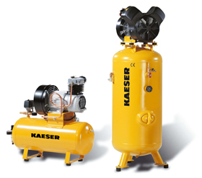
Available in a range of different versions, Kaeser's KCT series reciprocating compressors are the perfect choice for efficiently producing high-quality compressed air.

