Caveat emptor: let the buyer beware!

Many compressed air users will reach a cross roads when it comes to replacing the consumables in their portable compressor. That being do they choose the original equipment manufacturer's genuine spare parts or do they try and save a few dollars and buy non-genuine - or 'spurious' - spare parts. In making this decision, there are however a number of factors that should be considered...
From replacing the air filter and oil filter right down to the choice of lubricant, there are a number of consumables that need to be periodically changed within a portable compressor. The lifetime of the compressor, its overall performance and reliability as well as its maintenance requirements will all be impacted by whether the user opts to replace these consumables with genuine or non-genuine parts.
The compatibility of spurious spare parts with a portable compressor is one factor that will have a large bearing on its resultant performance and maintenance requirements. Only genuine OEM spare parts will have been rigorously tested by the OEM with the compressed air equipment. The durability, performance, efficiency, safety or even the compatibility of spurious parts will not have been tested with the compressed air equipment. There is no way of knowing how spurious spare parts will therefore interact and how they may affect the performance of the compressed air equipment. It is therefore possible that they may compromise the efficiency, reliability and safety of the portable compressor as well as the air quality required.
It is also worth bearing in mind that only the OEM's genuine spare parts have been designed to meet the demands of the applicable operating conditions, quality tested to ensure the best possible performance and, designed to assure the life cycle is commensurate with the maintenance intervals.
In addition, it is highly likely that opting for non-genuine parts which are not recommended by the OEM will void the manufacturer's warranty. This could become costly if a fault occurs within the portable compressor that would ordinarily have been covered under the warranty.
Without a doubt reliability, efficiency and durability would all have been key criterion in choosing to invest in a high quality portable compressor. It stands to reason then, that maintaining the integrity of the compressed air system is therefore critical to ensure that the system continues to operate at its peak performance. And, undoubtedly the decision of whether to opt for genuine or spurious spare parts will have a large bearing on this.
In the end the decision may be as simple as asking oneself; is some potential short term financial gain worth the long term pain that using spurious spare parts may cause? As they say, caveat emptor - or, let the buyer beware!

File: n-let-the-buyer-beware-aus
Approved for publication, copy acknowledgement appreciated
Image:

Only genuine OEM spare parts will have been rigorously tested by the OEM with the compressed air equipment
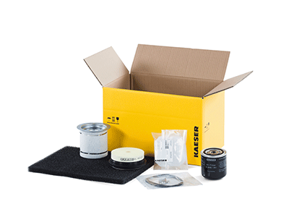
Choosing OEM genuine spare parts will impact the all up energy efficiency of the compressed air system

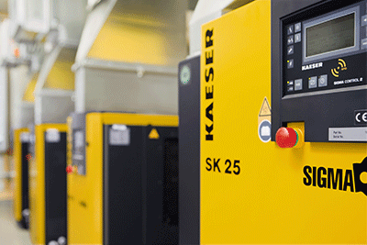
Energy savings can be made by opting for premium efficiency compressors

