March 2022

Next-gen compressed air management systems:
Evolution brings significant life-cycle cost benefits

Since inception, master controllers have played an important role in increasing the efficiency of compressed air stations. The latest generation of these intelligent control systems represents a further evolution. Adaptable and easy to operate, they are able to monitor and control an entire compressed air system, whilst producing data that can be utilised for numerous purposes. The result? Reduced energy costs, increased convenience, enhanced operational security and additional functionality - such as predictive maintenance and life-cycle management.

The drive towards efficiency, reliability and – most importantly – energy savings and sustainable usage of resources, increasingly compels developers and users to optimise existing compressed air solutions ever further. Modern air stations are comprehensive systems, including compressors, cooling systems, dryers and filters. Even the individual components have auxiliary systems, such as ventilation or cooling-water systems. Moreover, stations are often incorporated into heat recovery processes in order to achieve optimal use of the available energy. The range and number of individual components that make up a complete compressed air system can therefore be considerable.

Complex systems such as these require an organising hand to guide them, which is where master controllers such as the Sigma Air Manager 4.0 come into play. By monitoring the individual components and optimally coordinating the interaction between them, these controllers transform the individual ‘players’ into a truly cohesive team that operates reliably and efficiently.

The use of management systems such as these have already yielded a high degree of optimisation. For instance, master control systems have for some time been capable of coordinating multiple compressors with different internal controllers, thereby ensuring that they supply the required set working pressure with maximum energy efficiency.

Better communication between components
Yet there were still certain aspects where improvement was possible. For example, potential remained for the development and refinement of communications between components and controllers. Some compressors are equipped only with floating contacts, which merely signal the basic status of the compressor (running / not running), rather than integrated controllers capable of detecting and communicating more detailed information about the compressor.

Furthermore, within the wide range of different bus systems available on the market, many are not compatible with one another or can only be made compatible with difficulty. This makes it hard to communicate all the necessary information regarding the system’s status.

Contemporary Ethernet-based bus systems enable more straightforward integration and communication of large data volumes. Systems equipped with modern internal controllers therefore already rely on Ethernet technology in order to communicate with other networked systems.

Latest generation of management systems
The very latest controllers are true management systems which act like master controllers, yet are capable of much more. They gather information regarding the connected components, measurement points via Ethernet and are able to transfer a limitless amount of such data to a centralised control system for evaluation.

The various methods used to gather information means that the data can be used in a range of ways, with the ultimate aim of optimising the compressed air system. For example, whilst also ensuring maximum operational reliability and efficiency, the compressors and treatment components are switched on and off as needed, or operate at partial load, so that compressed air volumes and quality always remain in step with actual demand.

Keeping an eye on system parameters
Management systems additionally monitor all other relevant system parameters, such as the temperature and pressures in the compressor and compressed air treatment system, as well as ambient conditions. This means the control system can also check whether the compressor cooling is performing as required and whether environmental conditions (temperature, pressure) are consistent with requirements.
Where heat recovery systems are used, all associated parameters are also integrated into the management system.
Predictive maintenance
However, progress is not restricted to system operation alone. Maintenance represents a key area to consider when it comes to maximising cost-effective compressed air production. It goes without saying that poorly maintained systems with contaminated coolers or filters, for example, also operate with impaired specific package input power.

The latest management systems therefore also take maintenance parameters into account and include them in overall optimisation strategies. Over the long-term, predictive maintenance not only reduces both energy consumption and costs, but also helps boost value-retention of the system as a whole. Moreover, complex monitoring enables the creation of predictive maintenance schedules.

Monitoring can take place either internally within the company, or via an external service provider. For some years now, providers of compressed air systems have offered operators the option of remote monitoring. This means that they not only benefit from continuous monitoring of the operating parameters for their daily compressed air generation, but the system is also constantly checked and rechecked from a life-cycle management point of view. In this way, any increase or decrease in requirements can be identified early on and the air station optimised accordingly.

Documentation and management
In addition to control of the compressor station itself, management systems also enable the gathering, forwarding and evaluation of important data to produce documentation in accordance with ISO 50001.
Management systems collect data regarding air consumption and, where applicable, heat recovery. Based on such data, costs are automatically calculated and can be assigned once again to the various individual components within the system.
These functions, including visualisation, are accessed via the web using standard browsers without the need for any additional software.

Integration of older systems
Older systems can also be integrated with modern compressed air management systems. Monitoring is more difficult if the available compressor system is not appropriately equipped from a technical point of view, however it is still possible.

Conclusion
Compressed air management systems such as the Sigma Air Manager 4.0 optimise the compressed air supply and require no additional software to provide valuable cost-monitoring information. Such management systems not only control the compressors in accordance with compressed air demand, but also monitor the compressed air system as a whole, as well as any associated auxiliary systems, for optimum efficiency. They also offer enhanced data evaluation options, coupled with predictive maintenance, remote monitoring and life-cycle cost management, which in turn delivers improved reliability. And, with more detailed information regarding the system available, this leads to significantly reduced operating costs. For more information visit au.kaeser.com or phone 1800 640 611.
-END- Free for publication, copy appreciated
Editors Notes
From 0.18 to 515 kW, Kaeser Compressors manufactures a wide range of compressors and associated auxiliary equipment that meet the varying requirements of a diverse range of industries and applications.
One of the world’s largest manufacturers of compressors, blowers and compressed air systems, Kaeser Compressors is represented throughout the world by a comprehensive network of branches, subsidiaries and authorised distribution partners in over 140 countries.

Kaeser Compressors Australia provides comprehensive sales and service from its purpose built factory in Dandenong, Victoria alongside an extensive network of sales and service centres and authorised partners that cover Australia and New Caledonia.

For editorial and advertising enquiries contact: Beth Wood, Marketing Manager
Press office: +61 3 9791 5999 E-mail: beth.wood@kaeser.com

KAESER COMPRESSORS Australia Pty Ltd
45 Zenith Road, Dandenong, VIC 3175, Australia
Phone: +61 3 9791 5999 Email: info.australia@kaeser.com
au.kaeser.com
File: M-SAM-4-0-2022-aus
Approved for publication, copy acknowledgement appreciated
Images:
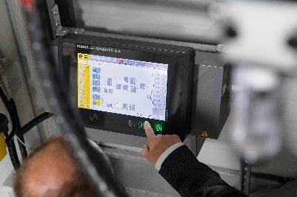
Caption: Compressed air management systems such as the Sigma Air Manager 4.0 are the centrepiece of a modern air station.

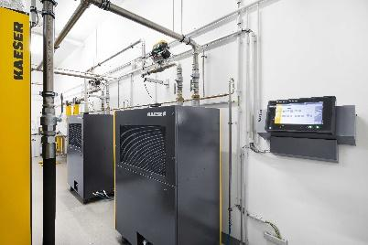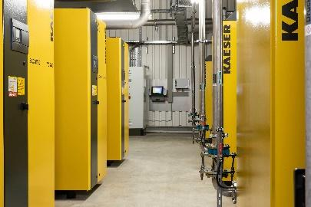
Caption: The latest generation of compressed air management systems, such as the Sigma Air Manager 4.0, now provide a range of enhanced benefits with a view to achieving optimisation of the entire system.
((Kaeser photo – free for publication))

