Kaeser and Mediquip breathes life into veterinary clinics
Mediquip opts for the Kaeser Aircenter to complement its oxygen supply systems which are assisting numerous veterinary clinics nationwide to efficiently and economically manufacture their oxygen requirements on site.
It is sometimes surprising when you stop and consider all of the places where compressed air is used. Typically we think about manufacturing, processing and engineering applications. However, compressed air serves a very important function in numerous other industry sectors, not least the veterinary industry where it is used to manufacture oxygen. From small veterinary clinics to large animal hospitals, oxygen generation plays a key role in healing pets and animals. And, with one of the highest rates of pet ownership in the world and over 33 million pets, Australia certainly has a demand for the lifesaving services they provide!
The traditional method of obtaining the oxygen would be to purchase it in cylinders. However, this method is costly and comes with the added inconvenience of having to move and change heavy and dangerous oxygen cylinders. Mediquip, a biomedical and medical gas equipment sales and service company, offers the Australian veterinary industry with a highly economical, convenient, safe and compact alternative - oxygen supply plants.
Powered by a compressor, an oxygen supply plant generates near pure oxygen from the air we breathe by using a method called pressure swing adsorption. Air is forced under pressure by a compressor into a cylinder. The cylinder contains a material that effectively separates the oxygen from the other gases in the air. Once the material has adsorbed these gases, a valve is opened for the almost pure oxygen to exit into a holding reservoir. An exhaust valve is then opened, allowing the other gases to escape. This system employs two cylinders running in opposite cycles to produce a continuous flow of oxygen.
Mediquip has over 30 years of experience in providing biomedical and medical gas solutions to the Australian healthcare, aged care, emergency and veterinary industries. The company chose to partner with Kaeser to present a complete oxygen supply plant solution to its customers several years ago, as Kurt Hogan, General Manager at Mediquip explains; 'Kaeser was originally recommended to us by a supplier in America that was already successfully installing the oxygen supply plants with Kaeser compressors. With a reputation for manufacturing German made and top quality compressors and accessibility to nationwide service support, Kaeser was the right choice to complement our oxygen supply systems.'
The oxygen supply plants from Mediquip come with a Kaeser Aircenter; a complete and compact turn-key system for the production of dry compressed air, which incorporates a compressor, dryer and air receiver all within a single housing.
At the heart of each Aircenter lies a proven Kaeser rotary screw compressor featuring a premium quality screw compressor block with Kaeser Sigma Profile rotors that have been designed for maximum energy efficiency.
The inclusion of a thermally shielded refrigeration dryer further ensures a dependable supply of dry and clean air - a feature that was key in Mediquip's decision in selecting the Kaeser Aircenter for this application as Hogan explains; 'The air must be clean to adhere to the same quality standards expected of breathing air and as the oxygen generation process uses a material molecular structure which is susceptible to moisture and contaminants, choosing a compressor from a manufacturer that we could trust to meet these high air quality standards was paramount.'
The RSPCA Victoria's veterinary clinic in Burwood East is one customer that has realised the benefits of the Mediquip oxygen supply plant. Providing care to animals seven days a week, 365 days a year, oxygen needs to be readily available at the clinic for a number of uses including the anaesthetic machines and humidicribs used in intensive care.
Andrew Byrne, Chief Veterinarian at the RSPCA Victoria said; 'We were previously obtaining the oxygen we required in cylinders. This was proving to be costly and required a lot of attention to ensure that we always had enough oxygen on hand. The oxygen supply plant from Mediquip solved these issues, allowing us to make our own oxygen as and when required. Compactly installed the system generates the oxygen we need on demand which is then available via a piping system in all of our surgery rooms.'
Simple to install and easy to maintain, the compact and all-in-one Kaeser Aircenter delivers a reliable and cost-effective supply of quality compressed air, available with drive motors 2.2 to 22 kW, working pressure 8 to 15 bar and with free air deliveries from 0.26 to 3.5 m³/min.

File: Q-mediquip-aus
Approved for publication, copy acknowledgement appreciated
Images: (contact the press office for high res copies of the following images)

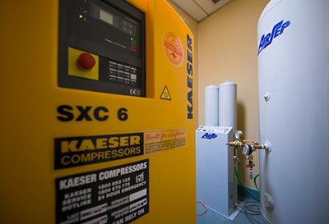
Caption: Compactly installed, the oxygen supply plant at the RSPCA Victoria's veterinary clinic in Burwood East, generates oxygen which is then available via a piping system into all of the surgery rooms.

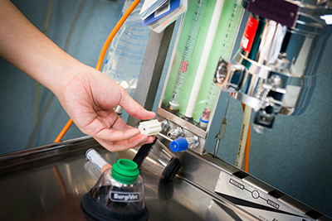
Caption: The oxygen supply plant allows the RSPCA Victoria's veterinary clinic in Burwood East to make its own oxygen as and when required.

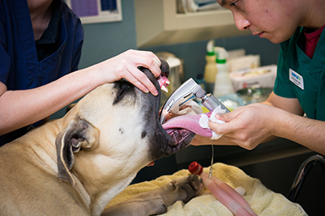
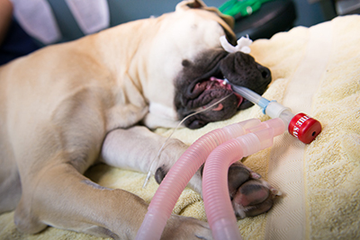
Caption: The RSPCA Victoria's veterinary clinic in Burwood East utilising the oxygen supply plant system to provide oxygen to Alfie in surgery.

