June 2020
A compact and robust oil free compressed air system:
Kaeser launches the i.Comp Tower T series

Kaeser Compressors has recently launched the new i.Comp Tower T series all-in-one compressed air systems which are ideal wherever an oil free and compact compressed air system is required, such as in breweries and food production to medical applications, laboratories and automotive workshops. Featuring a completely new compressed air supply concept, the i.Comp Tower T series delivers an efficient and reliable supply of oil free compressed air from a compact, robust and service friendly package.

The i.Comp Tower T series from Kaeser Compressors is an all-in-one compressed air station comprising a reciprocating compressor, refrigeration dryer and optional filters all within one robust housing and assembled on two compressed air receivers.

With the i.Comp series Kaeser has introduced a genuine world first for reciprocating compressors. Robust, compact and perfectly in tune with the operators needs, the i.Comp series impresses with its brand new drive concept;

The i.Comp series reciprocating compressor features a specially developed high performance permanent magnet motor with integrated control electronics. This particularly efficient motor operates at a 90 percent efficiency rate. In addition, the motor’s in-built frequency converter minimises switching operations and energy losses. This makes the i.Comp series extremely efficient in all load phases, delivering the exact amount of compressed air actually required at any one time. In addition, these compact powerhouses have considerably better specific performance than conventional piston compressors (up to 18 per cent lower).

Ideal for sensitive applications, the i.Comp Tower T series feature single stage 100 percent oil free compression reciprocating compressors, able to deliver up to 570 l/min at pressures up to 11 bar. The compressor block does not contain any oil and these complete compressed air supply systems deliver constantly dry compressed air at a pressure dew point of + 3 ° C, with any condensate reliably drained off.

To ensure the right levels of quality are achieved consistently Kaeser manufactures every one of its single stage 100 percent oil free compression reciprocating compressor blocks in house. Using the best quality materials available all components are assembled, tested and installed with the greatest care and attention. The result is an extremely durable oil free compressor block that offers high levels of air delivery and cost efficiency. Optimised flow paths and highly effective cylinder cooling keep wear and tear to a minimum whilst ensuring maximum efficiency.
The cylinders combined inlet area helps to minimise intake air losses. The reduced size crank drive guarantees a smooth operation. Optimising the motor and compressor performance serves to reduce stress on both mechanical and electrical components minimising wear and tear.

Thanks to a unique design, state-of-the-art technology and highly effective cooling air flow, the new i.Comp Tower T series compressed air systems can easily manage ambient temperatures of up to 45ºC. What’s more, low vibration bearings and a sound-insulating PE hood, make these units astoundingly quiet.

The i.Comp Tower T series are compact with a footprint of less than one square metre. Designed to allow full access to all service relevant components, this compact powerhouse can be installed right up against the wall. Because the PE enclosure opens upwards multiple units can be installed side by side to save space.

The i.Comp Tower T series from Kaeser delivers a reliable and energy efficient source of oil free compressed air. Ideal for sensitive applications, these high quality plug and play compressed air supply systems are both quiet in operation and compact in design. For more information visit au.kaeser.com or phone 1800 640 611.
-END-
Editors Notes
From 0.18 to 515 kW, Kaeser Compressors manufactures a wide range of compressors and associated auxiliary equipment that meet the varying requirements of a diverse range of industries and applications.

One of the world’s largest manufacturers of rotary screw compressors, Kaeser Compressors is represented globally in over 100 countries through a dedicated network of branches, subsidiary companies and authorised partners.

Kaeser Compressors Australia provides comprehensive sales and service from its 30,000 ft² purpose built factory in Dandenong, Victoria alongside an extensive network of sales and service centres and authorised partners that cover Australia and New Caledonia.

For editorial and advertising enquiries contact: Beth Wood, Marketing Manager
Press office: +61 3 9791 5999 Fax: +61 3 9791 5733
E-mail: beth.wood@kaeser.com

KAESER COMPRESSORS Australia Pty Ltd
45 Zenith Road, Dandenong, VIC 3175, Australia
Phone: +61 3 9791 5999 Email: info.australia@kaeser.com
au.kaeser.com

File: B-Kaeser-iComp-tower-t-aus
Approved for publication, copy acknowledgement appreciated
Images:

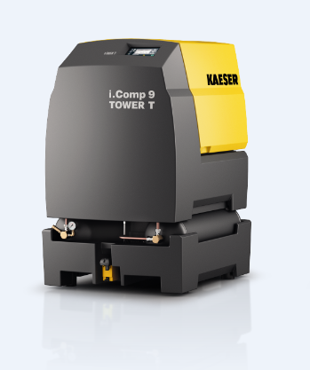
Caption: Featuring a 100 percent oil free compression reciprocating compressor, the i.Comp Tower T is the ideal solution for sensitive applications.

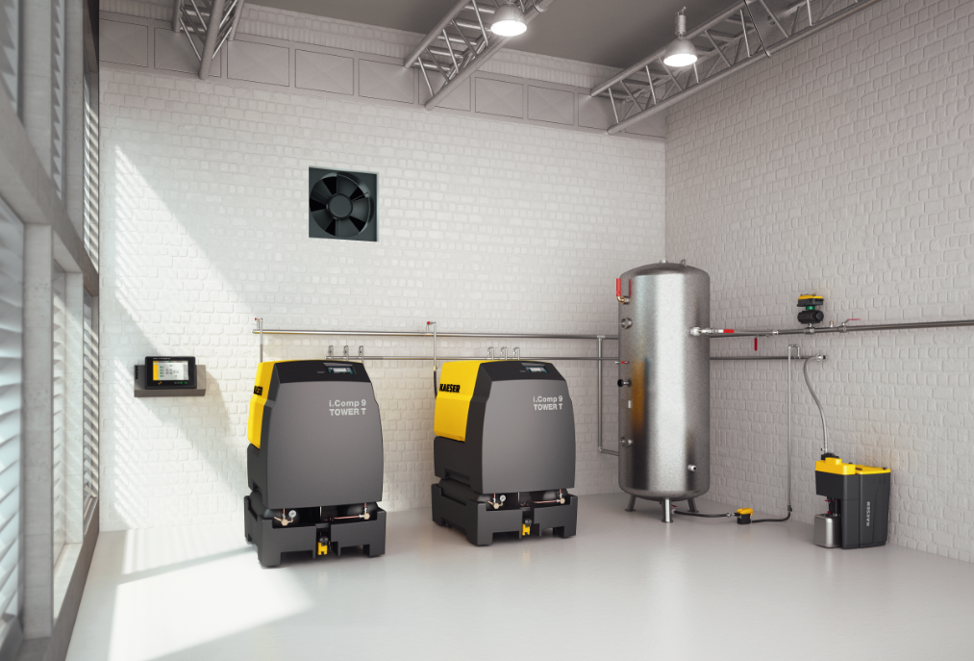
Caption: Thanks to a compact design and the upward opening PE enclosure, multiple units can be installed side by side to save space.

Kaeser photo(s) – free for publication, credits appreciated.

