Kaeser 4.0: Discover tomorrow’s technology today at WIOA VIC 2017
Kaeser Compressors will present the Sigma Air Manager 4.0 - a key technology in the advanced world of Industrie 4.0 - at the 80th Victorian Water Industry Operations Conference and Exhibition.
The Sigma Air Manager 4.0 (SAM 4.0) from Kaeser brings users ever closer to Industrie 4.0 applications, which enables optimal coordination and control of all components within a blower station to meet the customer's exact requirements. The real-time gathering, transmission and management of in-process operating data enables users to anticipate faults and act promptly before they occur.
SAM 4.0 is at the core of a blower station and is the key technology for opening up access to the services that Industrie 4.0 will offer. As the central brain of the blower station, SAM 4.0 controls the various machines in its control for optimum efficiency, and precisely matches air delivery with the required airflow profile. Within seconds it analyses the operating data, simulates possible responses and selects the most efficient alternative. The result: an entirely new level of energy efficiency.
With the greatest of ease the SAM 4.0 can also display and analyse pressure data, air delivery, performance, maintenance messages and any fault messages, past or present. The network connection also offers the convenience of working with this data on a PC. Aside from providing peace of mind and enabling predictive maintenance, this permits energy management in compliance with ISO 50001.
Multi-device control additionally opens up new possibilities for the advance planning of blower maintenance. In the past, maintenance was possible only when fault messages occurred or as part of scheduled servicing. With SAM 4.0, it is now possible to initiate maintenance work before faults occur, helping to avoid downtime and the further damage that faults may cause.
The onboard sensors in the Kaeser machines, and the Sigma Control 2 compressor control system, collect process data and forward it to the SAM 4.0 in real time. With special software, the data is then forwarded to the Kaeser Data Center and subjected to real-time analysis. The Kaeser Data Center performs central monitoring and handles system messages, initiating predictive maintenance measures as needed. As a result, maintenance can be carried out at the precise time when it is needed. This saves time and expense and ensures maximum blower availability - and therefore the processes that they support.
The SAM 4.0 has been designed to accommodate potential blower system expansion. A straightforward software upgrade allows for expansion with no need for additional investment in new hardware.
Visitors to stand number 47 at the Victorian Water Industry Operations Conference & Exhibition will be able to experience the SAM 4.0 first hand, as well as learn about other Kaeser 4.0 products and services.
Are you Industrie 4.0 ready? Join Kaeser at the Victorian WIOA Conference and Exhibition on stand number 47 to learn more. 6-7 September at the Bendigo Exhibition Centre, VIC.

File: o-WIOA-VIC-2017-aus
Approved for publication, copy acknowledgement appreciated
Image:

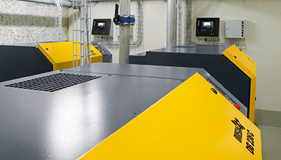
The Kaeser SAM 4.0 is a key technology in the advanced world of Industrie 4.0

