Complete lifecycle efficiency:
Industrie 4.0 compressed air maintenance
Significantly enhanced reliability, cost-optimised servicing, longer system service life and assured specific power are all benefits that compressed air users can realise with Industrie 4.0, needs-based maintenance as Kaeser Compressors Australia explains…
The way we manufacture is no doubt entering a new era led by the advances, networking and connectivity capabilities of production processes and technology. Coined Industrie 4.0, this new era presents a number of opportunities and benefits to manufacturers that choose to embrace this ‘factory of the future’.
When it comes to compressed air production, intelligent contracting model-based solutions have been available for quite some time now. These so-called hybrid service bundles combine highly efficient, innovative products with intelligent services in the fields of engineering and predictive maintenance. In essence, it is these solutions that laid the foundation for Industrie 4.0 in the compressed air production sector. Now, thanks to new communications technologies and services, these compressed air contracting models are being further refined and improved.
On the one hand, these solutions include the components of the compressed air station which are responsible for the actual production and treatment of the compressed air itself; specifically the compressors, dryers, filters, etc. as well as peripheral equipment such as ventilation louvres. On the other, they also include the many services that can be rendered throughout the entire lifecycle of the compressed air station. These encompass precision air demand analysis, optimal design for compressed air supply systems and regular maintenance and servicing; not to mention energy management options, as well as planning of new systems, expansion of existing ones and investment in replacement equipment.
Let’s first examine the components. To take full advantage of their Industrie 4.0 capabilities, components must meet two sets of requirements: they must support efficient control when utilised in combination with other machines and also provide real-time operating data for monitoring purposes and be able to forward all relevant data to master control systems.
Modern compressors and compressed air treatment components are therefore equipped with internal controllers based on industrial PC technology which are able to pass data to a master control system via convenient interfaces, such as Ethernet. The data generated by the components are first delivered to a master controller. This controller fulfils two roles: it acts as an actual management system for the compressed air station as well as a central node for the forwarding of relevant data.
Advanced management systems such as these must successfully meet some highly demanding conditions. Not least, they must be capable of efficient and, most importantly, predictive compressor control, taking into account a range of contributing factors, such as switching losses, control losses, etc. Another key requirement is the ability to handle the sheer volume of incoming data from the compressor station. This data must be compiled appropriately, then sent on to a superordinate service centre.
Multiple levels of functionality
These advanced controllers allow for varying levels of involvement by external service providers, so compressed air system operators can still choose to perform all of the maintenance, evaluation and servicing of the system themselves. In this case, the master controller is integrated into the operator’s control system and the data can be requested by any desired part of the company.
Alternatively, system operators can simply opt for a conventional service agreement. Or, in order to take advantage of further services, they can choose a predictive maintenance service model, and then there’s the option of remote diagnostics. Real-time monitoring of a full range of sensor data enables immediate response to unusual operating statuses and also lays the foundation for optimal service planning. Thanks to intelligent predictive tools, operators will already know what’s actually going to occur in the compressed air station.
Advanced solutions such as these therefore represent the highest level of operational reliability and offer some key advantages: Firstly, operators are released from the burden of performing maintenance and service on the compressed air station. This saves fixed costs in the form of payroll expenses, as well as the cost of investment in their own service management system. Secondly, outsourcing of these services allows customers to benefit from the very latest knowledge and expertise in the compressed air technology sector. The value of this should not be underestimated, since the field of compressed air engineering is now so complex that normal industrial companies are rarely able to maintain such high-level knowledge in-house.
Thirdly, outsourcing of these services to a compressed air specialist delivers clear-cut cost advantages. The data from the compressed air station is requested, transmitted and analysed in real-time. This of course translates into a huge amount of data, which, in turn, requires significant investment in IT infrastructure in order to handle and utilise such large data volumes. For most operators, such an investment would be neither possible nor economical.
Always up-to-date
Moreover, real-time monitoring gives the service provider a detailed picture of what is happening in the compressed air station – whenever desired. Such detailed monitoring is not restricted to the main system components, but can be extended to peripheral equipment as well, such as control louvres, etc.
If irregularities occur, a notification is automatically generated in the service provider’s service centre; this then triggers preventative measures to avoid system disruption or failure. In addition, sophisticated algorithms developed by compressed air engineering experts allow specialists to predictively estimate whether potential disruptions may occur in the near future, and if so, to take appropriate preventative measures.
This type of maintenance, which is based on usage or need, cuts costs and prevents system failures. Operators enjoy significantly enhanced reliability, cost-optimised servicing, longer system service life and assured specific power thanks to needs-based maintenance.
Customers’ benefits from predictive maintenance agreements, however, extend far beyond the guaranteed high availability of their compressed air systems. For instance, lifecycle costs can be reduced by up to 30 percent since the compressed air specialists can adjust the energy performance of the compressed air station according to demand (e.g. with rising or falling compressed air demand, expansion, etc.) to ensure that it operates at peak performance at all times. Needless to say, this increases the system’s overall effectiveness. Furthermore, the usefulness of the data does not end with the service technicians who optimise the customers’ systems: the service provider’s research and development department also benefits. Through analysis of how products behave during disruptions, they are able to identify patterns, and the causes of malfunctions – in order to ultimately further develop and optimise the components themselves and to further enhance operational reliability into the future.
Intelligent planning
In most cases, however, another key service is required in order for operators to take full advantage of their compressed air system’s Industrie 4.0 capabilities: proper planning of the compressed air system.
Such a service involves the gathering of all parameters and components relevant for compressed air production in a planning tool, which allows operators to systematically track every aspect of their compressed air system throughout its entire lifecycle. It also ultimately serves as the foundation for intelligent services, such as efficiency management and predictive maintenance.
In the past, systems were usually mapped out by hand, on paper. The documentation was hardly ever kept together in one place, but rather stored in disparate locations. Moreover, subsequent modifications were not usually recorded or if so, this documentation was stored yet elsewhere. As a consequence, information regarding the compressed air station was seldom up to date and there was no single, centralised way of accessing the information.
Opting for an intelligent planning tool is therefore a powerful way to record and maintain data correctly, quickly and completely, storing it securely and ensuring the information is always up-to-date thanks to real-time transmission and evaluation. To a certain extent, with such an intelligent planning tool, it is even possible to integrate existing systems or those of different manufacturers, provided the compressors have a suitable microprocessor.
In terms of planning new systems, utilising an intelligent planning tool elevates optimal design of the compressed air station to a new level; it also ensures secure and efficient operation indexed to actual demand, both after and during commissioning.
The data also act as an ideal resource that is always available whenever it is time for implementation of optimisation measures. Consistent and complete collection of all data for the compressed air station and its peripheral equipment also saves valuable time when it comes to expanding or reconfiguring the system.
Operators that take advantage of all the solutions on offer for their compressed air station enjoy highly efficient components and all of the benefits of precision planning. Yet the whole package is far greater than the sum of its parts: a state-of-the-art system in terms of energy efficiency; which in turn translates into the most significant reductions in energy costs currently possible; not to mention innovative services like predictive maintenance, which reduce other service costs throughout the system’s entire lifecycle – up to 30 percent based on common current costs.
Energy efficiency monitoring also enables yet further savings over the system lifecycle as continuous adjustment to fluctuating operating conditions ensures that the system always operates at optimal load.

File: n-complete-lifecycle-efficiency-aus
Approved for publication, copy acknowledgement appreciated
Image:

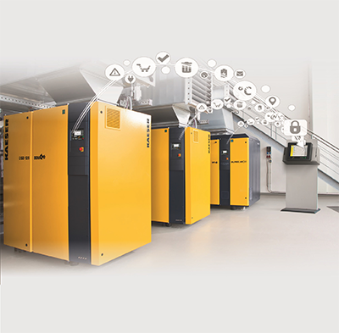
In the station itself, the individual components communicate with the master controller for optimal coordination of compressed air production.

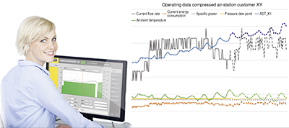
The data is monitored in real time at a Service Centre.

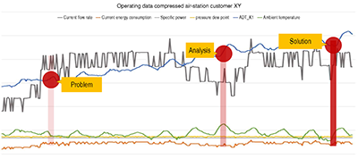
Irregularities are immediately detected, accurate predictions are generated using modern analytical tools and appropriate measures are initiated.
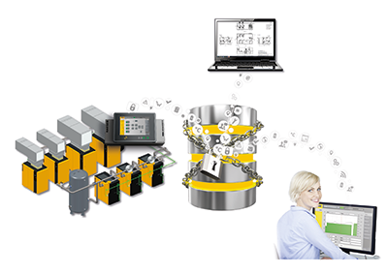
Sophisticated master controllers act as both a management system for the compressed air components and as a central node for secure data transmission.

