Make a date with Kaeser
Kaeser will be exhibiting at the 78th WIOA Victorian Water Industry Operations Exhibition at the Bendigo Event and Exhibition Complex from 2nd to the 3rd of September 2015. Water operators wishing to learn how they could achieve significant energy savings with their blower system are invited to visit Kaeser on Stand No. 23.
Kaeser manufactures a comprehensive range of blowers to meet the varied requirements of the water and waste water industries. This includes a highly energy efficient range of screw blowers which are up to 35 per cent more efficient than conventional rotary blowers, outclassing other comparable screw and turbo blowers on the market. Such significant energy savings are realised thanks to the inclusion of the same proven and trusted technology inherent in the standard Kaeser compressor range.
The rotors found in the EBS and FBS series screw blowers from Kaeser are uncoated. This ensures that the user can enjoy outstanding efficiency, year after year. The data provided for the effective total energy consumption and usable flow capacity correspond precisely to the machines' actual performance (as per the conservative tolerance outlined by Standard ISO 1217; measurements validated by TÜV-Süd). This ensures that the estimated savings calculated as a result of investing in this piece of equipment are actually realised.
The EBS and FBS series screw blowers possess numerous other outstanding qualities that Kaeser products are renowned for. This includes an internal cooling system that makes the energy-intensive use of oil pumps and oil coolers redundant. Furthermore, they feature a highly effective sealing concept that ensures long-term seal integrity without the need for vacuum pumps. The durability and reliability of these machines is also enhanced by eliminating the need for auxiliary equipment and circulating oil lubrication. Cooling and process air are drawn in separately from outside the machine enclosure, which not only provides greater usable air mass flow for the same power consumption, but also ensures optimum cooling and efficiency.
For advice on your blower system and to discover your energy efficient Kaeser screw blower solution, visit Kaeser on Stand Number 23 at the WIOA Victorian Water Industry Operations Conference and Exhibition in Bendigo, 2 and 3 September 2015.

File: o-WIOA-VIC-2015-aus
Approved for publication, copy acknowledgement appreciated
Image:

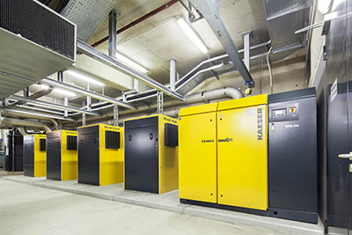
Discover your energy saving blower solution at Stand Number 23; WIOA Victorian Water Industry Operations Conference and Exhibition in Bendigo on 2 and 3 September 2015.

