June 2018

A crushing success for Kaeser and Teusner Wines

Award winning winemaker Teusner Wines recently invested in two Kaeser SK 25 rotary screw compressors, which are responsible for delivering a reliable and energy efficient supply of compressed air to the pneumatic - grape crushing - presses at their new purpose built winery in the Barossa Valley, South Australia.

Based in one of Australia’s most well-known wine producing regions, Teusner Wines has been making a variety of wines in the Barossa Valley for over 15 years. The heritage of their wines however far exceeds this, sourcing fruit from vineyards in the region that are up to 130 years old!

Everything is crushed one small picking bin at a time so that Teusner can keep a close eye on colour, flavor, aroma and structure, ensuring that the eminent flavours found in old Barossa vineyards take centre stage in the wines. Compressed air plays an important role in this process, powering up the pneumatics presses which are responsible in modern winemaking for pressing the grapes. The pneumatic press is filled with grapes and once the door has been closed, compressed air is used to inflate a sealed bag within the press which effectively pushes the grapes against a large sieve that softly squeezes the remaining juice out.

To keep up with growing demand, Teusner recently developed a much larger purpose built winery. This included sourcing two higher capacity pneumatic presses, which of course created a requirement for a larger capacity compressed air system.
With a typical harvest lasting only three months, the window to process the grapes is fairly short. It was therefore important to Teusner that they invested in a compressed air system that would be reliable and efficient, allowing them to maximise the harvest period.

Having received a recommendation on the Kaeser compressor for this application, owner Kym Teusner, contacted the local authorised Kaeser partner - Mobile Compressed Air (MCA) for a solution.

After reviewing Teusner’s requirements, MCA recommending and subsequently installed two Kaeser SK 25 rotary screw compressors along with a 5,000 litre capacity air receiver.

Filling the presses with the grapes is a labour intensive process, so when a two-press system is in operation - as is the case at Teusner - they tend to run in separate sequences. This results in flatter air demand cycles. MCA was therefore able to recommend the installation of two 15 kW rotary screw compressors to meet the compressed air requirements rather than one larger unit, as the time in between presses gives the two compressors time to refresh the air receiver, bringing it back up to pressure between the crushing cycles. For Teusner this meant cost savings, not only in terms of the initial capital investment cost, but also the longer term associated lifecycle costs of running the compressed air system.

The SK series from Kaeser Compressors, would also provide the reliability and efficiency that Teusner required, not only delivering more compressed air for less power consumption, but also combining ease of use and maintenance with exceptional versatility in an environmentally responsible design.

At the heart of every SK series rotary screw compressor lies a premium quality screw compressor block featuring the Kaeser Sigma profile rotors. Superior efficiency is assured with these flow-optimised rotors that are able to achieve power savings of up to 15 percent compared with conventional screw compressor block rotor profiles.
Needless to say, all Kaeser SK series rotary screw compressors feature energy-saving, premium efficiency IE3 drive motors, that comply with, and exceed prevailing Australian GEMS regulations for 3 phase electric motors.

In addition the SK series features Kaeser’s innovative cooling system which uses a high efficiency dual flow fan and separate air flow channels for cooling of the motor, the fluid/compressed air cooler and the control cabinet. This not only achieves optimum cooling performance, low compressed air discharge temperatures and minimal sound levels, but also promotes efficient air compression.
Finally, the internal Sigma Control 2 controller ensures efficient control and system monitoring, helping to push the boundaries of efficiency even further.

The compressed air system at Teusner Wines has now been up and running for over a year, as Kym said; ‘We have now had the Kaeser compressed air system in play for one harvest and it worked perfectly. We have been really happy with the quality of the machines and the level of support we received from Mobile Compressed Air.’

The SK series of rotary screw compressors from Kaeser are available with drive powers of 11 and 15 kW, and produce flow rates from 0.53 to 2.70 m³/min, designed for pressures 5 to 15 bar. For more information on phone 1800 640 611 or visit www.kaeser.com.au
-END-
Editors Notes
From 2.2 to 500 kW, Kaeser Compressors manufactures a wide range of compressors and associated auxiliary equipment that meet the varying requirements of a diverse range of industries and applications.

One of the world’s largest manufacturers of rotary screw compressors, Kaeser Compressors is represented globally in over 100 countries through a dedicated network of branches, subsidiary companies and authorised partners.

Kaeser Compressors Australia provides comprehensive sales and service from its 30,000 ft² purpose built factory in Dandenong, Victoria alongside an extensive network of sales and service centres and authorised partners that cover Australia, New Zealand and New Caledonia.

For editorial and advertising enquiries contact:
Press office: +61 3 9791 5999 Fax: +61 3 9791 5733
E-mail: info.australia@kaeser.com

KAESER COMPRESSORS Australia Pty Ltd – 45 Zenith Road, Dandenong South, VIC 3175, Australia
Phone: +61 3 9791 5999 – www.kaeser.com.au – E-mail: info.australia@kaeser.com

File: Q-Teusner-Wines-aus
Approved for publication, copy acknowledgement appreciated
Images: (contact the press office for high res copies of the following images)

Compressors
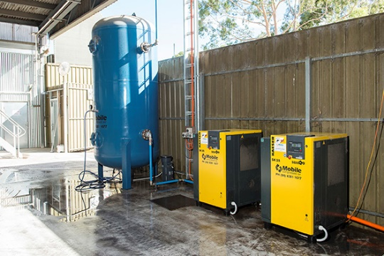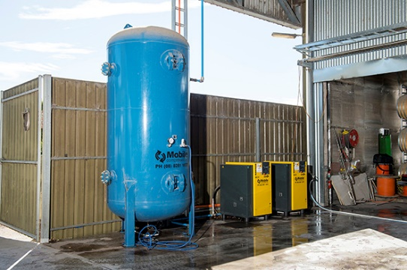

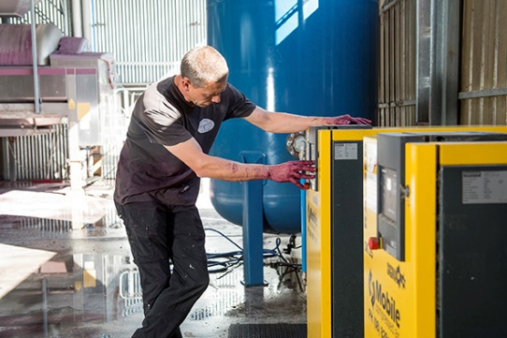
005_Image 1_KAESER compressors at Teusner Wines.jpg
005_Image 2_KAESER compressors at Teusner Wines 2.jpg
005_Image 3_KAESER compressors at Teusner Wines 3.jpg

Caption: Two Kaeser SK 25 rotary screw compressors along with a 5,000 litre capacity air receiver installed at Teusner Wine’s new purpose built winery.

Fermentation

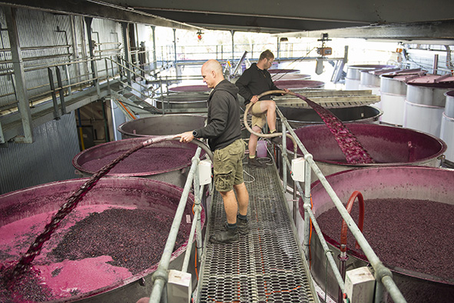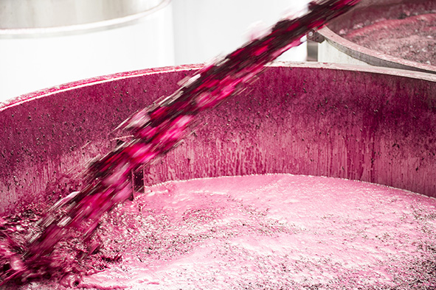

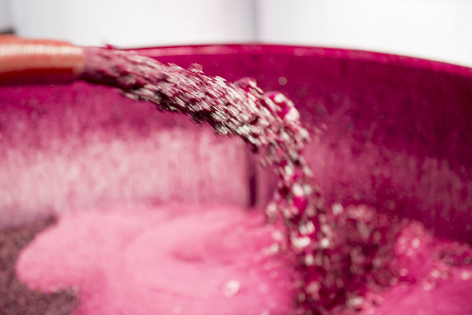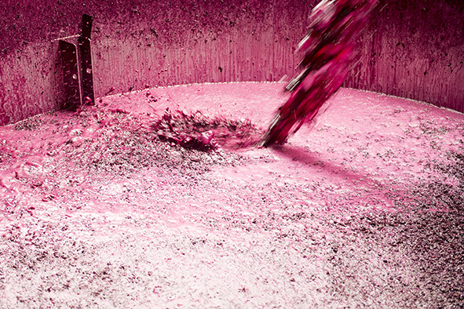
005_Image 4_Juice entering fermentation tanks at Teusner Wines.jpg
005_Image 5_Juice entering fermentation tanks at Teusner Wines 2.jpg
005_Image 6_Juice entering fermentation tanks at Teusner Wine 3.jpg
005_Image 7_Juice entering fermentation tanks at Teusner Wines 4.jpg

Caption: Crushed grapes enter open top stainless steel fermenters for fermentation

Pressing
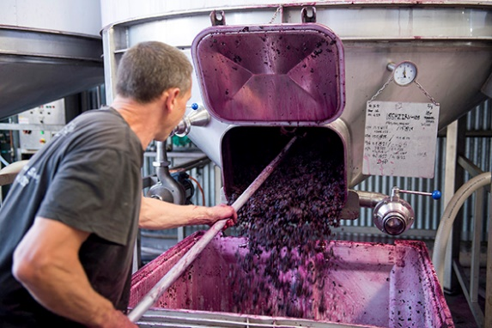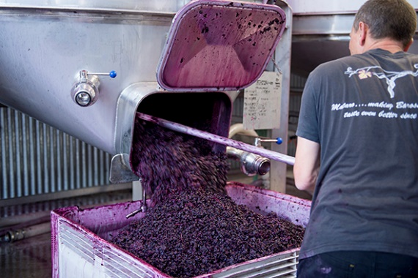
005_Image 8_skins being transferred from fermenters to pneumatic press at Teusner Wines.jpg
005_Image 9_ skins being transferred from fermenters to pneumatic press at Teusner Wines 2.jpg

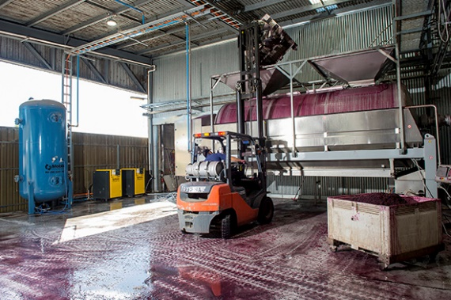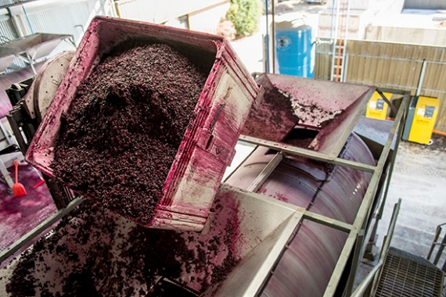
005_Image 10_Pneumatic press being filled at Teusner Wines.jpg
005_Image 11_Pneumatic press being filled at Teusner Wines 2.jpg

Caption: 5 to 7 days later the fermented juice and remaining skins are transferred into the pneumatic press.

The press working
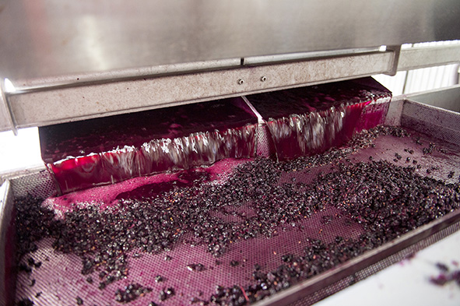
005_Image 12_Juice coming out of the pneumatic press at Teusner Wines.jpg

Caption: Compressed air inflates a sealed bag inside the pneumatic press which effectively pushes the grapes against a large sieve that softly squeezes the remaining juice out.

Wine ageing

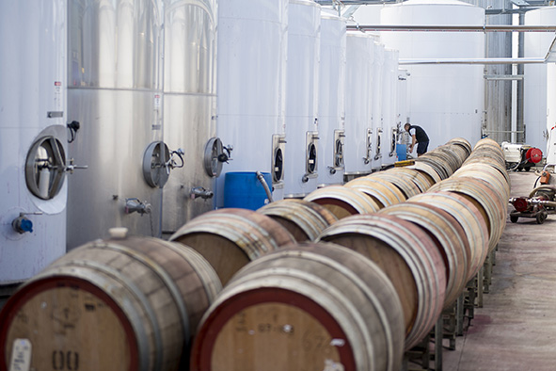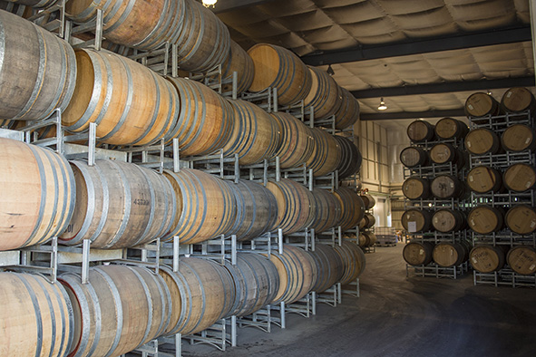
005_Image 13_Wine being settled in stainless steel tanks at Teusner Wines.jpg
005_Image 14_Wine in barrels stored in the aging room at Teusner Wines.jpg

Caption: The wine is then settled in stainless steel tanks before being transferred to barrels and stored in the aging room.

((Kaeser photo – free for publication))

