August 2019

The total package: saving energy costs with complete blower packages

Aeration is a central part of the treatment process at a wastewater plant. It is also a major contributor to energy costs. As a result operators are always looking for ways to revamp, replace or modify the blowers and their packaging in order to improve the aeration stage. Understanding what makes an efficient and cost-saving blower system is therefore paramount. Here Kaeser Compressors explains the cost and energy efficiency gains that can be made with complete blower packages.

Blower packages assembled by sourcing components from a variety of suppliers is still quite common and usually a result of adding to the blower as new requirements arise. As an example, a blower is determined to be too loud, so a new silencer is sourced. Perhaps even a sound enclosure is purchased. However, this now means that being inside a box, the blower runs warm, so now the operating temperature must be monitored. Then perhaps it is determined that the blower needs to make more or less air, so a frequency controlled drive is installed. The needs grow and so does the package and its components. There are many versions of these packages in the field and while they may get the job done, there is no clear way to see how efficient they are.
With energy for aeration one of the highest operating costs to a WWTP (wastewater treatment plant) it is therefore essential to understand equipment efficiency in order to better control and manage these expenses.

The total package
Opting for a fully packaged blower solution is one way operator’s can meet all of their requirements in the most cost effective and energy efficient manner. Fully packaged blowers have been available for some years now however different manufacturers have different levels of packaging. Most includes the basics; full cabinet enclosure, motor, drive, inlet/outlet silencers, and basic instrumentation. Some manufacturers go a step further and have onboard sensors and controls. Packaged blowers from Kaeser for example include a full sensor kit that monitors several points on the machine for pressure and temperature. This information is fed back into the onboard controller which not only monitors these points, but also makes calculations for differential pressure and temperature. The machine is then able to provide alarms or warnings, notifying the user of impending problems. It can even turn the machine off to prevent catastrophic failures.
These machines are also fitted with motor starters or a frequency controlled drive. Here again, all of the devices feed into the controller, providing a central point for monitoring and operator interface. A communication module can even be purchased which extracts all of this data to a plant program logic controller (PLC).

Saving energy costs with complete blower packages
Significant energy cost savings in terms of specific performance (kW/m³/min) can be achieved with complete packaged blowers. Specific performance is the ratio for how much power it takes to generate the desired air flow. When a decision is made on which blower to purchase an evaluation is done to compare all of the quoted blowers. Quite often the values are stripped down to the bare blower block performance before equal values are assigned to each blower for package losses in the form of motor efficiencies, silencer losses and so on. This is done in order to ascertain how much each machine will cost to operate over a period of time.

The problem however is that while the blower performance is guaranteed, the package performance is not. Again this is because the end product is assembled from a variety of suppliers, where each of the suppliers it not able to guarantee an end result. However, when the end-user opts for a complete packaged blower system manufactured by one supplier, provided performance values can be guaranteed.

Optimised maintenance
Whether it is a blower made up of various supplier components or a complete packaged system, the maintenance requirements are the same, i.e. oil, belts, grease and air filters. The key benefit of complete packaged systems such as those from Kaeser, are the onboard controllers which keep track of the running hours and maintenance intervals. When it is time to change the oil, inspect the belts or filter, or grease the motor, the controller lets you know. And, in order to clear an alarm the user or maintenance person must log into the controller. All of this activity is kept as a log inside the controller, therefore should a problem occur, all data and activities can be accessed for future reference and troubleshooting.

Rotary lobe versus rotary screw blower packages
A rotary lobe blower package such as the ones manufactured by Kaeser, have all of the components required of a blower system; silencers, motor, air filter, belts, relief valves, sound enclosure, check valve, sensor kit, controller and starter (contactors or frequency controlled drive). As all plants require all of these elements, every plant can benefit from this design. For most WWTP’s these blowers will be running all day every day. Performance, reliability and longevity are critical to the plant’s operation and compliance. A factory-engineered and developed machine has been optimised through years of experience to provide the best performance and highest reliability. Furthermore, integrating the blower package into a plant’s master control system allows for better product maintenance monitoring which can reduce downtime and repair costs.

The rotary screw blower package has the same scope of supply as the lobe blower package. All of the package design concepts and goals remain more or less the same – low noise, easy access to maintenance, and a small footprint – but a screw blower gives a decided boost in efficiency over any lobe-type blower design. Screw blowers offer the advantage of internal compression which can result in up to a 35 percent gain over lobe technology under certain conditions.

Screw blower designs are beneficial for all aeration processes, however they are best suited for a process with a constant fluid depth and with extended running hours. Constant fluid depths allow the user to accurately predict the efficiency gains and to realise the expected payback on the investment. Variable fluid depth applications will see fluctuations in efficiency gains and intermittent duty systems will experience extended payback on the investment, both of which will extend payback periods. In these cases, it may be best to stick with the PD lobe machine.

If the effort required to install, wire, program and commission a blower is considered, the costs would easily surpass the cost of a complete packaged system. Additionally, the end product would not provide the same level of functionality or protection as the complete packaged system offers. A completed packaged system also gives the peace of mind that the end-user is getting the performance calculated during their evaluation process. For more information visit au.kaeser.com or phone 1800 640 611.
-END-
Editors Notes
From 2.2 to 500 kW, Kaeser Compressors manufactures a wide range of compressors and associated auxiliary equipment that meet the varying requirements of a diverse range of industries and applications.

One of the world’s largest manufacturers of rotary screw compressors, Kaeser Compressors is represented globally in over 100 countries through a dedicated network of branches, subsidiary companies and authorised partners.

Kaeser Compressors Australia provides comprehensive sales and service from its 30,000 ft² purpose built factory in Dandenong, Victoria alongside an extensive network of sales and service centres and authorised partners that cover Australia, New Zealand and New Caledonia.

For editorial and advertising enquiries contact:
Press office: +61 3 9791 5999 Fax: +61 3 9791 5733
E-mail: info.australia@kaeser.com

KAESER COMPRESSORS Australia Pty Ltd – 45 Zenith Road, Dandenong South, VIC 3175, Australia
Phone: +61 3 9791 5999 – https://au.kaeser.com/ – E-mail: info.australia@kaeser.com

File: H-blower-packages-aus
Approved for publication, copy acknowledgement appreciated
((Captions)) :

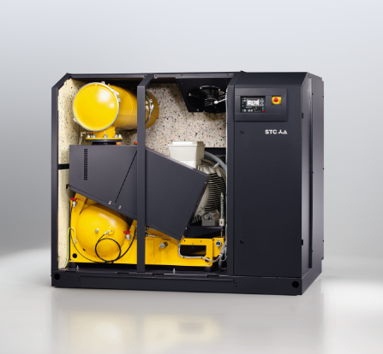
Caption: Packaged rotary screw blowers include everything in one enclosure for optimum performance and energy efficiency
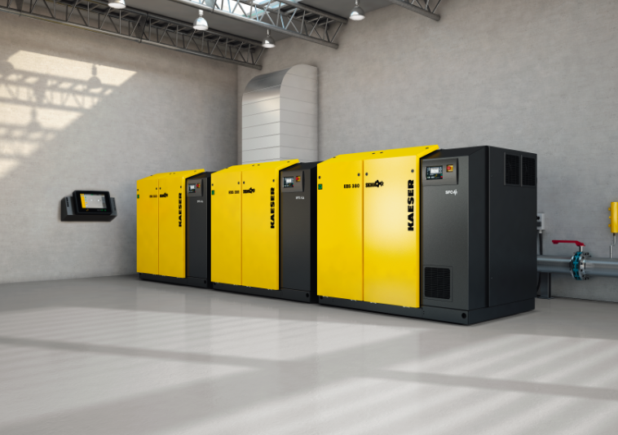
Caption: Multiple Kaeser rotary screw blower system
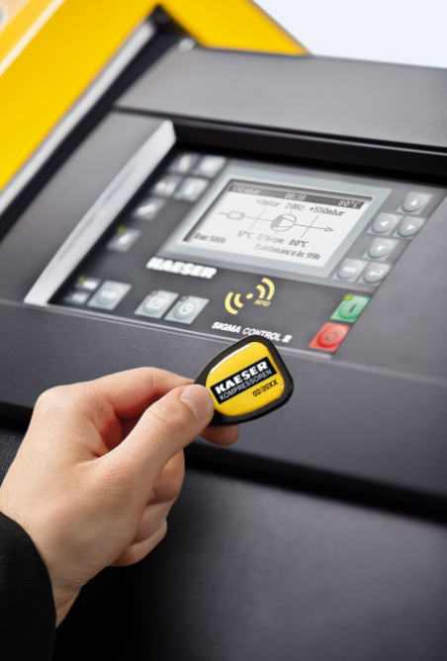
Caption: The key benefit of complete packaged systems from Kaeser are the onboard controllers
((Kaeser photo – free for publication))

