The Mobilair 13, 15 & 17 portable compressors from KAESER
Portable Powerhouses
Even the smallest models in the Mobilair portable compressor range from KAESER combine outstanding power, efficiency and quiet operation with exceptional manoeuvrability. Furthermore, the 15 bar maximum working pressure version, the M 17, is the ideal choice for trenchless laying of glass fibre cables.
With a free air delivery of 1.4 m³/min at 7 bar, the Mobilair 15 is more than capable of powering breakers, drills, saws, grinders, impact wrenches and even impact borers. As already mentioned, the 15 bar version of the M 17 is perfect for trenchless laying of glass fibres and delivers an impressive 1m³ of compressed air per minute; the 7 bar model delivers 1.6 m³ per minute. The M 13 is also available as a 7, 10, 12 or 13 bar version.
An air-cooled, 4-stroke Honda petrol engine drives the screw compressor unit via a maintenance-free V-belt drive system. All models are also equipped with a generous 20-litre capacity fuel tank that enables uninterrupted operation during long work shifts and eliminates the need for frequent refuelling. A continuous air delivery control system precisely matches compressor performance to suit actual compressed air demand, which further reduces fuel consumption of these already highly efficient compressor units. Furthermore, all models feature an innovative corrosion- and scratch-resistant sound enclosure made from rotation-sintered polyethylene that guarantees exceptionally low sound levels.
As these compressors are so compact and lightweight, they can be easily transported in any delivery vehicle, or on the loading floor of a truck, leaving the vehicle’s tow coupling free for use.
In addition, the compressor can be equipped with an external compressed air after-cooler for certain applications that may require cool and condensate-free compressed air. The after-cooler is installed in a frame equipped with fixed connections for compressed air, condensate return and electrical power (12 V supply from compressor) to drive the after-cooler fan. Accumulating condensate is vaporised with help from the hot engine exhaust.
The M 13 to M 17 are also especially user-friendly when it comes to maintenance and handling: Manoeuvrability on the construction site is made simple thanks to the long handle, rugged wheels with pneumatic tyres, 4 convenient lifting-lugs and a counter-sunk crane eye. Last but not least, maintenance tasks are easy to carry out, as the wide-opening sound enclosure enables excellent component accessibility.

File: c-Mobilair 13_17_aus
Approved for publication, copy acknowledgement appreciated
Image:

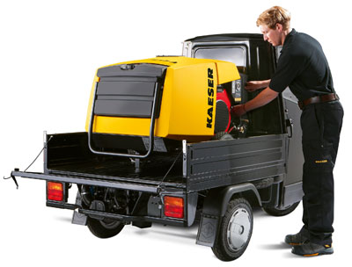
Powered by a quality petrol engine from Honda, the M 13 portable compressor from KAESER combines quiet performance with exceptional efficiency and manoeuvrability.

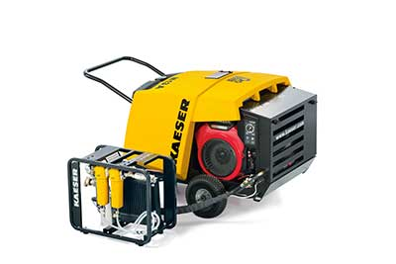
Handy support frame with compressed air aftercooler and microfilter combination for technically oil-free compressed air.

