Topping out ceremony: The roof is up
Just over a year after ground was broken on the project, one of Kaeser Compressors two new production halls at the Head Office in Germany, is that much closer to completion: the topping out ceremony was held just last week.
On completion this hall will house production for medium-sized rotary screw compressors designed for producing compressed air for use in industrial production processes, especially by small and medium-sized companies. Production of the larger compressors will take place in the second production hall, which is being constructed in parallel with this one. Kaeser Compressors began construction of two new production halls last year as the previous production site for this size of rotary screw compressor was no longer large enough.
Aside from the need for more space, the significant technical progress that has occurred in the field of production technology constitutes another important reason behind the investment in the new production equipment. “When it’s finished, this “Smart Factory” will be fully Industry 4.0 capable and will truly be a state-of-the-art facility,” says Thomas Kaeser, Chief Executive for the Coburg-based compressed air systems provider. Industry 4.0 refers to the ever-increasing level of communication and networking between humans and computer systems, which is furthering the development of exciting new products and services. “This investment is yet another element that will ensure Kaeser Kompressoren remains internationally competitive and successful well into the future.”
The next step is to begin fitting-out the interior of the production hall. If everything goes according to plan, part of the production facility will be ready for use in early 2017.
The company's building campaign isn’t restricted to just production infrastructure: the cornerstone of a new office building was also just laid in September.

File: p-topping-out-ceremony-aus
Approved for publication, copy acknowledgement appreciated
Images:
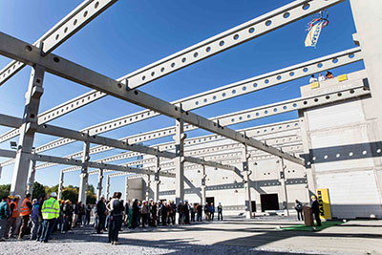
A toast is given in honour of Production Hall 11
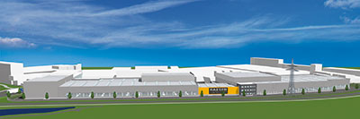
The two new production halls under construction will span the entire length of the company grounds. In the image, Hall 11 is shown on the left, next to the building with the yellow company logo.
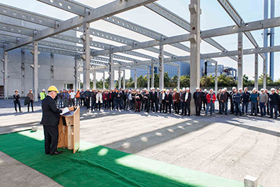
A toast is given in honour of Production Hall 11.

