March 2022
Rapid Hydraulics announced as Kaeser distributor

Kaeser Compressors Australia has announced the appointment of Rapid Hydraulics & Pneumatics as a distributor of the full range of Kaeser compressed air equipment for Albury Wodonga and the surrounding area.

Established over 15 years ago, Rapid Hydraulics & Pneumatics (Rapid) is the largest hydraulic sales and service company between Melbourne and Sydney. A family owned and operated business based in Wodonga, Victoria, Rapid delivers a wide range of quality hydraulic and pneumatic products and services to its customers in Albury Wodonga and the surrounding area spanning over 150 kms. The company has a large team of service and sales professionals, which combined together bring over 100 years of hydraulic and pneumatic experience and knowledge to its customers.

Highly recognised in the region, Rapid is known not only as a trusted, quality provider of hydraulic and pneumatic equipment and services - but also as a one-stop shop for many other associated products.

Rapid houses the latest technology and diagnostic capabilities in its modern facilities, and as such offers its customers a wide range of services including; hydraulic and system fault finding, component rebuilds and bench testing of cylinders, pumps, motors and valves - as well as a comprehensive fluid service to name only a few.

From the timber and paper industry, to food manufacturing, drilling rigs, agriculture and hydro power - Rapid design, build and install hydraulic and pneumatic systems to meet the needs of a diverse range of applications.

On the new distributorship agreement with Kaeser Compressors, Peter Ryder, Managing Director at Rapid said: ‘We take great pride in the partnerships we already have with a number of quality multinational brands. Bringing the Kaeser Compressors brand to our portfolio was an obvious choice in complementing our existing high quality product range and our offering to many of our existing clients in regards to our sales and service capability.’

From 0.18 to 515 kW, Kaeser Compressors manufactures a wide range of compressors and associated auxiliary equipment that meet the varying requirements of a diverse range of industries and applications. The Kaeser product range meets and exceeds Australian conditions and regulations and the standard machines are suitable for continuous operation at ambient conditions up to 45ºC and higher.

Kaeser Compressors Australia provides comprehensive sales and service from its purpose built factory in Dandenong, Victoria alongside an extensive network of sales and service centres and authorised partners that cover Australia and New Caledonia. For further information visit au.kaeser.com or phone 1800 640 611.
-END- Free for publication, copy appreciated
Editors Notes
From 0.18 to 515 kW, Kaeser Compressors manufactures a wide range of compressors and associated auxiliary equipment that meet the varying requirements of a diverse range of industries and applications.
One of the world’s largest manufacturers of compressors, blowers and compressed air systems, Kaeser Compressors is represented throughout the world by a comprehensive network of branches, subsidiaries and authorised distribution partners in over 140 countries.

Kaeser Compressors Australia provides comprehensive sales and service from its purpose built factory in Dandenong, Victoria alongside an extensive network of sales and service centres and authorised partners that cover Australia and New Caledonia.

For editorial and advertising enquiries contact: Beth Wood, Marketing Manager
Press office: +61 3 9791 5999 E-mail: beth.wood@kaeser.com

KAESER COMPRESSORS Australia Pty Ltd
45 Zenith Road, Dandenong, VIC 3175, Australia
Phone: +61 3 9791 5999 Email: info.australia@kaeser.com
au.kaeser.com
File: P-Rapid-appointment-aus
Approved for publication, copy acknowledgement appreciated
Image:
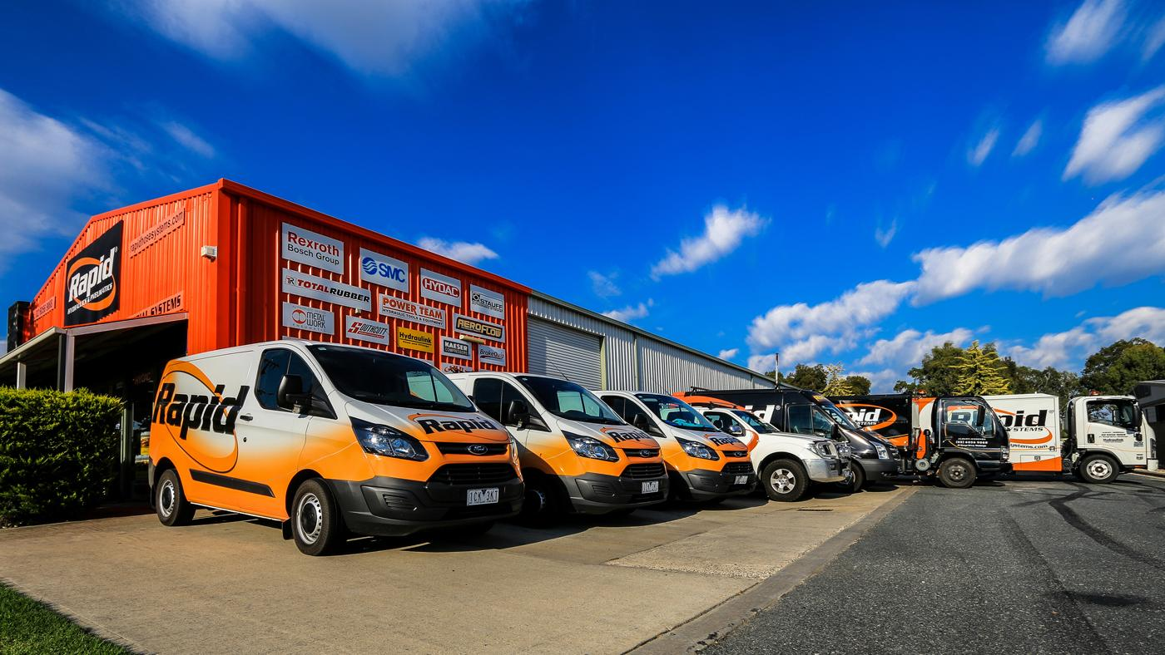
Caption: Rapid delivers a wide range of quality hydraulic and pneumatic products and services to its customers in Albury Wodonga and the surrounding area spanning over 150 kms.

((Kaeser photo – free for publication))

