June 2019

Sigma Air Manager 4.0: Tomorrow's technology today

Industrie 4.0, or the Internet of Things: the Sigma Air Manager 4.0 (SAM 4.0) makes it all possible, the ability to make predictions far in advance, know today what the future holds, network components and exploit much larger data volumes than ever before, whilst also ensuring significant energy cost savings and delivering a reliable, consistent and efficient compressed air supply.

Presenting the latest generation of SAM 4.0 – the master control system for all of a user’s compressed air production and treatment components. It optimises pressure values, automatically adjusts compressor system air delivery to accommodate fluctuating pressure demand and optimises system efficiency based on control losses, switching losses and pressure flexibility. Moreover, with the SAM 4.0 the end user can take advantage of services such as Sigma Smart Air, for predictive maintenance. All of these features not only boost operational reliability and efficiency, but also significantly reduce energy costs.

Best possible pressure quality, tailored to specific needs
This is in no small part made possible by Kaeser’s adaptive 3-D^{advanced} Control, which takes into account additional factors, aside from switching losses (start/stop), that affect compressed air system energy efficiency. These include control and idling losses, frequency converter operation and pressure flexibility (average increase above required pressure). The patented optimisation method predictively calculates the optimum achievable configuration and adjusts the connected components accordingly – all based on the specific pressure required by the user.

When machines talk
The SAM 4.0 supports operation in 30 languages, while the easy-to-use 12-inch colour touchscreen shows at a glance whether the station is operating in the 'green zone' from an energy management perspective. Operating status, pressure history, free air delivery, power consumption, as well as maintenance and any error messages can be easily displayed and analysed – both in real-time and retroactively. Using a PC and network connection, this data can be accessed conveniently from anywhere, not just at the machine itself. This not only gives users peace of mind and lays the foundation for digital products in the pipeline, it also enables energy management in accordance with ISO 50001.

Sigma Network
The far-reaching benefits of the SAM 4.0 are expanded even further when users take advantage of Kaeser’s Sigma Network. Based on Ethernet technology, the powerful Sigma Network is a closed and secure network that has been specially developed to support optimal monitoring and coordinated control of compressed air stations.

SAM 4.0: Future-ready
Moreover, the SAM 4.0 is versatile in other ways. An interface for plugin communication modules lends itself to flexible adaptation to accommodate future requirements. The SAM 4.0 is up to date with the latest trends and ensures the reliable, cross-system exchange of data and information.

SAM 4.0: Upgradable
The SAM 4.0 is designed to accommodate potential future compressed air system expansion. A straightforward software upgrade allows for expansion with no need for additional investment in new hardware. For more information from Kaeser visit www.kaeser.com.au or phone 1800 640 611.
-END-
Editors Notes
From 2.2 to 500 kW, Kaeser Compressors manufactures a wide range of compressors and associated auxiliary equipment that meet the varying requirements of a diverse range of industries and applications.

One of the world’s largest manufacturers of rotary screw compressors, Kaeser Compressors is represented globally in over 100 countries through a dedicated network of branches, subsidiary companies and authorised partners.

Kaeser Compressors Australia provides comprehensive sales and service from its 30,000 ft² purpose built factory in Dandenong, Victoria alongside an extensive network of sales and service centres and authorised partners that cover Australia, New Zealand and New Caledonia.

For editorial and advertising enquiries contact:
Press office: +61 3 9791 5999 Fax: +61 3 9791 5733
E-mail: info.australia@kaeser.com

KAESER COMPRESSORS Australia Pty Ltd – 45 Zenith Road, Dandenong South, VIC 3175, Australia
Phone: +61 3 9791 5999 – www.kaeser.com.au – E-mail: info.australia@kaeser.com

File: M-SAM-4-2019-aus
Approved for publication, copy acknowledgement appreciated
Image:
((Captions)) :

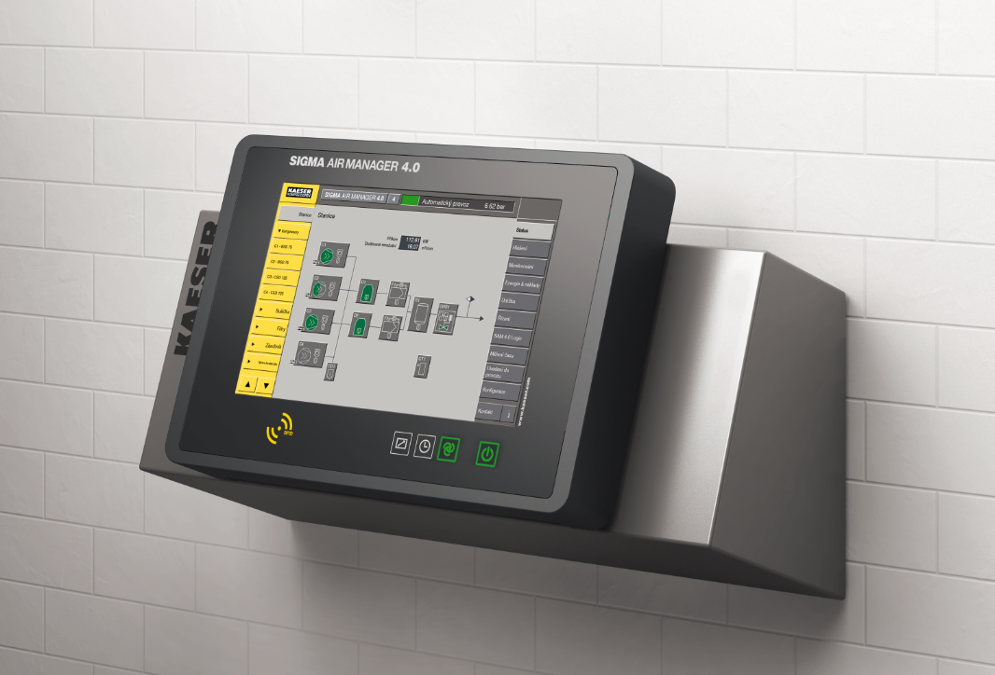
Caption: “The Sigma Air Manager 4.0 (SAM 4.0) not only ensures highly efficient monitoring and control of all compressed air station components, it also enables them to take advantage of the future-oriented benefits that Industrie 4.0 has to offer.”

((Kaeser photo – free for publication))

