April 2021

Meeting green goals:
A reliable and energy saving solution for laminate benchtops manufacturer

Master Benchtops – a specialist in the manufacture of laminated benchtops - has opted for a Kaeser compressed air system featuring an ASD 60 SFC rotary screw compressor with Sigma Frequency Control, to deliver a reliable and energy efficient supply of compressed air to its manufacturing facility.

Master Benchtops specialises in the manufacture of laminated benchtops. Located in Smithfield it is one of the largest postformers in NSW, delivering its customers with the latest innovations in edge profiles. For over 30 years, the company has been supplying the Australian woodworking, joinery and kitchen industry with a range of laminates consisting of over 2,000 colours and patterns.

Priding itself on providing high quality products and the best service available to its customers in a fast and efficient manner, Master Benchtops relies on not only a highly qualified and efficient team - but also high quality, efficient and reliable equipment.

An essential utility
Compressed air is an essential utility used throughout the manufacturing process at Master Benchtops. From powering the high tech CNC’s through to the beam saw, panel saws and bending machines - the list of applications that rely on a dependable and quality supply of compressed air at the facility is extensive.

Unfortunately the existing compressed air system at Master Benchtops was becoming less reliable with frequent breakdowns occurring. This prompted Managing Director Joe Chamoun to start investigating their compressed air supply further. As Chamoun explains:

‘We were not happy with the existing compressor. It was not performing to our requirements and we were experiencing more frequent breakdowns. When we started to look into this further we also found that the compressor was actually oversized for our requirements, and therefore it was also using more energy and therefore costing us more in electricity than it needed to.
As a company we are very focused on becoming green in every way. To us this means making every part of our operation as energy efficient as possible, and therefore using less energy to manufacture our products. Frequent breakdowns, increased maintenance requirements and the growing unreliability of the existing compressed air system - coupled with the fact that it was oversized and therefore not energy efficient - all led us to the conclusion that it was time to change to a better compressed air system.
After researching a number of options, we contacted Kaeser Compressors for a solution.’

Opting for a greener solution
Kaeser Compressors then evaluated Master Benchtops compressed air requirements and recommended installing an ASD 60 SFC rotary screw compressor with Sigma Frequency Control (variable speed drive) complete with an air treatment package.

The latest generation of ASD SFC series of Sigma frequency controlled rotary screw compressors from Kaeser deliver superior efficiency and save energy in multiple ways:

They incorporate a completely new and innovative drive technology. Representing a significant technological milestone for Kaeser, the new synchronous reluctance motors - which were developed in close partnership with Siemens - boast significantly greater efficiency, thanks to considerably lower losses in the crucial partial-load range compared to asynchronous motors. The low moment of inertia of synchronous reluctance motors allows high cycle rates, thereby boosting machine and system productivity.

Some of the technical advantages of the new motor design include near zero heat losses from the rotors, which keeps bearing temperatures noticeably lower. This in turn has a positive effect on service life, ease of maintenance, as well as drive availability. Moreover, Kaeser’s use of variable-speed fans in compressed air production systems delivers additional energy savings.

Controlled and monitored via the advanced industrial-PC-based Sigma Control 2 compressor controller, compressed air delivery is matched with actual demand. Moreover it uses dynamic control to keep costly idling time to an absolute minimum.

Delivering consistent results
The ASD 60 SFC series rotary screw compressor complete with an air treatment package, has been up and running at Master Benchtops now for some 6 months.
Chamoun concluded:

‘We’re happy with the decision we made to invest in a Kaeser compressed air system. There’s no doubt that opting for a Kaeser was not the cheapest option on the market. However as they say you do get what you pay for, and for us that is proving to translate into consistency in terms of the supply of air, the quality of the air and the reliability of the air. The compressed air system is also helping us meet our green goals and we’re already seeing the result of its energy efficiency in power savings. In the end it pays off to opt for quality machinery.’

The ASD SFC series of rotary screw compressors with Sigma Frequency Control (variable speed drive) deliver flow rates from 0.93 to 6.17 m³/min, max. working pressure 8.5 to 15 bar and drive motor rated power 22 to 30 kW. For more information visit au.kaeser.com or phone 1800 640 611.
-END- Free for publication, copy appreciated
Editors Notes
From 0.18 to 515 kW, Kaeser Compressors manufactures a wide range of compressors and associated auxiliary equipment that meet the varying requirements of a diverse range of industries and applications.

One of the world’s largest manufacturers of rotary screw compressors, Kaeser Compressors is represented globally in over 100 countries through a dedicated network of branches, subsidiary companies and authorised partners.

Kaeser Compressors Australia provides comprehensive sales and service from its 30,000 ft² purpose built factory in Dandenong, Victoria alongside an extensive network of sales and service centres and authorised partners that cover Australia and New Caledonia.

For editorial and advertising enquiries contact: Beth Wood, Marketing Manager
Press office: +61 3 9791 5999 Fax: +61 3 9791 5733
E-mail: beth.wood@kaeser.com

KAESER COMPRESSORS Australia Pty Ltd
45 Zenith Road, Dandenong, VIC 3175, Australia
Phone: +61 3 9791 5999 Email: info.australia@kaeser.com
au.kaeser.com
File: Q-Master-Benchtops-aus
Approved for publication, copy acknowledgement appreciated. Contact our press office to request high res versions of the images found below.

Images:
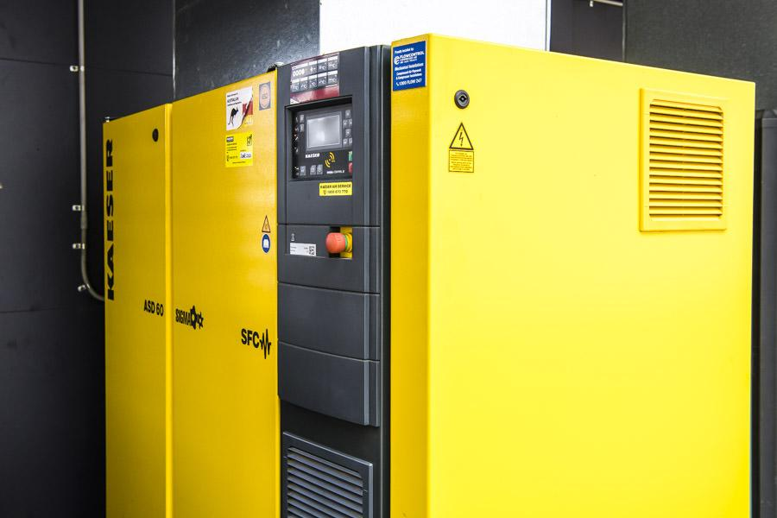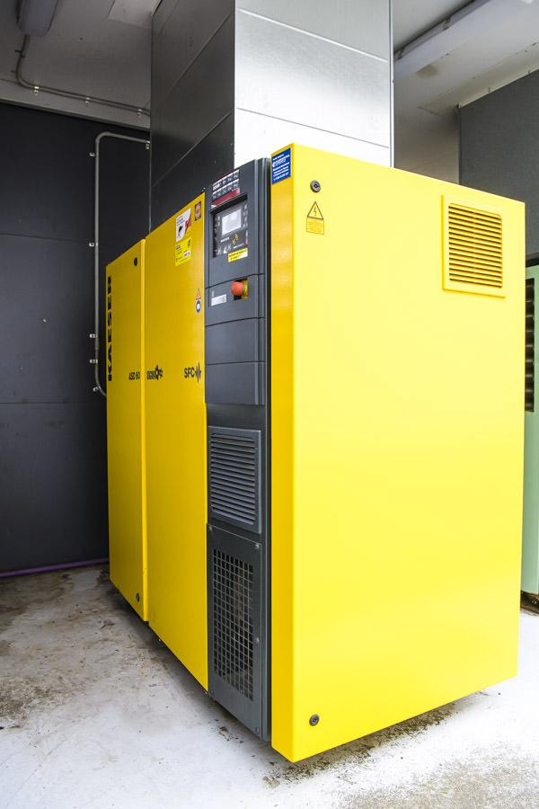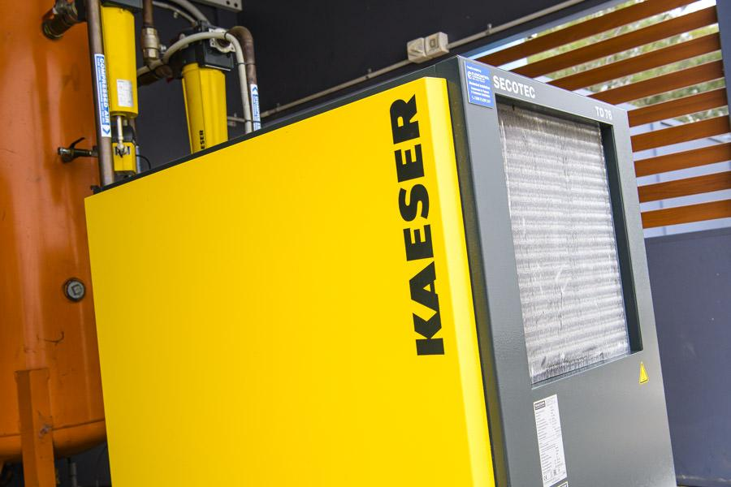
Caption for above selection of photos: The Kaeser ASD 60 SFC rotary screw compressor with Sigma Frequency Control complete with an air treatment package at Master Benchtops.

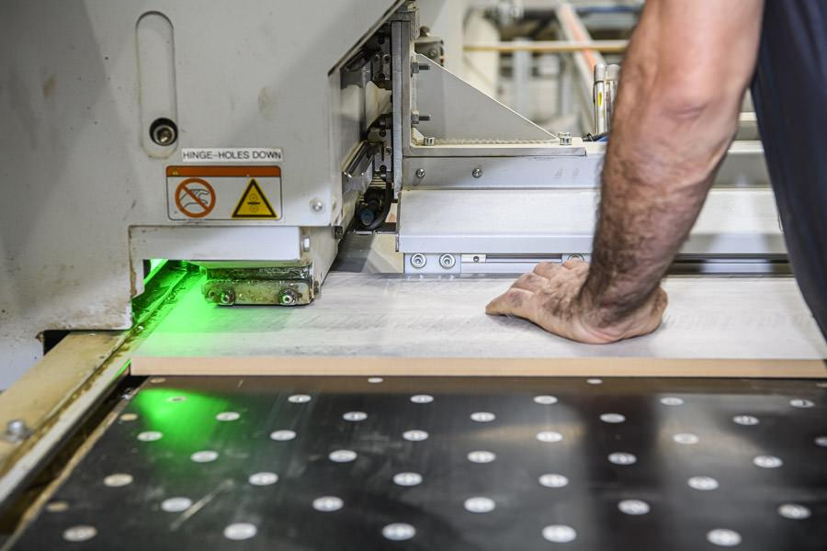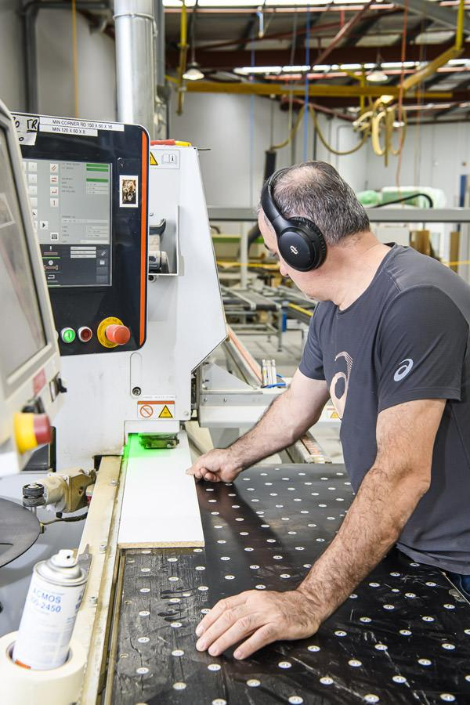

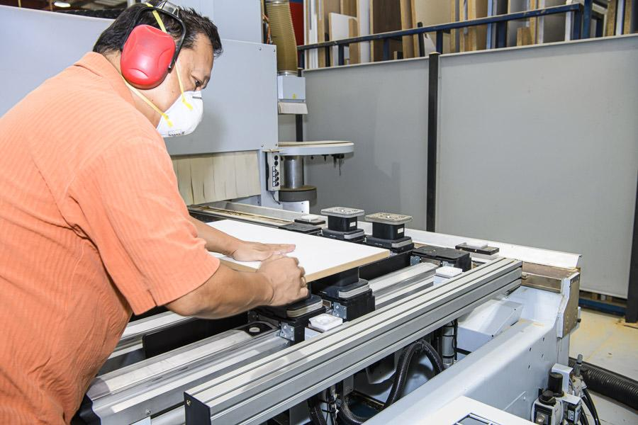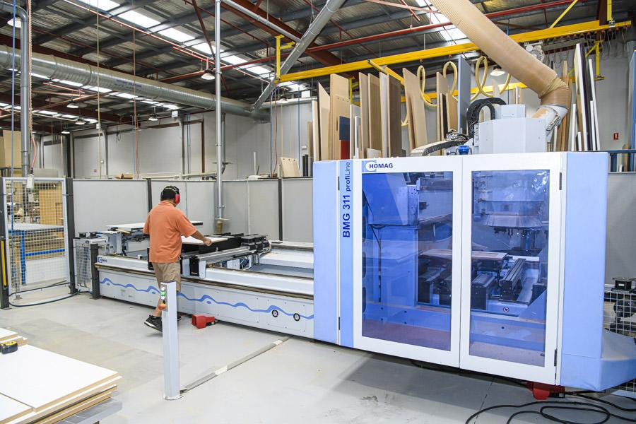

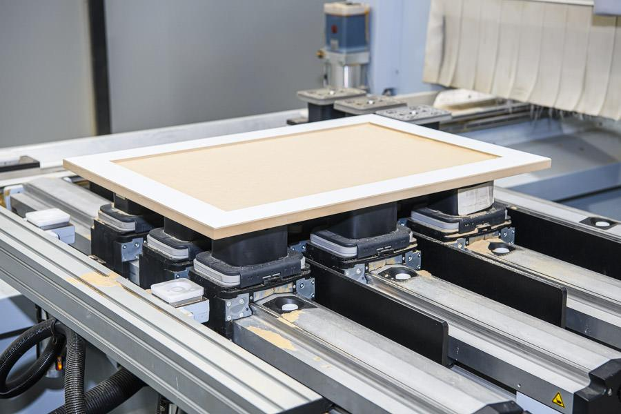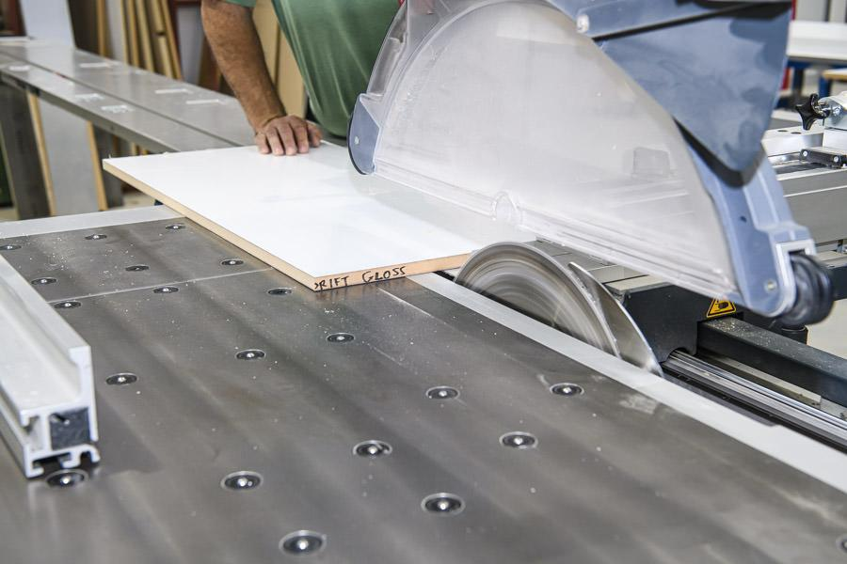

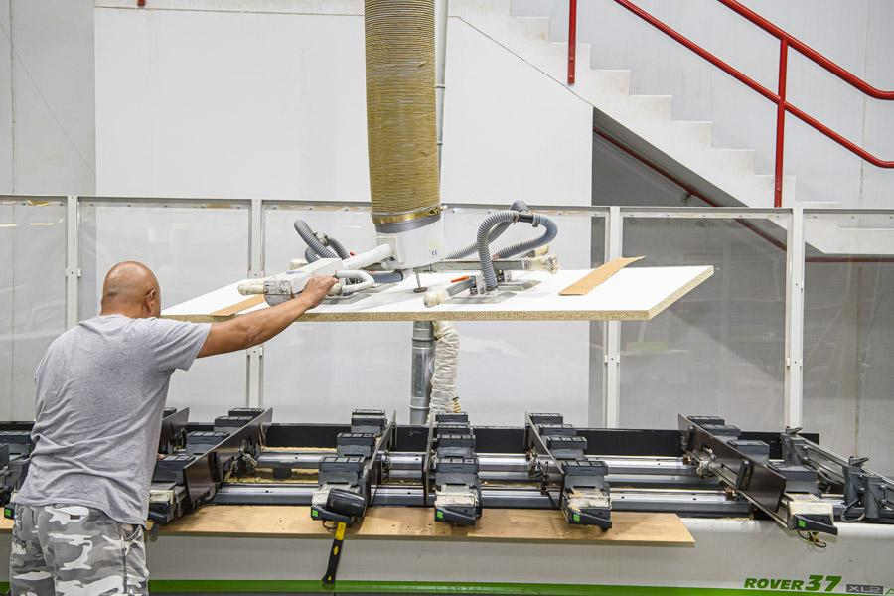
Caption for above selection of photos: From powering the high tech CNC’s through to the beam saw, panel saws and bending machines, compressed air is an essential utility used throughout the manufacturing process at Master Benchtops.

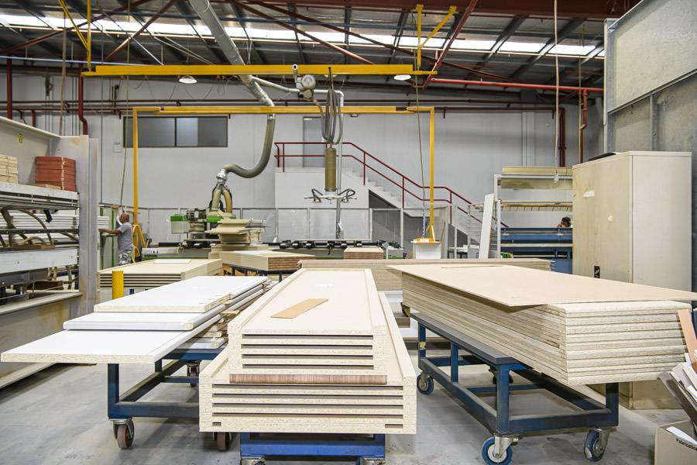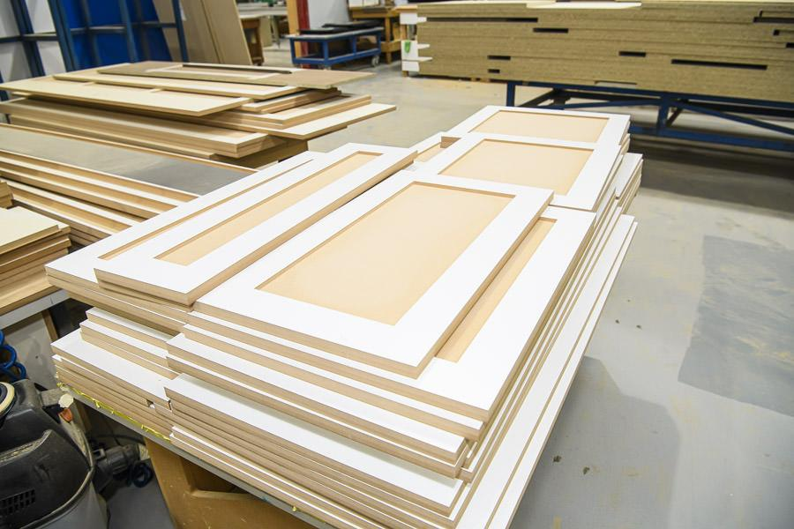

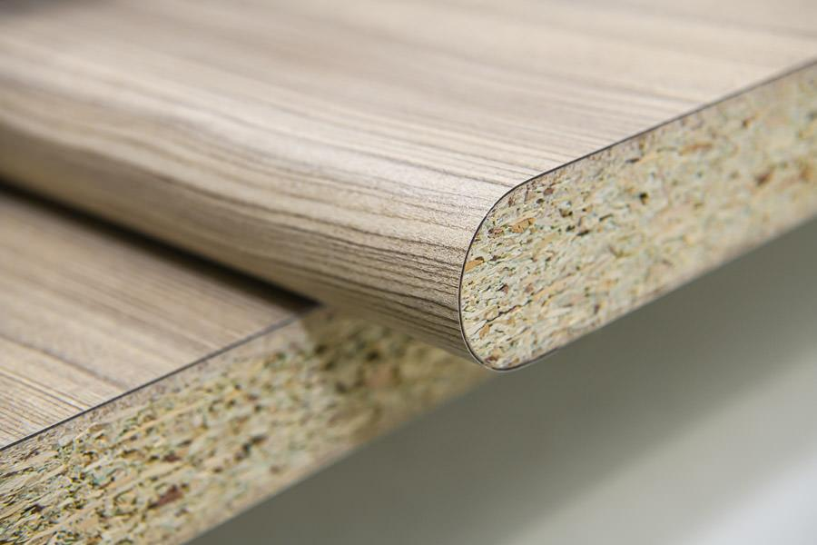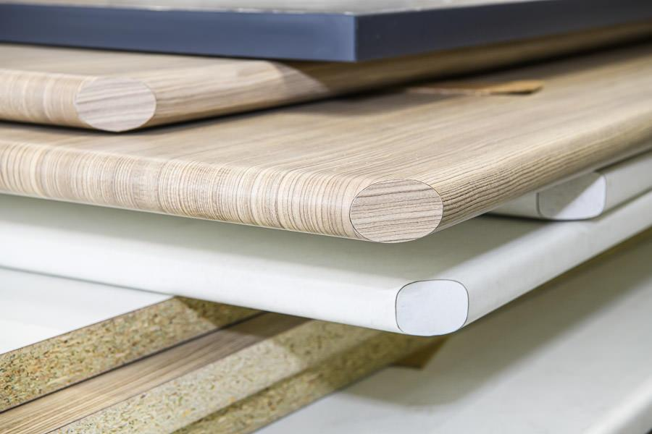

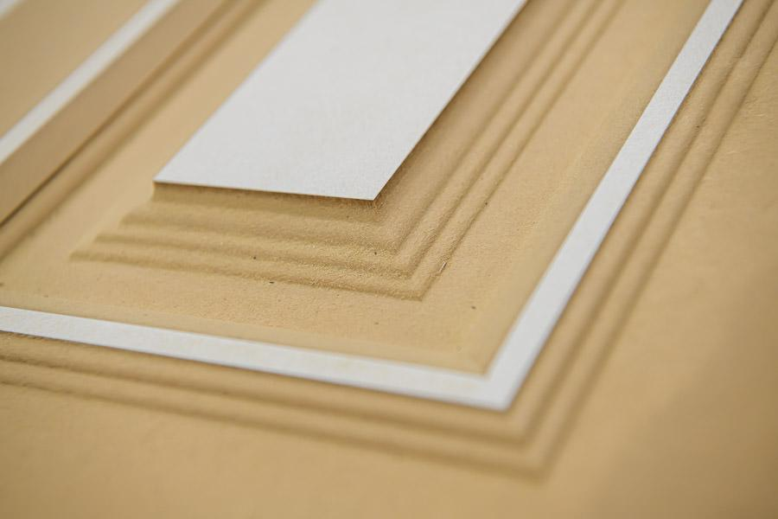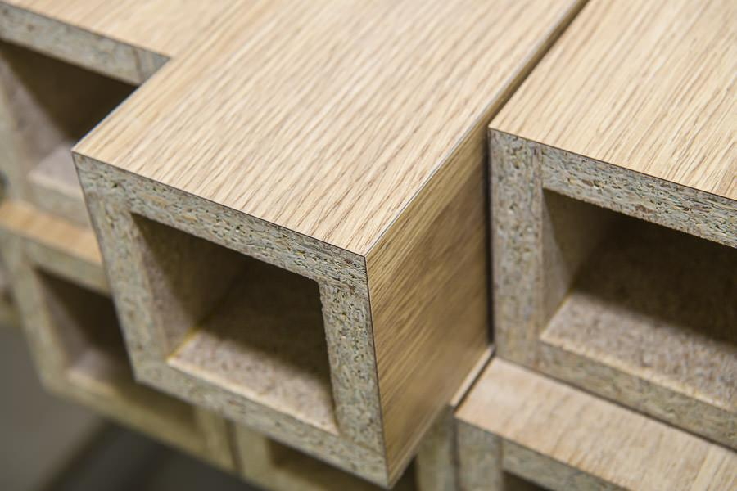

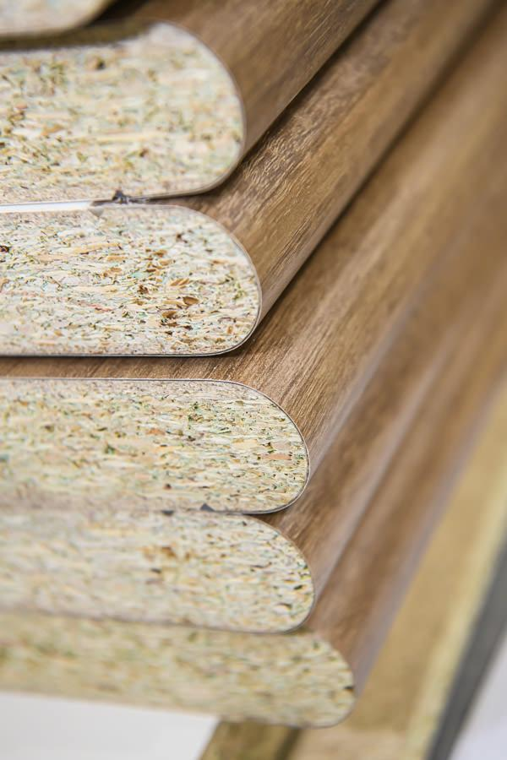
Caption for above selection of photos: Master Benchtops specialises in the manufacture of laminated benchtops. Located in Smithfield it is one of the largest postformers in NSW, delivering its customers with the latest innovations in edge profiles.

Kaeser photo(s) – free for publication, credits appreciated.

