Achieve multiple savings with Kaeser!
Kaeser has recently expanded its ASD SFC series of Sigma frequency controlled rotary screw compressors. Now available from 22 to 30 kW, the ASD SFC series not only deliver more compressed air for less power consumption, but they also combine ease of use and maintenance with exceptional versatility, all in one environmentally responsible design.
The new 22 kW ASD 40 SFC and ASD 40 T SFC rotary screw compressors from Kaeser produce free air deliveries between 1.02 - 4.58 m³/min. Like all other models in the ASD range, these new models save energy in multiple ways.
At the heart of every ASD series rotary screw compressor lies a premium quality screw compressor block featuring Kaeser's Sigma Profile rotors. The Kaeser screw compressor block is equipped with flow optimised rotors for superior efficiency.
All Kaeser rotary screw compressor blocks are powered by premium efficiency IE3 drive motors for maximum performance and reliability that complies with, and exceeds, prevailing Australian MEPS regulations for 3 phase electric motors.
Significant savings can also be achieved with the ASD series rotary screw compressors due to the inclusion of a 1:1 direct drive. The motor drives the compressor screw block directly without transmission loss via a maintenance free coupling. 1:1 direct drive rotary screw compressors provide outstanding performance and minimise maintenance costs.
Costly idling periods are effectively minimised with the ASD series thanks to the inclusion of the industrial PC-based Sigma Control 2 compressor controller which ensures efficient system control and monitoring.
The ASD SFC models are designed with optimum efficiency in mind. Featuring variable speed control, the volumetric flow rate can be adjusted within the control range according to pressure. As a result, operating pressure is precisely maintained to within +0.1 bar. This allows maximum pressure to be reduced which saves both energy and money.
The SFC variable speed drive is housed in its own control cabinet to shield it from the heat of the compressor. A separate fan keeps operating temperatures in the optimum range to ensure maximum performance and service life.
Premium compressed air quality can be further achieved by opting for an ASD T model which features an integrated refrigeration dryer. The integrated refrigeration dryer in the ASD T units provides high efficiency performance thanks to its energy saving control.
A service friendly design ensures that all service and maintenance points are within easy reach and are directly accessible. This saves both time and money when it comes to servicing.
The ASD SFC series rotary screw compressors from Kaeser, are available with drive power 22 to 30 kW, working pressure 7.5 to 15 bar with free air deliveries from 0.92 to 6.04 m³/min.

File: A-ASD40SFC-aus
Approved for publication, copy acknowledgement appreciated
Image:

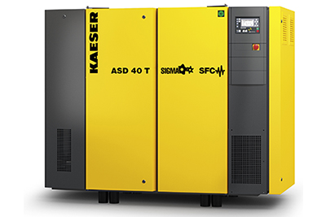
Achieve multiple savings with the Kaeser ASD SFC rotary screw compressors!

