June 2019

Kaeser hits the sweet spot at Pennant Hills Golf Club

Ten years on and four Kaeser Compact series rotary lobe blower packages continue to deliver a reliable supply of low pressure process air to the water recycling plant at Pennant Hills Golf Club, built in 2008 to supply the club with its own secure, sustainable and drought-proof supply of irrigation water.

Nestled in the Hills Shire in the north-west region of Sydney you will find 37 hectares of picturesque landscape which is home to Pennant Hills Golf Club (PHGC). The fourth oldest golf club in Sydney still to be occupying its original site, PHGC was formed in 1923. It holds both Championship and Group One status and has produced some outstanding players who have achieved national and international success not least Tony Gresham, one of the finest Australia amateur golfers to have played the game and Peter Fowler, a successful contender on the professional circuit.

With almost 100 years of history, PHGC attest its ongoing durability to a number of factors including the direct ownership of the land as well as the careful maintenance of the course. And as you can imagine, such a beautifully presented eighteen hole course does require some significant commitment to maintenance.

Since the club first opened its doors in 1923, it has relied on potable water to irrigate the tees, greens and fairways. However, the millennium drought (which lasted over 10 years from 1997 to 2009) placed extreme pressures on urban water supplies. It saw Sydney’s water storage plummet to its lowest level since 1950 at around 33 percent of capacity. For PHGC this meant restrictions started to come into place on their use of potable water, ultimately capping their consumption to 10ML/month. Unfortunately that was not enough in the dry summer months to meet their requirements. With the real possibility looming that PHGC could lose their supply of potable water all together, the golf club began investigating how they could reduce or eliminate their reliance on potable water.

Ground breaking sewer mining project
After investigating a number of options PHGC concluded that developing their own water recycling plant would be the best option and chose Permeate Partners to assist them in the process.

Permeate Partners is a specialist consultancy which assist its clients with the investigation, procurement, operation and maintenance of water and waste water infrastructure. A key focus area for Permeate Partners is finding local water solutions - local source, local treatment and local reuse.

Through a thorough investigative process, it was determined that utilising the water from a 300 mm sewer which runs adjacent to the golf course using a technique called sewer mining would be the most cost effective option for PHGC. Proven in similar applications, sewer mining for such purposes was however unprecedented in Sydney at that time.

As the term implies, sewer mining is literally the mining of a sewer system to extract water for further treatment. Sewage is extracted when required and then treated to the quality level required of the application. For PHGC the system provides a reliable supply of high quality recycled water.

Designing this ground breaking water recycling plant required consultation and approval from many levels including; Sydney Water, NSW Department of Water and Energy and Hornsby Council to name only a few. Once approvals had been sought work on building the plant commenced. Fortunately for PHGC they had a largely unused piece of land not far from the 10th hole which was less than 100 metres from the sewer. This presented the ideal place to construct the plant.

Low pressure process air
Blowers are a key component of any waste water treatment plant, and the water recycling plant at PHGC is no exception. In designing the plant, two 15 kW and two 7.5 kW BB compact series blowers from Kaeser were selected to meet the treatment processes requirement for low pressure process air.

At the heart of the treatment process is a membrane bioreactor. Here the treated water from the biological reactor is drawn through the surface of a membrane while solids and pathogens are rejected. When the ‘bugs’ - or mixed liquor suspended solids - are rejected from the membrane surface, they are returned to the start of the biological reactor. The water which passes through the membrane can then be reused following further disinfection via UV and chlorine.

A reliable supply of low pressure process air is essential to this process. Two of the BB series rotary lobe blower packages from Kaeser are installed duty / standby and used for aeration of the biological reactor. Here oxygen is introduced by the aeration blower which increases the bacterial activity. This in turn brakes down the organic matter.
The other two BB series rotary lobe blower packages are installed duty / standby and used for membrane aeration. In essence this stops the solids sticking to the outside of the membrane.

The all-in-one Compact series of rotary lobe blower systems from Kaeser are compact and delivered ready for immediate use with; sound enclosure, integrated electrical equipment, an integrated control system and star-delta starter. Together such features significantly reduced the amount of work required for planning, installation, certification, documentation and commissioning.

As with all Kaeser products, the Compact series of rotary lobe blowers are designed and constructed for maximum efficiency, reliability and durability in mind. Together with their minimal maintenance and service requirement, these versatile blowers ensure lowest possible life cycle costs.

Ten years on and still going strong
The Pennant Hills Water Reclamation Plant commenced operation just over 10 years ago in May 2008 and is capable of producing 650KL of high quality recycled water per day with 2.5ML storage. Approximately 98 percent of the water extracted from the sewer is converted to recycled water while the remaining 2 percent is returned to the sewer as waste activated sludge.

At around 30 percent of the size of a conventional bioreactor, for PHGC the membrane bioreactor method has allowed them to minimise their biological process footprint as well as achieving a high level of pathogen removal at 99.9 percent.

Since completion of the plant, Permeate Partners has continued to provide service support. With regard to the blowers, Kurt Dahl, Managing Director at Permeate Partners said: ‘In operation now for over 10 years, they have proven to be reliable and run perfectly. As the plant is nestled within the course, it was important that we selected equipment with low noise levels, and the Kaeser blowers have certainly proven to be quiet in operation contributing to the overall minimal noise levels of the plant.’

The Compact series of rotary blower packages from Kaeser are available with working pressures up to 1000mbar, motor powers 1.5 to 200 kW and free air deliveries 4.5 to 93 m³/min. For more information visit www.kaeser.com.au or phone 1800 640 611.
-END-
Editors Notes
From 2.2 to 500 kW, Kaeser Compressors manufactures a wide range of compressors and associated auxiliary equipment that meet the varying requirements of a diverse range of industries and applications.

One of the world’s largest manufacturers of rotary screw compressors, Kaeser Compressors is represented globally in over 100 countries through a dedicated network of branches, subsidiary companies and authorised partners.

Kaeser Compressors Australia provides comprehensive sales and service from its 30,000 ft² purpose built factory in Dandenong, Victoria alongside an extensive network of sales and service centres and authorised partners that cover Australia, New Zealand and New Caledonia.

For editorial and advertising enquiries contact:
Press office: +61 3 9791 5999 Fax: +61 3 9791 5733
E-mail: info.australia@kaeser.com

KAESER COMPRESSORS Australia Pty Ltd – 45 Zenith Road, Dandenong South, VIC 3175, Australia
Phone: +61 3 9791 5999 – www.kaeser.com.au – E-mail: info.australia@kaeser.com

File: Q-PHGC-aus
Approved for publication, copy acknowledgement appreciated
Images: All high res photos are available on request. Contact the marketing department – info.australia@kaeser.com

((Captions)) :

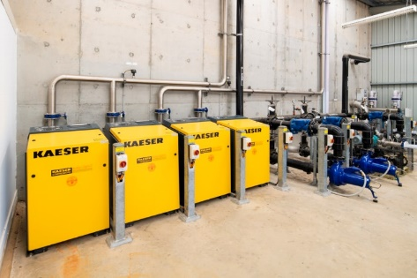
020_Image 1_Kaeser process air at PHGC.jpg
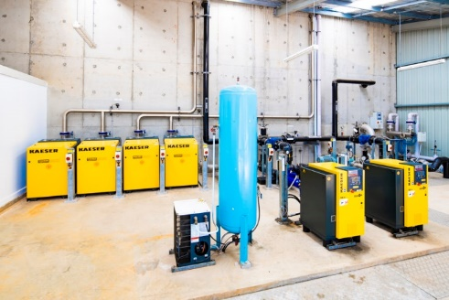
020_Image 2_Kaeser process air at PHGC.jpg
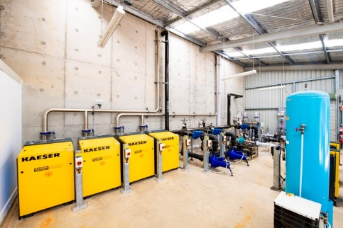
020_Image 3_Kaeser process air at PHGC.jpg
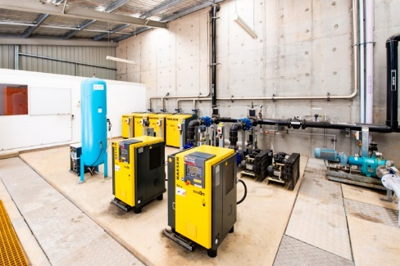
020_Image 4_Kaeser process air at PHGC.jpg
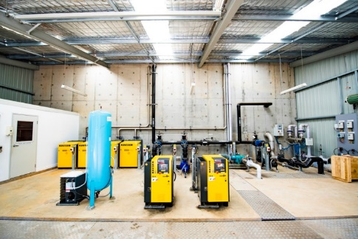
020_Image 5_Kaeser process air at PHGC.jpg

Caption: The Kaeser Compact series rotary lobe blower packages continue to deliver a reliable supply of low pressure process air to the water recycling plant at Pennant Hills Golf Club.

Water recycling plant
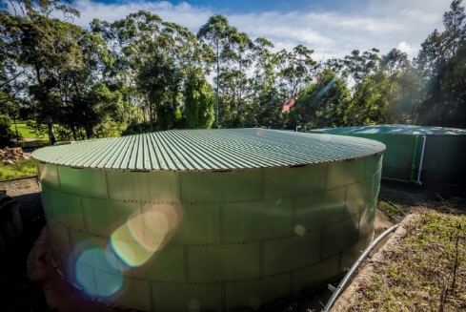
020_Image 6_water recycling plant at PHGC.jpg
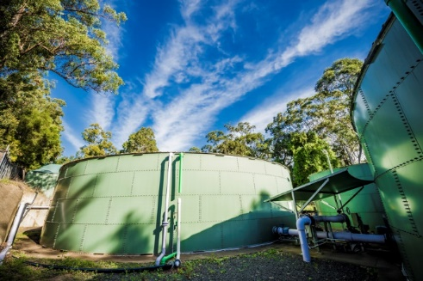
020_Image 7_water recycling plant at PHGC.jpg
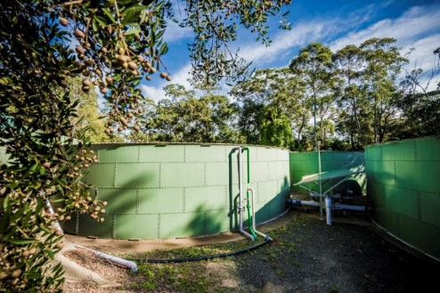
020_Image 8_water recycling plant at PHGC.jpg

Caption: The water recycling plant at Pennant Hills Golf Club was built in 2008 to supply the club with its own secure, sustainable and drought-proof supply of irrigation water.

Irrigiation in action
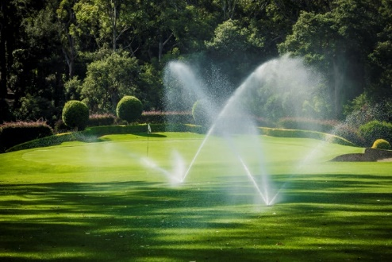
020_Image 9_irrigation at PHGC.jpg
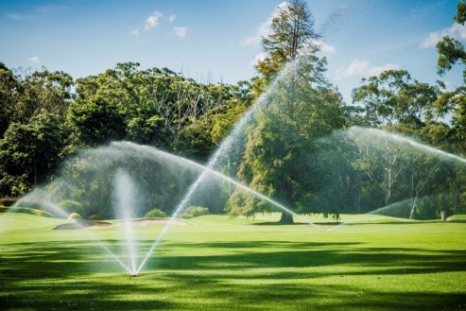
020_Image 10_irrigation at PHGC.jpg
020_Image 11_irrigation at PHGC.jpg
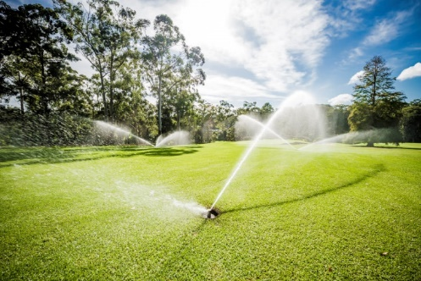
020_Image 12_irrigation at PHGC.jpg

Caption: The Pennant Hills Water Reclamation Plant commenced operation just over 10 years ago and is capable of producing 650KL of high quality recycled water per day, pictured here being used to irrigate the course.

Overview images – golf clubhouse / golfer
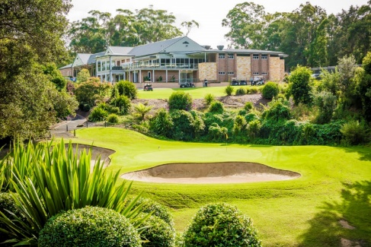
020_Image 13_PHGC.jpg
020_Image 14_PHGC.jpg

Caption: Nestled in the Hills Shire in the north-west region of Sydney you will find 37 hectares of picturesque landscape which is home to Pennant Hills Golf Club (PHGC).

((Kaeser photo – free for publication))

