Kaeser launch portable compressors with built-in electric brakes
In order to meet the unique requirements of the Australian Trailer Design rules for towing trailers, Kaeser has developed a range of its larger Mobilair portable compressors with built-in electric brakes. A world first for Kaeser, owners of these new models can now register the compressor for the road, for ease of transportation.
The Mobilair M 123 and M 135 series portable compressors from Kaeser are now available with built-in electric brakes. A world first for Kaeser, these compressors meet the requirements of the Australian Trailer design rules that state that any trailer with a mass over 2000 kg must have a braking system that is activated independently of the trailer.
This requirement is unique to Australia. In Europe, for example, an overrun braking system is the accepted standard. As a result portable compressors currently imported into the Australian market place will no doubt be fitted with overrun brakes. Users wishing to transport these mobile compressors will have to remove the wheels and mount them onto a plant trailer – an expensive and time consuming process. However, with the new Mobilair M123 and M 135 portable compressors featuring electric brakes, the user can now register the compressor for the road, making transportation a breeze.
Constructed and manufactured at Kaeser’s state-of-the-art facility in Germany, the new Mobilair portable compressors with electric brakes have been specifically designed by Kaeser to meet the specific requirements of the Australian market.
The electric drum brakes come with a safety break-away system. This ensures that if the tow vehicle became detached from the compressor, the brakes on the compressor would lock.
Activation of the electric brakes is via a controller mounted inside the towing vehicle. There are a number of compatible controller options available which can be purchased from all good motor vehicle parts retailers.
Designed for maximum performance and exceptional efficiency, at the heart of every Mobilair portable compressor lies a proven Kaeser rotary screw compressor block equipped with flow optimised Sigma Profile rotors designed to ensure maximum energy efficiency. All components found in these compressors have been manufactured to the highest standards and, along with the generously sized and precision aligned roller-bearings, ensure long service life and outstanding reliability.
The electric brakes are currently an option available on the Mobilair M 123 and M 135 portable compressor models from Kaeser. The M 123 series is available in four pressure stages between 8.6 bar and 14 bar, free air delivery 8.1 to 11.4 m³/min, and the M 135 series is available in four pressure stages between 10 and 14 bar, free air delivery 10.5 to 13 m³/min.

File: c-Mobilair-M135-electric-brakes-aus
Approved for publication, copy acknowledgement appreciated
Image:

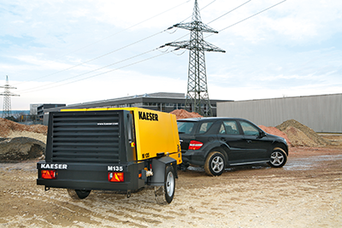
Kaeser launch portable compressors with built-in electric brakes

