Tomorrow's technology today
Kaeser to present Industrie 4.0 compressed air technology at Austech 2017
Kaeser Compressors Australia will be exhibiting at Austech 2017 – Australia’s premier advanced manufacturing and machine tool exhibition - from 9 to 12 May at the Melbourne Convention & Exhibition Centre. Part of the Industry 4.0 Pavilion, visitors to stand number 870 will be able to learn more about the future-oriented benefits of Kaeser’s Industrie 4.0-ready compressed air technology.
Industrie 4.0 - or the fourth industrial revolution - presents a new era of manufacturing led by a number of cyber-physical systems. As a leader in the engineering of compressed air technology, Kaeser products and services are not only designed to deliver the most reliable, efficient and cost-effective compressed air supply possible, but they are also fully ready to take advantage of the future-oriented benefits that Industrie 4.0 has to offer.
In the ultra-flexible Industrie 4.0 production environment, intelligently networked compressed air systems provide the optimal compressed air power and quality required. Moreover, potential issues within the compressed air network are identified at a very early stage so that appropriate service measures can be taken before a fault even occurs.
Visitors to stand 870 will be able to experience a number of Kaeser 4.0 products and services that can seamlessly be incorporated into a production or energy management system. This includes the Sigma Air Manager 4.0 (SAM 4.0).
A key technology in the advanced world of Industry 4.0, SAM 4.0 is a cutting-edge compressed air controller and the central mastermind that controls the entire compressed air supply system. Via IoT (the Internet of Things), the SAM 4.0 is responsible for data streaming to a centralised application in real-time via the powerful Ethernet-based Sigma Network. Here the parameters are analysed, processed, supplemented with expert knowledge and output to various mobile end devices.
Monitoring key operating parameters ensures that compressed air system efficiency can be kept in the optimum range at all times, and thanks to real-time transmission and evaluation, data is always as up to date as possible.
A key advantage of Kaeser 4.0 compressed air technology is the unprecedented efficiencies that can be achieved. Kaeser will be speaking on this topic – ‘air compressor technology and energy efficiency’ - at the Industrie 4.0 Pavilion Theatre at Austech 2017, 11 am on 11 May.
Are you Industry 4.0-ready? Join Kaeser at Austech 2017 on stand number 870 to discover tomorrow’s technology today. 9 – 12 May at the Melbourne Convention & Exhibition Centre.

File: o-Austech-aus
Approved for publication, copy acknowledgement appreciated
Image:

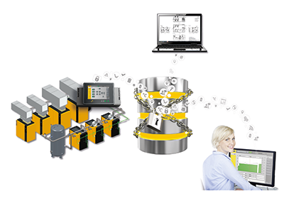
In the Industrie 4.0 production environment, intelligently networked compressed air systems provide the optimal compressed air power and quality required.

