October 2020

Planning ahead for the festive plant shutdown:
Recalibrate, refresh and reset ready for the New Year

It’s hard to believe that the festive season is just around the corner. However as we fast approach the holiday shutdown - now is the perfect time to schedule in plant maintenance or upgrades. Here Kaeser Compressors discusses how compressed air users can make the most of the coming festive season.

2020 has thrown us all quite the curveball with COVID-19. Lockdowns, operating restrictions and social distancing have meant that for some businesses, compressed air maintenance has been neglected. And, this can cause a myriad of problems - from costly and unplanned downtime (we have seen more breakdown calls in recent months) - as well as premature wear of components and consumables. Together this could also have a negative impact on the expected life of the compressed air equipment. With many companies deferring capital expenditure budgets and planned projects stalled, maintaining the integrity of your existing compressed air system has never been so important.

With the festive season fast approaching - a time when many businesses typically have a long period of shutdown - now is a great time to start planning in compressed air maintenance and in particular the larger maintenance jobs that need to be completed which take longer to do.

Get your compressor summer-ready
Some common compressed air system maintenance tasks that require a longer shutdown period include; replacing motor bearings, removing and cleaning coolers as well as oil/water separator cleaning and replacement.

As the festive period falls towards the beginning of summer, the shutdown period is also the ideal time to perform a number of routine maintenance tasks which will ensure your compressed air system is ready for the hot weather ahead such as; changing the oil and the inlet filter to checking the fluid system, belts and couplings.

Keeping your coolers clean is probably one of the most important things you can do during the summer months. Dirty coolers can cause a number of problems such as contributing to your compressor running hot. And, elevated running temperatures increase oil carry over from your compressor which will eventually lead to a low oil level and ultimately a compressor shutdown. Depending on the state of your coolers, high pressure cleaning and/or ultrasonic cleaning may be advised. The festive shutdown period presents the ideal time to have your coolers cleaned.

Future-proof your compressed air system
It is also a great time to implement system upgrades where capital expenditure allows. More businesses than ever are now realising the importance of implementing Industrie 4.0 technologies. COVID-19 has demonstrated how beneficial it is to be able to, for example, monitor and manage your compressed air system remotely.
The Sigma Air Manager 4.0 (SAM 4.0) from Kaeser is an example of a progressive and Industrie 4.0-ready compressed air management system, that binds all individual components into a complete team, monitoring and controlling them so that the required volume of compressed air is available at all times, at the required quality.
Probably one of the greatest advantages of such advanced compressed air technology in the current COVID-19 situation – where many facilities still have staff working remotely, where the number of people in a facility may have been reduced, and where many facilities are still limiting access to suppliers - has been the ability to remotely monitor a compressed air system in real-time.
From a PC, laptop, tablet or smartphone - the SAM 4.0’s integrated web server provides a visual display of all compressed air system data in the form of HTML pages. All operational and energy consumption data, as well as cost information, can therefore be called up on any network-compatible device anytime, anywhere. In addition, the end user can choose to configure the system so they receive alarm and maintenance messages for individual components as well as timely warnings or service requirement notifications via email or text message.
At the best of times a fully networked compressed air system offers the end user numerous benefits. However, many of these benefits, from remote monitoring and diagnostics, to achieving the lowest possible compressed air production costs through intelligent, energy-saving switching strategies - are even more advantageous in the current climate. After all as an essential utility to industry, many businesses rely on their compressed air system and will now more than ever demand maximum compressed air supply reliability.

Where end users are considering system upgrades it's worth remembering that there are a number of Australian Government financial initiatives currently available, such as the Instant Asset Write-Off and the Backing Business Investment, which may make investing in new capital equipment more accessible at this time.

A recipe for festive success
Planning is essential in order to be able to take full advantage of the coming festive season. Consulting your compressed air provider now will allow you time to discuss together what maintenance jobs need to be conducted and any upgrade plans you are considering. Not only can you then get your visit booked in, but you can also place an order for the required consumables, spare parts and so on that will be required, ensuring they are all available and ready to go.

Time to reset
We’re all ready to press that reset button as we head into 2021. Using the festive shutdown to recalibrate and refresh your compressed air system will go a long way to ensure that you can hit the ground running in January, with a compressed air system that you can be assured will deliver maximum availability, as well as optimum reliability and efficiency. For further advice visit au.kaeser.com or phone 1800 640 611.
-END- Free for publication, copy appreciated
Editors Notes
From 0.18 to 515 kW, Kaeser Compressors manufactures a wide range of compressors and associated auxiliary equipment that meet the varying requirements of a diverse range of industries and applications.

One of the world’s largest manufacturers of rotary screw compressors, Kaeser Compressors is represented globally in over 100 countries through a dedicated network of branches, subsidiary companies and authorised partners.

Kaeser Compressors Australia provides comprehensive sales and service from its 30,000 ft² purpose built factory in Dandenong, Victoria alongside an extensive network of sales and service centres and authorised partners that cover Australia and New Caledonia.

For editorial and advertising enquiries contact: Beth Wood, Marketing Manager
Press office: +61 3 9791 5999 Fax: +61 3 9791 5733
E-mail: beth.wood@kaeser.com

KAESER COMPRESSORS Australia Pty Ltd
45 Zenith Road, Dandenong, VIC 3175, Australia
Phone: +61 3 9791 5999 Email: info.australia@kaeser.com
au.kaeser.com

File: N-Festive-season-aus
Approved for publication, copy acknowledgement appreciated
Images:

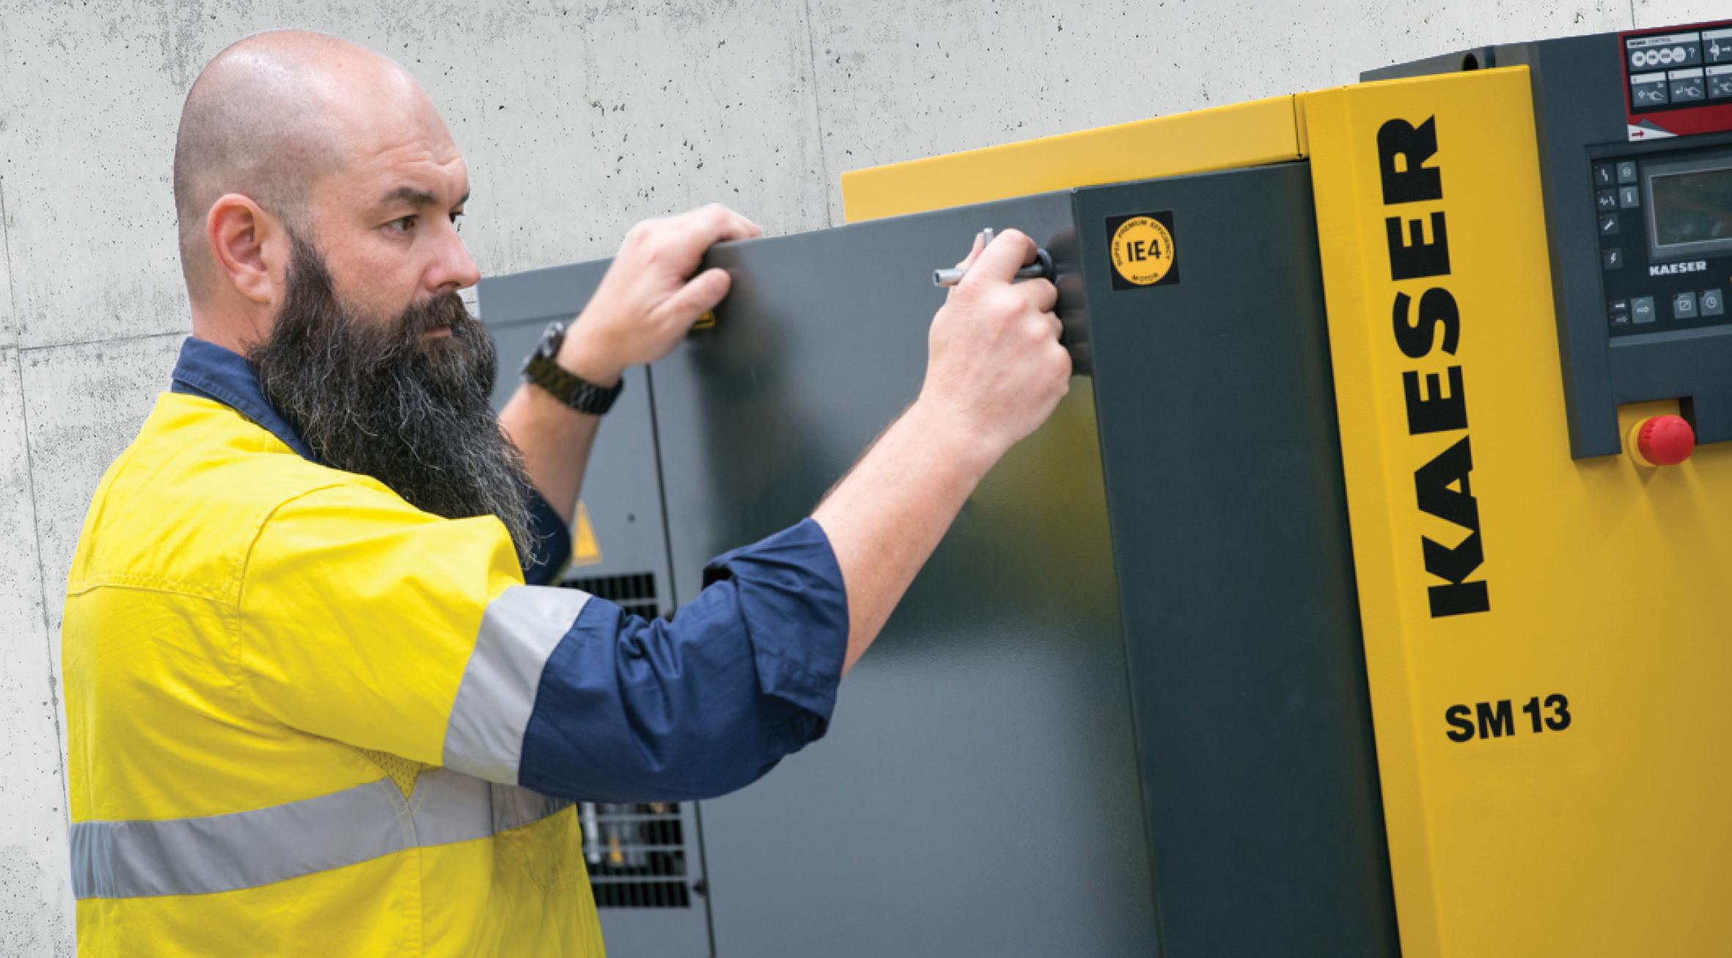
Caption: The festive shutdown is the perfect time to schedule in larger compressed air maintenance tasks.

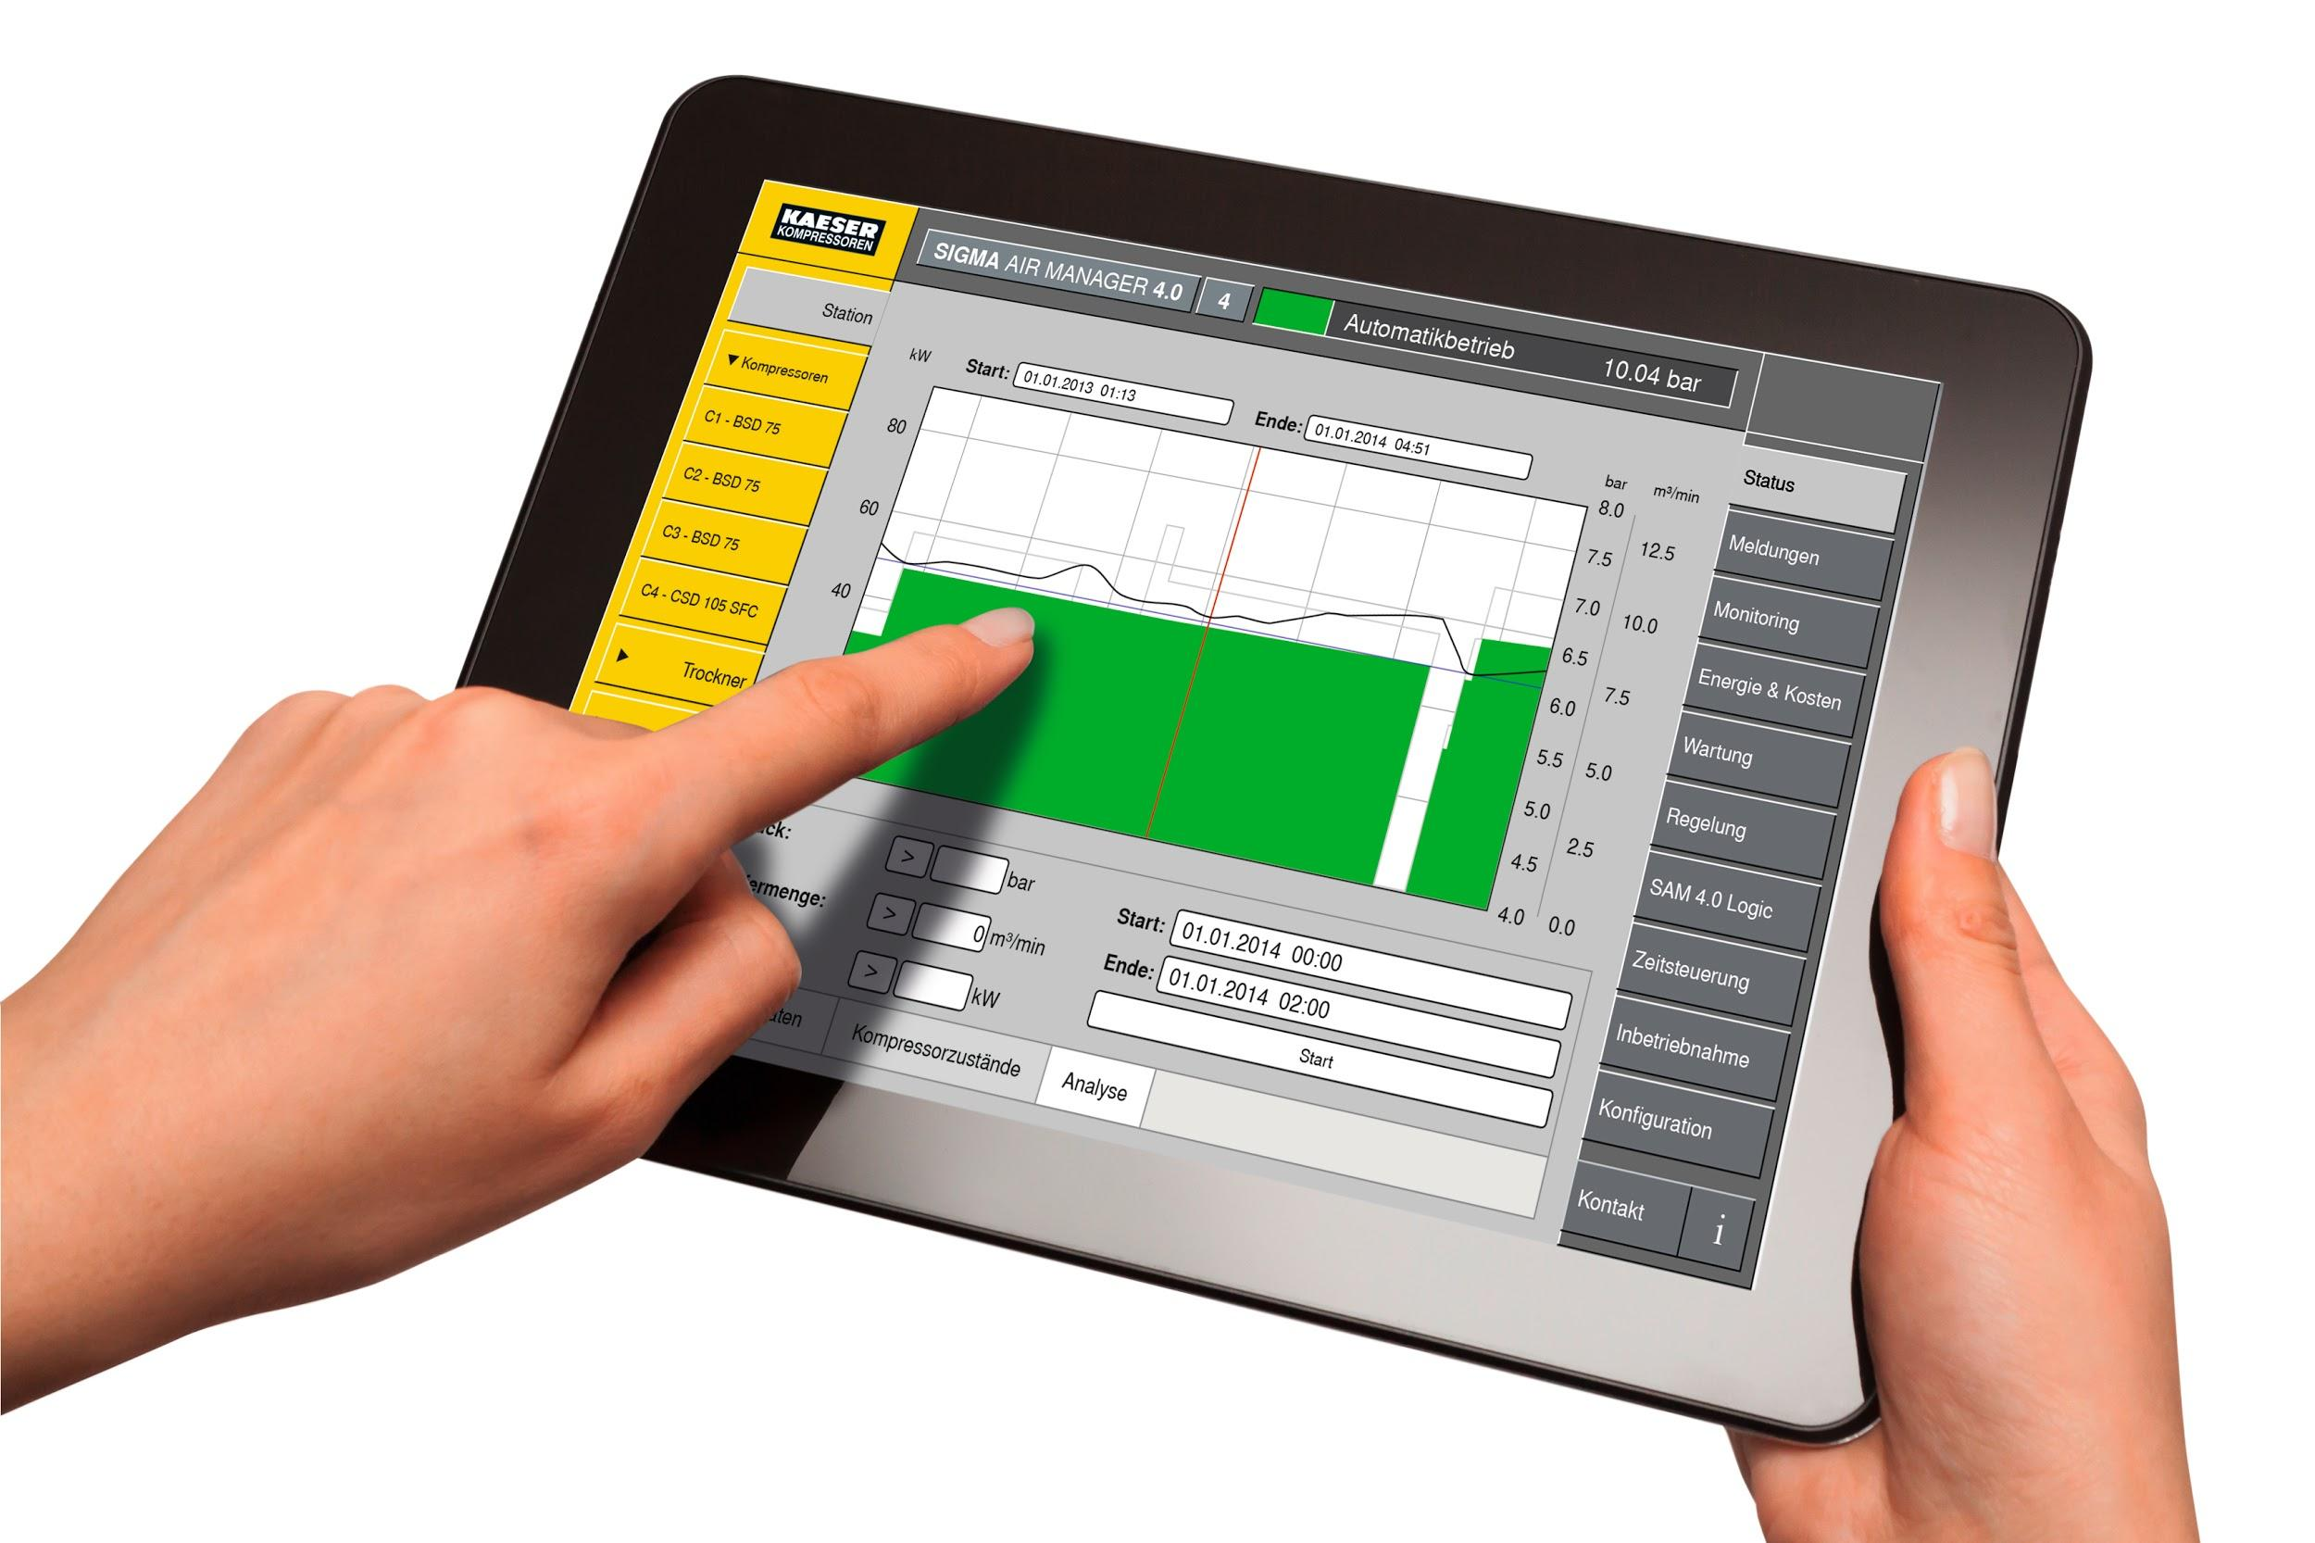
Caption: Remotely monitor a compressed air system in real-time with the Sigma Air Manager 4.0

((Kaeser photo – free for publication))

