June 2021
Save energy and money:
Identifying and implementing compressed air efficiency opportunities

Operating an energy optimised compressed air system brings a wealth of benefits, from reducing your electricity costs to reducing your carbon emissions and thereby your impact on the environment. But, when it comes to identifying energy saving opportunities within your existing compressed air system, what is the potential and where do you start?

‘Almost three quarters of the lifetime costs of a compressor are attributed to energy’ says Peter Eckberg, Managing Director at Kaeser Compressors Australia, ‘If you take the example of a 250 kW compressor, running 3 shifts, 7 days a week, and with electricity costs at $0.15/kWh, then over an average 10 year lifecycle that will cost $3.28 million to run in electricity costs alone!
What’s surprising to many people, is that in most compressed air systems only around 50 percent of the compressed air produced is actually production demand. With my example above, that means that over $1.6 million is being potentially wasted through; compressed air leaks (25 to 30 percent), artificial demand (10 to 15 percent) and inappropriate uses (5 to 10 percent).

But there is good news. Many existing compressed air systems are hiding an energy savings potential of up to 30 percent. Whether you’re looking to optimise the energy efficiency of your existing compressed air system (or upgrade to a new one) - understanding your precise compressed air requirements is essential in order to design and subsequently operate a reliable and energy efficient compressed air system.’

The path to an energy saving compressed air station
The first step in understanding your compressed air requirements is to undergo a compressed air audit. Here, meaningful and accurate performance data should be gathered from your existing compressed air system. This is most effectively carried out by attaching a data logger to your compressed air system for a set period of time (usually a minimum of 7 days). This collects data which can then be uploaded and analysed using proprietary software.

Eckberg said; ‘With Kaeser’s Air Demand Analysis (ADA) and the Kaeser Energy Saving System (KESS), our compressed air experts can provide compressed air users with the full picture when it comes to their compressed air station – and create the optimum solution for outstanding compressed air supply efficiency and dependability.

Our experts will first visit the plant to gather information about the compressed air system, such as: production parameters, existing components, installation location and plans for the future.

Using the Air Demand Analysis (ADA), we then data log the compressed air system over a fixed period of time. The data is then downloaded and analysed which allows us to generate precise consumption profiles of the compressed air station. This highlights the real compressed air demand. With the ADA we can also identify potential weak points in a compressed air system - as well as the all important energy savings potential. Utilising the ADA therefore lays the groundwork for an optimum compressed air station.
To determine the optimum solution, all gathered data is analysed using the Kaeser Energy Saving System (KESS). With this advanced software developed by Kaeser, multiple potential compressed air supply system solutions are compared against one another. We are then able to design the most efficient and economical solution that is precisely tailored to meet the end users needs.

Maximum compressed air availability and massively reduced energy costs are often the result of such plant optimisation performed by our engineers. A reduction of energy costs of up to 30 percent is not uncommon and it has been even more in some cases! The results are often so impressive that they mark a true turning point.’

The Air Demand Analysis (ADA) audit service from Kaeser Compressors was able to identify over 6,856,250.00 kWh of savings potential with some of its customers in 2019 to 2020 in Australia alone. That’s $1,028,437.00 in possible savings (based on $0.15/kWh). Eckberg continued: ‘Based on the 2020 estimate that the average medium sized household’s electricity usage in Australia is 6,570 kWh per year, that’s the equivalent of taking 1000 homes off the grid for one year!
Possibly one of the greatest advantages of using the ADA and KESS is providing the end user with the ability to make informed decisions - based on real data and by showing them a number of configuration options and their potential efficiency and investment outcomes.’

Investing into the future
Eckberg concluded: ‘Where efficiency gains can be made by upgrading equipment, there may never have been a better time to invest with many financial incentives currently available. This includes not least the announcement in the Federal Budget 2021/2, that the Instant Asset Write-Off scheme has been extended through to 30 June 2023.’

The ADA and KESS measurement and evaluation methods used comply with the requirements as per ISO 11011, a standard which establishes rules, methodologies and responsibilities to enable comparability between energy audits in order to achieve enhanced compressed air system efficiency. For more information visit au.kaeser.com or phone 1800 640 611.
-END- Free for publication, copy appreciated
Editors Notes
From 0.18 to 515 kW, Kaeser Compressors manufactures a wide range of compressors and associated auxiliary equipment that meet the varying requirements of a diverse range of industries and applications.

One of the world’s largest manufacturers of compressors, blowers and compressed air systems, Kaeser Compressors is represented throughout the world by a comprehensive network of branches, subsidiaries and authorised distribution partners in over 140 countries.

Kaeser Compressors Australia provides comprehensive sales and service throughout Australia, New Caledonia and the Pacific region, from its purpose built factory in Dandenong, Victoria alongside an extensive network of Sales and Service Centres and authorised partners.

For editorial and advertising enquiries contact: Beth Wood, Marketing Manager
Press office: +61 3 9791 5999 E-mail: beth.wood@kaeser.com

KAESER COMPRESSORS Australia Pty Ltd
45 Zenith Road, Dandenong, VIC 3175, Australia
Phone: +61 3 9791 5999 Email: info.australia@kaeser.com Web: au.kaeser.com
File: N-Kaeser-ADA-aus
Approved for publication, copy acknowledgement appreciated
Images:
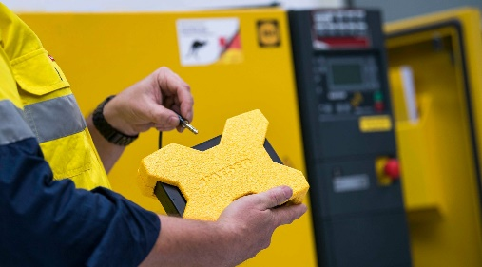
Caption: The Air Demand Analysis (ADA) measuring equipment logs a compressed air system for a fixed period of time.

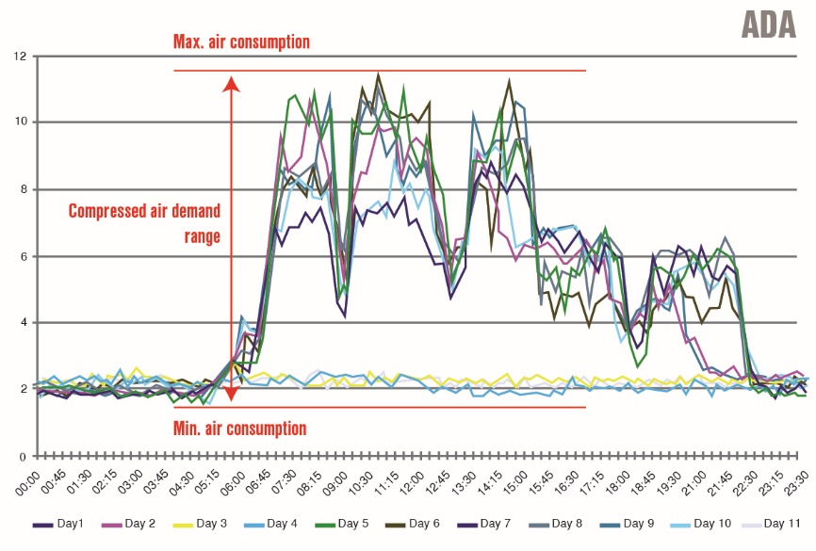
Caption: Example of the type of meaningful and accurate compressed air system performance data that can be gathered with the computer-aided ADA.

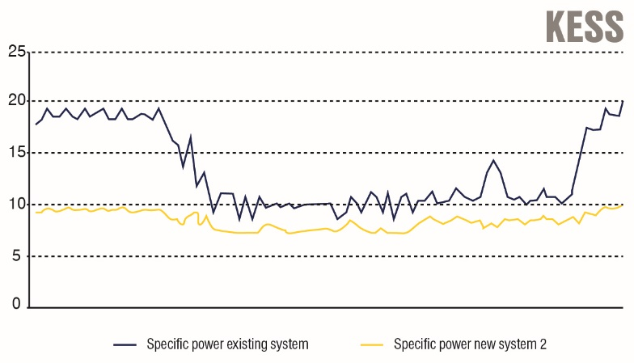
Caption: KESS processes the data acquired by the ADA. An efficiency comparison between the various system options determines the most suitable system for each specific application.

Kaeser photo(s) – free for publication, credits appreciated.

