Kaeser to demonstrate the energy savings capabilities of its screw blowers at WIOA 2016
Kaeser will demonstrate the energy savings that water operators can enjoy with its high efficiency screw blower range at the forthcoming 79th WIOA Victoria Water Industry Operations Exhibition.
Manufactured at the state-of-the-art production facility in Germany, the Kaeser EBS series screw blowers use up to 35 percent less energy than conventional rotary blowers, outclassing other comparable screw and turbo blowers on the market.
Such significant energy savings are achieved through the inclusion of the same proven and trusted technology inherent in the standard Kaeser compressor range. It is the combination of a blower screw compressor block with high efficiency Sigma Profile rotors, flow optimised components, efficient power transmission and drive components that all ensure exceptional performance which is guaranteed by Kaeser in accordance with the stringent requirements of ISO 1217.
The energy costs of operating a blower system can account for up to 80 percent of its total life cycle costs. This is where the EBS series screw blowers from Kaeser can make a real difference with their exceptional energy efficiency!
These turnkey blower systems are also exceptionally user-friendly. Simple to install and easy to maintain, all service components are accessible from one point, making the EBS series screw blowers ideal where space is at a premium.
Water operators wishing to learn more about the energy savings they could achieve with their screw blower system can visit Kaeser on stand number 39 at the WIOA 2016 Expo being held at the Bendigo Event and Exhibition Complex from 31 August to 1 September 2016.

File: o-WIOA-2016-aus
Approved for publication, copy acknowledgement appreciated
Image:

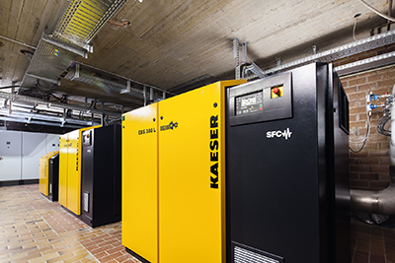
Kaeser to demonstrate the energy savings capabilities of its screw blowers at WIOA 2016

