September 2020

Maximum performance and energy saving

Specifically designed for trade and craft applications, the SXC screw compressor range from Kaeser Compressors combines exceptional efficiency and cost-effective performance with super-quiet compressed air production, treatment and storage. Moreover, the SXC can help achieve annual savings of approximately $1,300 compared with a conventional reciprocating compressor of equivalent power.

Many trade and craft businesses still use a trusty old reciprocating compressor that has provided years of loyal service. That’s no bad thing and says a lot about the quality of these machines. What isn’t so good however, is that although these compressors may reliably produce the necessary compressed air, they incur unacceptably high energy costs. This can amount to hundreds of dollars of unnecessary expense as the years pass by. This inefficiency is further compounded by the fact that older reciprocating compressors often take up more installation space and – to top things off – are usually far too loud. What's required therefore is a compressed air supply system that is not only efficient and cost-effective, but which is also compact and exceptionally quiet. The latest generation of SXC series compressed air supply systems from Kaeser Compressors meet all of these needs and more:

Under the SXC's eye-catching rotation-sintered polyethylene enclosure hides a complete compressed air supply system. The four available models are based on an innovative tower concept which integrates a screw compressor, a refrigeration dryer and a compressed air receiver all within a single compact unit that has an astonishingly small footprint of only 0.62 m². Furthermore, all condensate accumulating in the refrigeration dryer and air receiver is removed reliably and without pressure loss via an electronically controlled condensate drain.

At the heart of each unit lies a Kaeser rotary screw compressor featuring a specially designed screw compressor block with flow-optimised ‘Sigma Profile’ rotors which deliver more compressed air for less energy consumption. With models ranging in power from 2.2 to 5.5 kW for flow rates from 0.26 to 0.8 m³/min (at 8 bar), there's always an appropriate SXC configuration to meet the needs of a wide range of applications.

At only 61.5 cm wide, Kaeser’s SXC models are barely wider than your average washing machine, yet offer all the benefits of much larger compressed air systems. For outstanding reliability and efficiency, these 'all Inclusive' packages are equipped with a Sigma Control 2 controller featuring an efficient Start-Stop control. This state-of-the-art compressor controller guarantees secure operation through continuous monitoring of the whole SXC unit. A plain text display ensures efficient communication. For more information visit au.kaeser.com or phone 1800 640 611.
-END- Free for publication, copy appreciated
Editors Notes
From 0.18 to 515 kW, Kaeser Compressors manufactures a wide range of compressors and associated auxiliary equipment that meet the varying requirements of a diverse range of industries and applications.

One of the world’s largest manufacturers of rotary screw compressors, Kaeser Compressors is represented globally in over 100 countries through a dedicated network of branches, subsidiary companies and authorised partners.

Kaeser Compressors Australia provides comprehensive sales and service from its 30,000 ft² purpose built factory in Dandenong, Victoria alongside an extensive network of sales and service centres and authorised partners that cover Australia and New Caledonia.

For editorial and advertising enquiries contact: Beth Wood, Marketing Manager
Press office: +61 3 9791 5999 Fax: +61 3 9791 5733
E-mail: beth.wood@kaeser.com

KAESER COMPRESSORS Australia Pty Ltd
45 Zenith Road, Dandenong, VIC 3175, Australia
Phone: +61 3 9791 5999 Email: info.australia@kaeser.com
au.kaeser.com
Kaeser photo(s) – free for publication, credits appreciated.

File: A-SXC-Sep20-aus
Approved for publication, copy acknowledgement appreciated
Image(s):

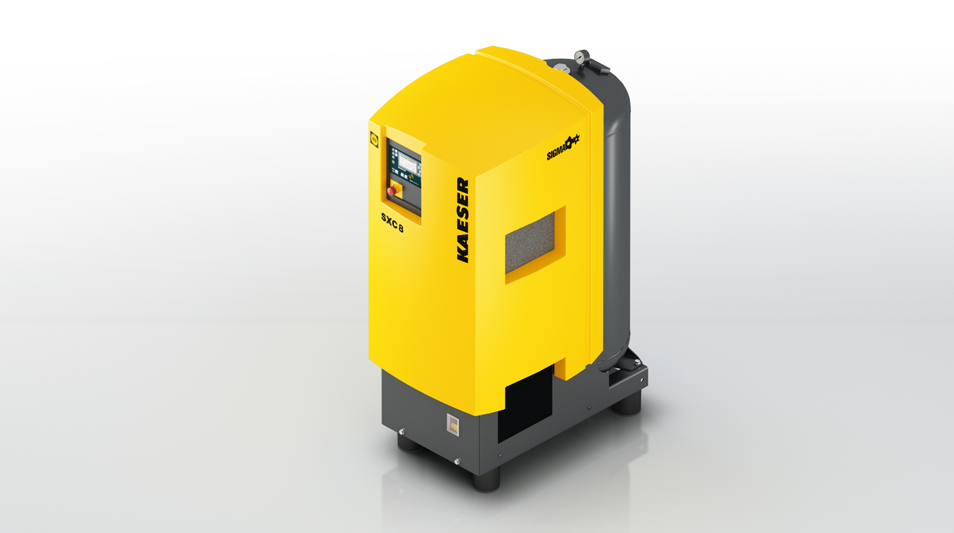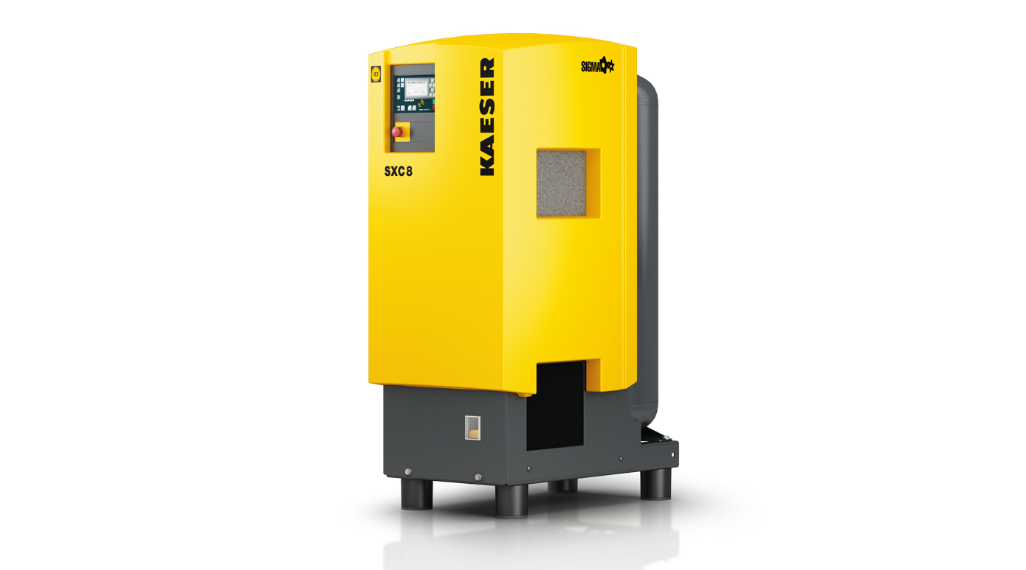
Caption: Kaeser's SXC compact compressed air systems combine outstanding reliability and efficiency with high quality air treatment and a compressed air receiver.

Kaeser photo(s) – free for publication.

