August 2019

Securing an energy efficient supply of compressed air:
Prowler Proof opts for Kaeser Sigma frequency controlled compressor to efficiently meet fluctuating compressed air demand

Over 25 years of reliable service from Kaeser has led premium Australian security door and window screens manufacturer Prowler Proof, to opt for a Kaeser ASD SFC Sigma frequency controlled rotary screw compressor, to energy efficiently meet its ‘World Class’ manufacturing facilities increased demand for compressed air.

Security, natural ventilation, UV and insect protection as well as protecting from the risk of bushfires - these are just some of the many reasons that numerous buildings throughout Australia are equipped with security window and door screens. Prowler Proof has been manufacturing premium security door and window screens to meet this myriad of requirements since 1984. Remaining proudly Australian owned and made, they deliver the highest performing doors and screens in Australia thanks to a manufacturing process which includes welding the security door and window screens, making them stronger than any screw or rivet.

All Prowler Proof door and window screens are manufactured in the company’s hi-tech fully automated facility in Banyo, Queensland – which is also currently Australia’s only ‘World Class’ manufacturing facility*. Compressed air is used extensively within the manufacturing facility to power a vast range of machinery, including cutting machinery and the powder coat line.
As all window and door screens are custom made to fit and manufactured to order with the industry’s shortest lead time, operating a reliable compressed air system is essential to the manufacturing process. Having recently scaled up production it became apparent that the existing 15 year old Kaeser compressed air system was struggling to meet the new demand for compressed air. Michael Henry, Managing Director at Prowler Proof, therefore contacted long standing compressed air partner Kaeser Compressors for a solution.

After reviewing Prowler Proof’s current compressed air system, the increased demand for compressed air and factoring in the company’s seasonal production cycles, Kaeser recommended replacing the existing compressed air system with an ASD 60 SFC Sigma frequency controlled rotary screw compressor.

The ASD SFC series from Kaeser deliver premium quality compressed air and superior efficiency, saving energy in multiple ways:

The latest release of the ASD SFC series of Sigma frequency controlled rotary screw compressors incorporate a completely new and innovative drive technology. Representing a significant technological milestone for Kaeser, the new synchronous reluctance motors - which were developed in close partnership with Siemens - boast significantly greater efficiency, thanks to considerably lower losses in the crucial partial-load range compared to asynchronous motors. The low moment of inertia of synchronous reluctance motors allows high cycle rates, thereby boosting machine and system productivity.

Some of the technical advantages of the new motor design include near zero heat losses from the rotors, which keeps bearing temperatures noticeably lower. This in turn has a positive effect on service life, ease of maintenance, as well as drive availability. Moreover, Kaeser’s use of variable-speed fans in compressed air production systems delivers additional energy savings.

The major advantage of this complete solution is that it delivers efficiency gains of up to ten percent in the partial-load range compared with conventional variable speed systems. This ensures minimal energy consumption and minimal operating costs particularly where compressed air demand fluctuates as is the case at Prowler Proof due to seasonal production cycles.

In addition, the compressor is controlled and monitored via the industrial-PC-based Sigma Control 2 internal compressor controller. The flow rate can be adjusted within the control range according to pressure. Operating pressure is kept constant to within ±0.1 bar. This allows maximum pressure to be reduced, which, in turn, leads to significant energy and cost savings.

Not only do these optimised compressors deliver more compressed air for less energy, but they also combine ease of maintenance in an environmentally responsible design. Prowler Proof recognises the importance of protecting the environment and therefore considers all aspects of the manufacturing process to ensure minimal impact on the environment. This was therefore a key consideration when selecting the new compressor.

Michael Henry concluded: ‘We picked the ASD SFC this time to better manage our seasonal production cycles and for optimum energy efficiency.
Kaeser has been our compressed air supplier now for over 25 years and we have been extremely pleased with the Kaeser equipment which has worked reliably all that time! Another big reason we continue to choose Kaeser is the service we have received. Kaeser is always reliable and the addition of the oil testing and analysis at service visits on the old compressor, has given us the extra confidence over the years that everything was in good working order.’

The ASD SFC series of Sigma frequency controlled rotary screw compressors are available with drive powers of 22 to 30 kW and produce flow rates from 0.93 to 6.17 m³/min, designed for pressures 8.5 to 15 bar. For more information from Kaeser visit au.kaeser.com or phone 1800 640 611.

*Prowler Proof has achieved the rating ‘World Class’ on the PROBE Manufacturing global benchmark. PROBE is one of the world’s leading organisational assessment and best practice bench marking tools, used in over 30 countries to promote and support the pursuit of Business Excellence across all sectors. The process compiles a report and provides a ‘World Class’ score compared against a cross-section of international companies.
-END-
Editors Notes
From 2.2 to 500 kW, Kaeser Compressors manufactures a wide range of compressors and associated auxiliary equipment that meet the varying requirements of a diverse range of industries and applications.

One of the world’s largest manufacturers of rotary screw compressors, Kaeser Compressors is represented globally in over 100 countries through a dedicated network of branches, subsidiary companies and authorised partners.

Kaeser Compressors Australia provides comprehensive sales and service from its 30,000 ft² purpose built factory in Dandenong, Victoria alongside an extensive network of sales and service centres and authorised partners that cover Australia, New Zealand and New Caledonia.

For editorial and advertising enquiries contact:
Press office: +61 3 9791 5999 Fax: +61 3 9791 5733
E-mail: info.australia@kaeser.com

KAESER COMPRESSORS Australia Pty Ltd – 45 Zenith Road, Dandenong South, VIC 3175, Australia
Phone: +61 3 9791 5999 – https://au.kaeser.com – E-mail: info.australia@kaeser.com

File: Q-Prowler-aus
Approved for publication, copy acknowledgement appreciated
Images: All high res photos are available on request. Contact the marketing department – info.australia@kaeser.com

((Captions)) :

Compressor system
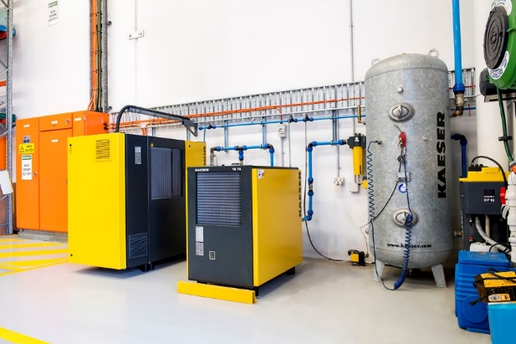
015_Image 1_compressed air at Prowler Proof.jpg
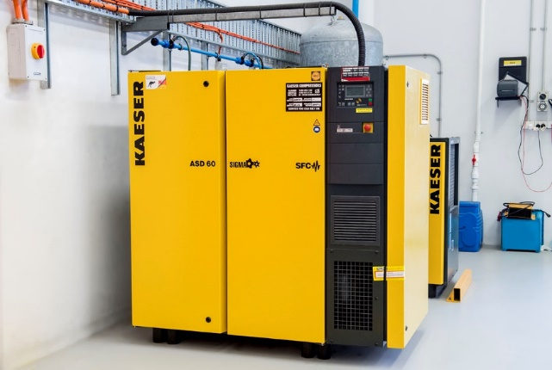
015_Image 2_compressed air at Prowler Proof.jpg

Caption: Operating a reliable compressed air system is essential to the manufacturing process – here the recently upgraded Kaeser compressed air system

Facility overview
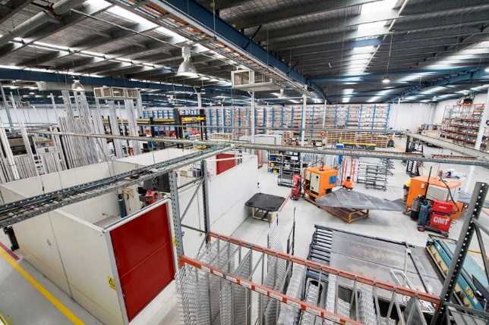
015_Image 3_Prowler Proof facility.jpg

Caption: All Prowler Proof door and window screens are manufactured in the company’s hi-tech fully automated facility in Banyo, Queensland

Welding
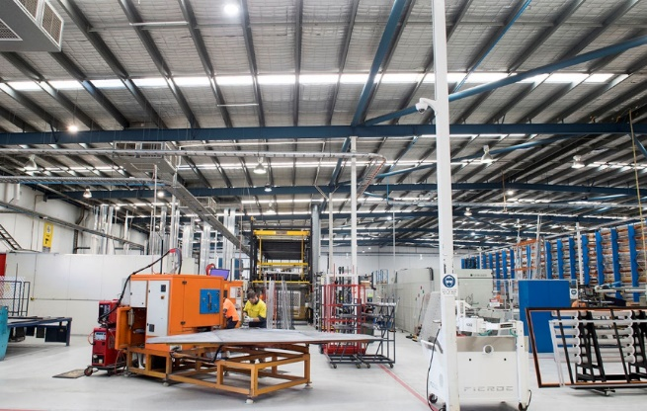
015_Image 4_compressed air application at Prowler Proof.jpg
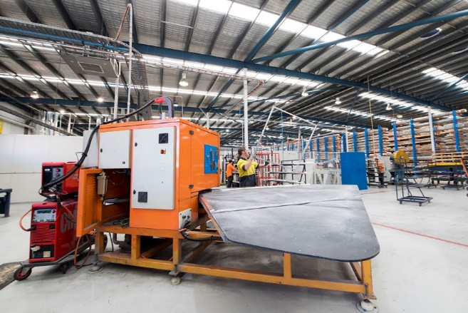
015_Image 5_compressed air application at Prowler Proof.jpg

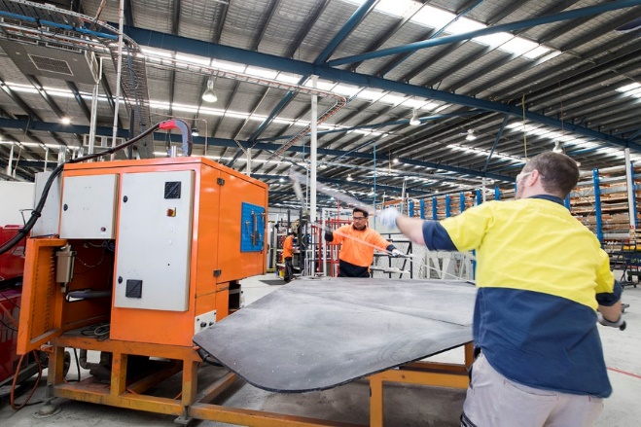
015_Image 6_compressed air application at Prowler Proof.jpg

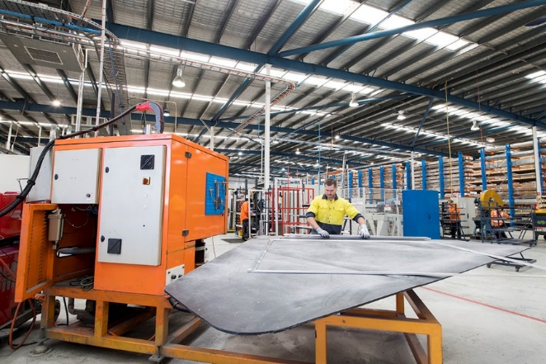
015_Image 7_compressed air application at Prowler Proof.jpg

Caption: The compressed air system powers a vast range of machinery. Above welding a frame.

Assembly table
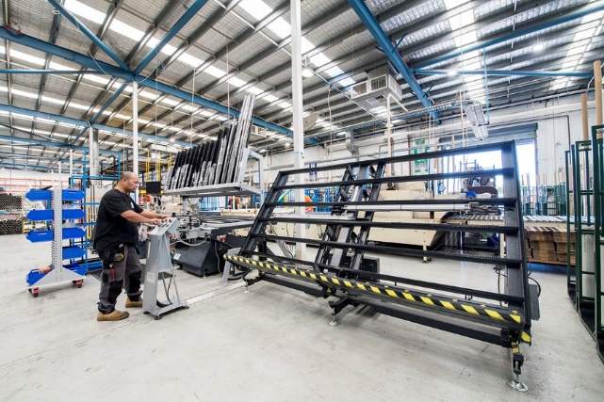
015_Image 8_compressed air application at Prowler Proof.jpg
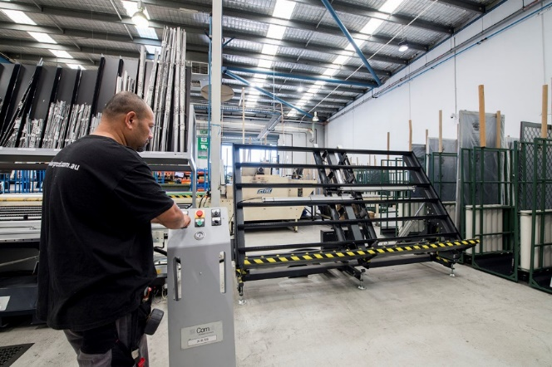
015_Image 9_compressed air application at Prowler Proof.jpg

Caption: Compressed air is essential to the manufacturing process, here used to power the hinge window frame and sash assembly table.

((Kaeser photo – free for publication))

