Victorian Desalination Project opts for energy efficient Kaeser turn-key compressor system
In constructing the Victorian Desalination Project, AquaSure chose to install four Kaeser DSD 238 SFC series frequency controlled rotary screw compressors to meet the plants' requirements for an energy efficient source of compressed air. Ready for action in times of drought, the Victorian Desalination Project can produce and supply up to 150 billion litres of water a year to Melbourne and Geelong.
In June 2007, the Victorian Government announced its intentions to construct a desalination plant as part of its Water Plan, which would create a drought-proof supply of water for Melbourne and Geelong. The contract to finance, design, construct, maintain and operate the Victorian Desalination Project (VDP) was awarded in July 2009 to the AquaSure consortium.
Located near Wonthaggi, construction commenced in September 2009 and was completed in 2012 by AquaSure and its contractors, which included design and construction contractors Thiess Degrémont and operations and maintenance contractors Degrémont Thiess Services (Watersure).
The VDP comprises; a reverse osmosis plant, marine structures which include two underground tunnels located 15 metres below the seabed, a two-way underground 84 km water transfer pipeline and 87 km underground power supply. With a production capacity of up to 150 billion litres of water a year, the VDP provides a rainfall-independent source of water to communities throughout Melbourne, South Gippsland and Westernport.
Reverse osmosis is the desalination technology used at the VDP to turn seawater into freshwater. It is also the most energy efficient method of desalination. This is not the only energy efficient measure implemented at the VDP. AquaSure introduced a number of innovative systems to ensure the plant operates as energy efficiently as possible. This included; incorporating systems within the plant to minimise power consumption during the reverse osmosis processes and the plant's compact modular design which reduces pipework and eliminates inefficient energy use.
The compressed air system was another area where AquaSure opted for equipment that possessed energy reducing features such as variable speed drives and high efficiency motors.
Compressed air is used to power a number of processes within the VDP. One of the main requirements for compressed air on the plant however, is to actuate a number of the 17,000 plus automated valves!
To maximise energy efficiency while meeting these requirements, AquaSure chose to install a Kaeser turn-key solution consisting of; four Kaeser DSD 238 SFC series frequency controlled rotary screw compressors, four air receivers along with four instrument air treatment skids which include pre- and post- duplex filter sets as well as a desiccant dryer.
Manufactured in Germany, the DSD SFC series frequency controlled rotary screw compressor packages from Kaeser provide the ultimate energy efficient solution. Every Kaeser rotary screw compressor is equipped with a large, efficient screw compressor block featuring high performance Sigma Profile rotors. Powered by a direct drive system, the screw compressor blocks in the DSD series compressors eliminate the transmission losses associated with gear driven systems. This significantly increases reliability and service life. The benefits speak for themselves; efficient power transmission, optimal power consumption, reduced servicing and downtime costs along with significant energy savings.
In addition, further and considerable energy savings are achieved with the inclusion of the Sigma frequency control (SFC) module. With the SFC module (variable speed drive) air delivery can be matched to actual air demand, according to the required system pressure, by continuously adjusting drive motor speed within its specified control range. This can lead to significant savings, as only the required compressed air at any one time is produced, with a 1 bar reduction in pressure amounting to a 7 percent reduction in energy consumption.
From construction completion in December 2012 to the end of the contract in 2039, Watersure will operate and maintain the plant, seawater tunnels, pipeline, and ecological reserve surrounding the plant site.
The contract with AquaSure provides for flexible water ordering of between 0 GL and 150 GL a year in set increments, enabling the State Government to order water if required. When the VDP is not producing water, there is a comprehensive maintenance program in place which guarantees that the VDP is available to produce water when the need arises, making an important part of Melbourne's water security in times of future drought and to support its growing population and economic prosperity.
Efficient and reliable, the DSD SFC series frequency controlled rotary screw compressors from Kaeser are available with drive powers up to 160 kW, working pressure 7.5, 10 or 13 bar and with free air deliveries from 3.6 up to 30.60 m³/min.

File: Q-VDP-aus
Approved for publication, copy acknowledgement appreciated
Images: (contact the press office for high res copies of the following images)

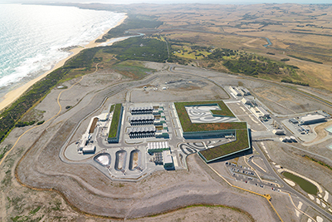
Caption: The VDP has a production capacity of up to 150 billion litres of water a year

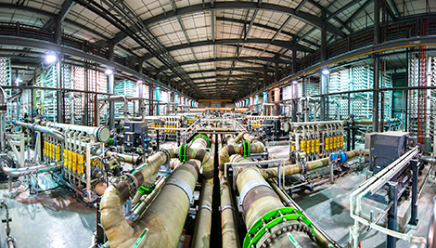
Caption: One of the main requirements for compressed air on the VDP is to actuate a number of the 17,000 plus automated valves

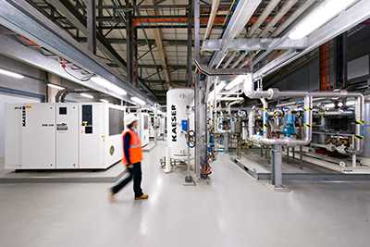
Caption: The VDP utilises 4 Kaeser DSD 238 SFC series frequency controlled rotary screw compressors

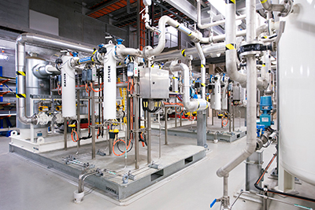
Caption: The VDP utilises 4 air receivers and 4 instrument air treatment skids which include pre- and post- duplex filter sets as well as a desiccant dryer

