May 2020
Complete connectivity for maximum compressed air supply

In this article Kaeser Compressors explains how a fully networked compressed air system works and the benefits this brings to the end user in terms of complete life cycle efficiency, and most importantly right now - being able to remotely and in real time view key information and diagnostics - for maximum compressed air supply reliability.

How a networked compressed air system works
A well orchestrated symphony
Every part of a compressed air station, whether it be the compressors, compressed air treatment components or distribution system, should operate as efficiently as possible for its own sake. Modern compressors and compressed air treatment components are therefore equipped with internal controllers based on industrial PC technology. But these components are not individual players – they must act together as a team, and a team works best when it is perfectly coordinated. A sophisticated compressed air management system is therefore required to perform this particular function.
The Sigma Air Manager 4.0 (SAM 4.0) from Kaeser is an example of a progressive and Industrie 4.0-ready compressed air management system, that binds all individual components into a complete team, monitoring and controlling them so that the required volume of compressed air is available at all times, at the required quality.
Advanced management systems must successfully meet some highly demanding challenges. Not least, they must be capable of predictive compressor control, taking into account a range of contributing factors, such as switching losses, control losses, etc. However, modern master controllers are now expected to do far more than optimise compressor operation according to current demand. Efficiency is playing an ever-increasing role. Here, through the development of a patented, simulation-based optimisation process, the SAM 4.0 is meeting these requirements by predictively selecting the most efficient switching operations based on compressed air consumption profile analysis and equipment and system behaviour, in relation to the prevailing technical operating conditions. Decisions are no longer dictated by a narrow pressure range. Instead, the key is to achieve the lowest possible compressed air production costs through intelligent, energy-saving switching strategies.

Predicting service requirements
Such advanced controllers like the SAM 4.0, also allow for varying levels of involvement by external service providers. The end user can therefore still choose to perform all of the maintenance, evaluation and servicing of the system themselves (the SAM 4.0 will send the end user notifications when service is required). Or, the end user can choose a predictive maintenance service model with remote diagnostics.
Here, the physical meets the virtual world within the framework of a structural model such as Sigma Smart Air from Kaeser, in which the specific compressed air system - configured according to the operator's requirements - is represented virtually by a digital twin. Operating data from the compressed air station is securely transmitted to the Kaeser Data Center, where it is analysed in real-time. Such real-time availability of operating data makes it possible to monitor the 'health' status of a compressed air station. This means that maintenance is carried out precisely as needed and potential faults can be detected in advance and appropriate maintenance measures automatically initiated at the right time. Ultimately, the end user benefits from significantly reduced compressed air production and operating costs, as well as improved compressed air availability.
The combination of remote diagnostics and demand-oriented predictive maintenance ensures maximum compressed air supply availability and complete system effectiveness; preventing unplanned downtime, increasing energy efficiency, reducing service costs by up to 30 percent and delivering demand optimised compressed air system control throughout the system’s entire life cycle.

Remote and real-time monitoring
Probably one of the greatest advantages of such advanced compressed air technology in the current Coronavirus situation - where facilities now have many staff working remotely, where the number of people in a facility has been reduced, and where many facilities are now limiting access to suppliers - is the ability to remotely monitor a compressed air system in real-time.
From a PC, laptop, tablet or smartphone - the SAM 4.0’s integrated web server provides a visual display of all compressed air system data in the form of HTML pages. All operational and energy consumption data, as well as cost information, can therefore be called up on any network-compatible device anytime, anywhere. In addition, the end user can choose to configure the system so they receive alarm and maintenance messages for individual components as well as timely warnings or service requirement notifications via email or text message.
And, where the end user integrates an advanced compressed air management system with a service model such as Kaeser Sigma Smart Air, they have the added peace of mind that a team of compressed air experts are also monitoring the real-time data from their compressed air system and acting accordingly.

Conclusion
At the best of times a fully networked compressed air system offers the end user numerous benefits. However, many of these benefits, from remote monitoring and diagnostics, to achieving the lowest possible compressed air production costs through intelligent, energy-saving switching strategies - are even more advantageous in the current climate.

After all as the fourth utility to industry, many businesses rely on their compressed air system and will now more than ever demand maximum compressed air supply reliability. For more information visit au.kaeser.com or phone 1800 640 611.
-END-
Editors Notes
From 0.18 to 515 kW, Kaeser Compressors manufactures a wide range of compressors and associated auxiliary equipment that meet the varying requirements of a diverse range of industries and applications.

One of the world’s largest manufacturers of rotary screw compressors, Kaeser Compressors is represented globally in over 100 countries through a dedicated network of branches, subsidiary companies and authorised partners.

Kaeser Compressors Australia provides comprehensive sales and service from its 30,000 ft² purpose built factory in Dandenong, Victoria alongside an extensive network of sales and service centres and authorised partners that cover Australia and New Caledonia.

For editorial and advertising enquiries contact: Beth Wood, Marketing Manager
Press office: +61 3 9791 5999 Fax: +61 3 9791 5733
E-mail: beth.wood@kaeser.com

KAESER COMPRESSORS Australia Pty Ltd
45 Zenith Road, Dandenong, VIC 3175, Australia
Phone: +61 3 9791 5999 Email: info.australia@kaeser.com
au.kaeser.com

File: N-Kaeser-complete-connectivity-aus
Approved for publication, copy acknowledgement appreciated
Images:

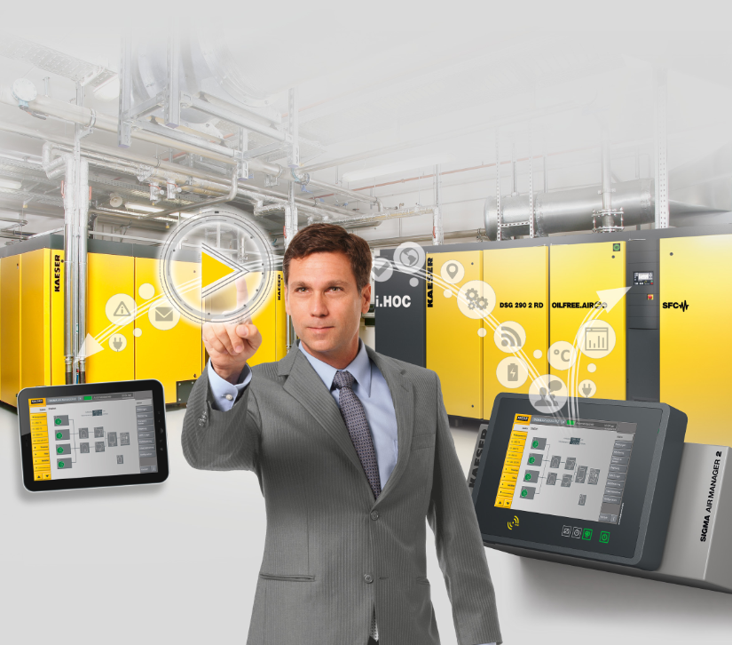
Caption: The SAM 4.0 compressed air management system binds all individual components into a complete team, monitoring and controlling them so that the required volume of compressed air is available at all times, at the required quality.

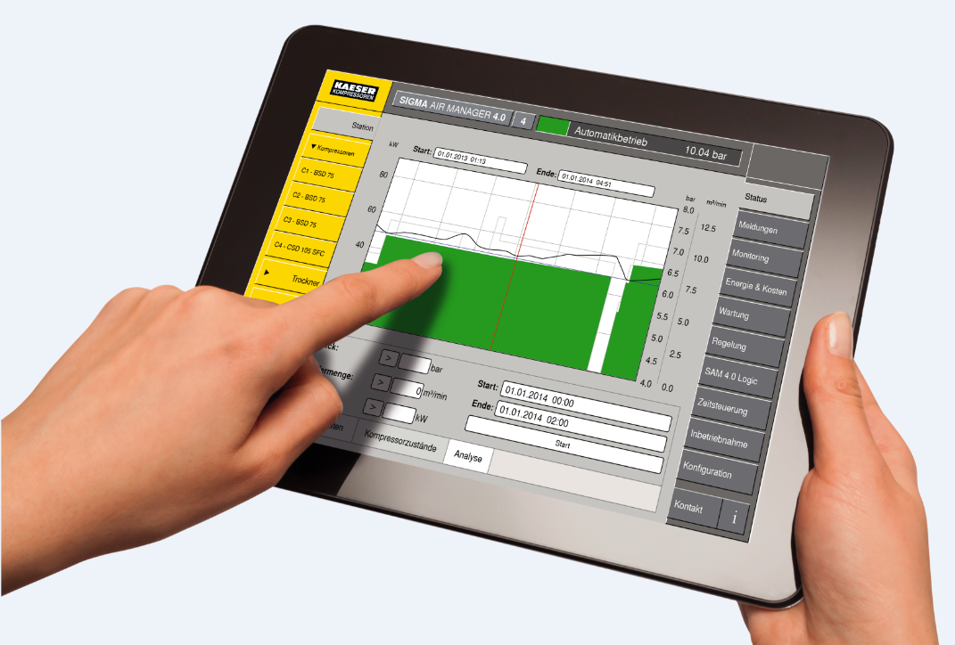
Caption: From a PC, laptop, tablet or smartphone - the SAM 4.0’s integrated web server provides a visual display of all compressed air system data in the form of HTML pages.

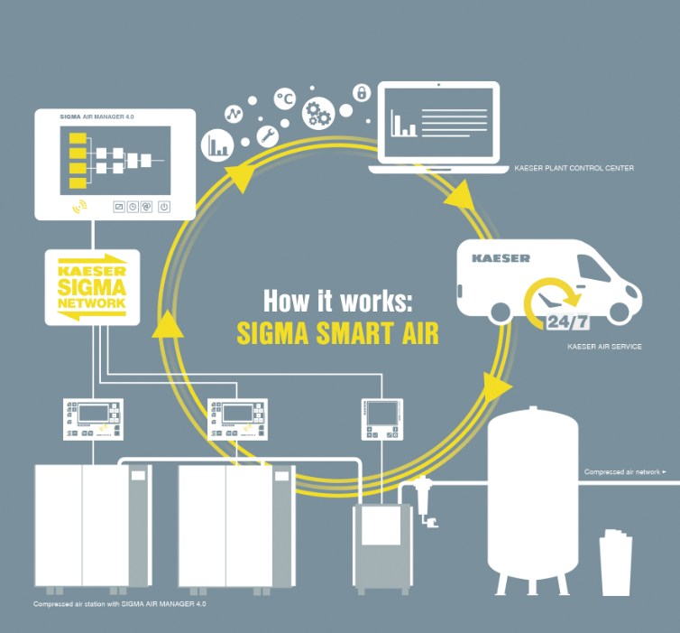
Caption: Aside from enabling access to the world of predictive maintenance, Sigma Smart Air also supports step-by-step digitalisation of a compressed air system – all within the scope of Industrie 4.0.

Kaeser photo(s) – free for publication, credits appreciated.

