Optimised air-mains charging systems for compressor stations
Save energy, safeguard compressed air quality
Many companies shutdown their compressors at night, or over the weekend, in order to prevent energy losses caused by air leakage from occurring. While this approach is effective, it has a distinct disadvantage: There is a risk of overloading the air treatment equipment and contaminating the compressed air system when the compressors are restarted. Help is at hand however with optimised air-main charging systems (initial pressure controllers) from Kaeser Compressors.
In a compressed air supply system with multiple leaks it is highly likely that the entire air distribution network will completely depressurise once the compressors have been shutdown for a while. When they are restarted, the compressors are initially feeding air into an empty air distribution network. As a result, compressed air treatment components such as dryers and filters are subjected to as much as ten times their normal load during this start-up surge. Contaminants therefore enter the air distribution network even if using the very best dryer and filter systems. This unwanted effect can be easily and cost-effectively avoided with air-main charging systems from Kaeser Compressors.
The air-main charging system is installed in the compressor station just downstream from the last air treatment component, which means that the compressed air system remains pressurised even after the compressors have been shutdown. When air demand returns, the required system pressure is quickly re-established without any associated overload. Because the air-main charging system’s valve opens only when nominal system pressure is reached, dryer and filter operating pressure is maintained at all times. Consequently, the initial pressure regulator not only saves energy, but also plays a key role in safeguarding compressed air quality. The new, optimised design also features a high visibility valve position indicator and electronic alarm functions. Moreover, the simple electronics are easily programmed via an intuitive menu and connection to control and monitoring systems is a breeze; the integrated pressure sensor provides the signal.

File: d-air-main-charging-valve-aus
Approved for publication, copy acknowledgement appreciated
Image:

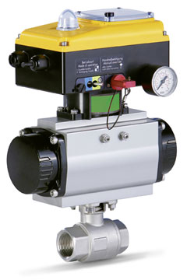
Kaeser Compressors’ optimised air-main charging systems (initial pressure controllers) are available in various sizes. They help save energy, safeguard compressed air quality and can be easily integrated with master control and monitoring systems.

