Kaeser announces the appointment of Delta Electrics as a distributor in the Northern Territory
Kaeser Compressors Australia has announced the appointment of Delta Electrics as a distributor of the full range of Kaeser compressed air equipment in the Northern Territory.
Established in 1969, Delta Electrics is a well-known and leading supplier of power related products and services in the Northern Territory serving clients in numerous industry sectors from; the mining and resources to defence, telecommunications, power utilities and manufacturing to name only a few.
From its premises in Winnellie, Delta Electrics prides itself on offering value for money and professional service support. This includes planned and unplanned maintenance, on-site field services, a 24/7 call-out and breakdown service as well as workshop repair and warranty work.
On the new distributorship agreement with Kaeser Compressors Mark White, Business Manager and Director at Delta Electrics said: 'Our partnership with Kaeser significantly extends our capabilities in supplying a range of high quality compressed air solutions that can cater to the small commercial user right up to the large industrial applications and projects. Kaeser Compressors has an enviable reputation for designing and manufacturing quality 'Made in Germany' compressed air systems and we are delighted to be partnering with them.'
From 2.2 to 500 kW, Kaeser Compressors manufactures a wide range of compressors and associated auxiliary equipment that meet the varying requirements of a diverse range of industries and applications. Kaeser Compressors Australia provides comprehensive sales and service from its 30,000 ft² purpose built factory in Dandenong, Victoria alongside an extensive network of sales and service centres and authorised partners that cover Australia, New Zealand and New Caledonia.

File: o-delta-eletrics-aus
Approved for publication, copy acknowledgement appreciated
Image:

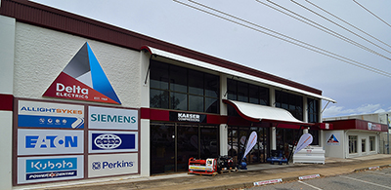
Kaeser announces the appointment of Delta Electrics as a distributor in the Northern Territory

