Foundation stone ceremony: New space for new ideas

The first stage of the significant investment into a new administration building at the Head Office in Coburg, Germany was recently marked by a foundation stone ceremony.
Representatives from the Coburg-based compressed air specialist and participating construction companies, together with local dignitaries, gathered on Friday 4th September 2015, to immure a time capsule commemorating construction of Kaeser's new administration building. Amongst other items, the capsule contains current newspapers and a selection of coins.
The new building will bring department's closer together, enhancing communication between employees. The new facility will therefore "create new space for new ideas", Thomas Kaeser explained.
The construction phase of the administration building itself is due for completion in late 2016, with the move-in phase prospectively beginning in Spring 2017. Once the new building is complete, modernisation of the non-renovated section of the existing building will then begin.

File: p-foundation-stone-ceremony-aus
Approved for publication, copy acknowledgement appreciated
Images:
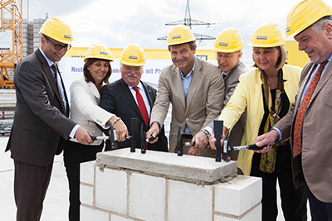
The first stage of this significant investment was marked by the recent foundation stone ceremony

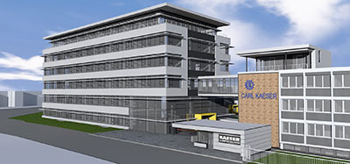
The new administration building will be located to the left of the existing building and will offer lots of new space for employees.

