February 2022

RAM announced as Kaeser distributor

Kaeser Compressors Australia has announced the appointment of Regional Asset Maintenance (RAM) as a distributor of the full range of Kaeser compressed air equipment in the Northern Territory.

Established over 30 years ago, RAM specialises in the maintenance of critical assets and infrastructure across the NT and northern Australia, serving clients in the oil and gas (both onshore and offshore), defence, marine and mining sectors to name only a few. As such RAM is trusted with some of the NT’s most critical infrastructure.
RAM is well placed to serve these industries from its facility in Darwin, which includes a mechanical workshop, NATA accredited temperature-controlled Torque and Pressure Gauge calibration laboratories, Department of Defence approved Hyperbaric Repairers Clean Room and high pressure hydrostatic testing. With a local workforce and large contractor network RAM are fully equipped to provide trade services for ongoing maintenance, projects and campaigns.
In 2020 RAM became a Kolsen business increasing the company’s capacity to scale up for larger campaigns and projects, this is in addition to the already established assets and critical infrastructure maintenance commitments.

On the new distributorship agreement with Kaeser Compressors Mike Apathy, Operations Manager at RAM said: 'RAM Services is pleased to have been appointed as a Kaeser distributor and authorised service provider in the NT.
Kaeser has an outstanding reputation for manufacturing world class compressed air system solutions that are synonymous with high quality, reliability and superior performance - as well as for delivering a product range that is backed up with local technical support. And, that’s even more important when operating plant and equipment in the harsh Territory conditions (and in often remote locations) that demand reliability and back-up capabilities in order to minimise any potential downtime or delays.
Since our inception, our strategy at RAM has always been to align with professional and quality suppliers. Partnering with Kaeser was therefore the perfect fit. This strategic partnership underscores our already recognised performance capability and track record.
We’re looking forward to a long-term relationship with Kaeser as the Territory moves into a period of significant growth.'
From 0.18 to 515 kW, Kaeser Compressors manufactures a wide range of compressors and associated auxiliary equipment that meet the varying requirements of a diverse range of industries and applications. The Kaeser product range meets and exceeds Australian conditions and regulations and the standard machines are suitable for continuous operation at ambient conditions up to 45ºC and higher.
Kaeser Compressors Australia provides comprehensive sales and service from its purpose built factory in Dandenong, Victoria alongside an extensive network of sales and service centres and authorised partners that cover Australia and New Caledonia. For further information visit au.kaeser.com or phone 1800 640 611.
-END- Free for publication, copy appreciated
Editors Notes
From 0.18 to 515 kW, Kaeser Compressors manufactures a wide range of compressors and associated auxiliary equipment that meet the varying requirements of a diverse range of industries and applications.
One of the world’s largest manufacturers of compressors, blowers and compressed air systems, Kaeser Compressors is represented throughout the world by a comprehensive network of branches, subsidiaries and authorised distribution partners in over 140 countries.

Kaeser Compressors Australia provides comprehensive sales and service from its purpose built factory in Dandenong, Victoria alongside an extensive network of sales and service centres and authorised partners that cover Australia and New Caledonia.

For editorial and advertising enquiries contact: Beth Wood, Marketing Manager
Press office: +61 3 9791 5999 E-mail: beth.wood@kaeser.com

KAESER COMPRESSORS Australia Pty Ltd
45 Zenith Road, Dandenong, VIC 3175, Australia
Phone: +61 3 9791 5999 Email: info.australia@kaeser.com
au.kaeser.com
File: P-RAM-appointment-aus
Approved for publication, copy acknowledgement appreciated
Image:
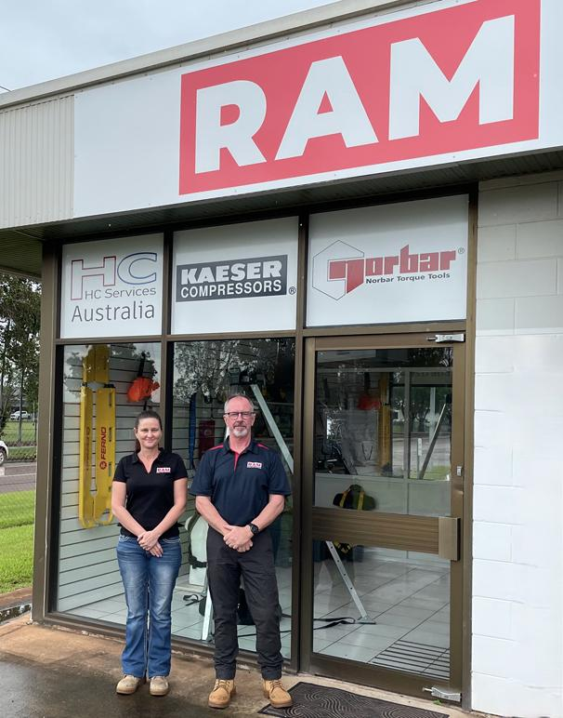
Caption: RAM was recently announced as a Kaeser distributor. Pictured in front of RAM’s Berrimah shop, Dana Harrower (Operations Support Supervisor at RAM) and Mike Apathy (Operations Manager at RAM).

((Kaeser photo – free for publication))

