January 2019

Topping out ceremony: The roof is up

Just three months after breaking ground, Kaeser Kompressoren celebrated the topping out ceremony for its new production hall on Friday.

Gera/Coburg – With full order books and growing sales, it was time for the compressor maker and compressed air system provider to expand capacity at its production centre for refrigeration dryers. The product range was also expanding. Apart from adding assembly space, the project includes a new dryer testing room and an expanded logistics department. In total, it will add 2,300 square metres of usable floor space. Thomas Kaeser, the CEO of Kaeser Kompressoren, is pleased with the progress: "If the work keeps moving ahead at this pace, production could start in the new facility as early as June". He added: "Gera is an important location for us and the employees here make a big difference in keeping our customers satisfied. The new production facilities will enable them to do that even faster."

Boosting innovation
In Gera, Kaeser manufactures blowers and refrigeration dryers with approximately 400 employees. All of the products stand out for their energy efficiency (e.g. energy-saving dryers), reliability and long service life. Thanks to a steady stream of innovations, KAESER is able to offer its customers state-of-the-art technologies on an ongoing basis. The expansion will help to maintain and enhance the company's ability to innovate and continue meeting demand in the refrigeration dryer segment. The total investment amounts to approximately 9 million euros.

Kaeser Kompressoren Gera emerged from Geraer Kompressorenwerke, originally established in 1877 as Heinrich Leo Metallwarenfabrik und Eisengiesserei. In 1890 it became Germany's first manufacturer of compressors and by 1945 was the country's leading producer, with a 70 percent market share. In 1991 the company was acquired by Kaeser Kompressoren.

The compressed air specialist, with its head office in Coburg, in the Upper Franconia district, now employs over 6,000 people in more than 100 countries around the world. The main production sites are in Coburg and Gera.
-END-
Editors Notes
From 2.2 to 500 kW, Kaeser Compressors manufactures a wide range of compressors and associated auxiliary equipment that meet the varying requirements of a diverse range of industries and applications.

One of the world’s largest manufacturers of rotary screw compressors, Kaeser Compressors is represented globally in over 100 countries through a dedicated network of branches, subsidiary companies and authorised partners.

Kaeser Compressors Australia provides comprehensive sales and service from its 30,000 ft² purpose built factory in Dandenong, Victoria alongside an extensive network of sales and service centres and authorised partners that cover Australia, New Zealand and New Caledonia.

For editorial and advertising enquiries contact:
Press office: +61 3 9791 5999 Fax: +61 3 9791 5733
E-mail: info.australia@kaeser.com

KAESER COMPRESSORS Australia Pty Ltd – 45 Zenith Road, Dandenong South, VIC 3175, Australia
Phone: +61 3 9791 5999 – www.kaeser.com.au – E-mail: info.australia@kaeser.com

File: o-richtfest-gera-en_17-184211-aus
Approved for publication, copy acknowledgement appreciated
Image:
((Captions)) :

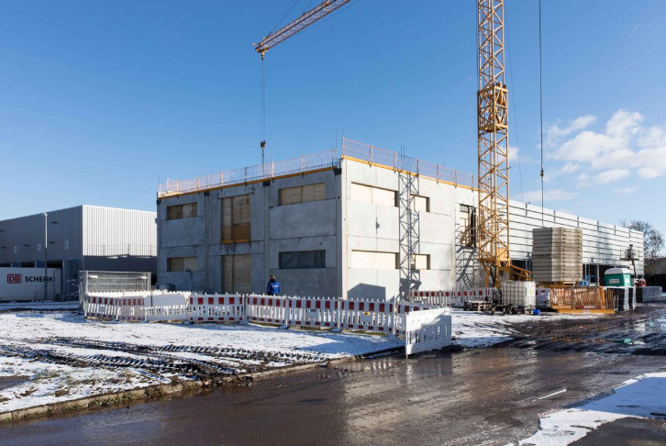
Topping out ceremony at Kaeser: Refrigeration dryers will be built in the new hall soon.

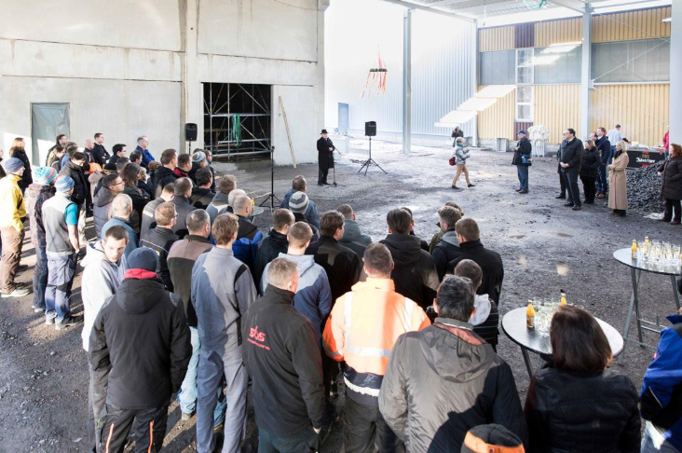
Thomas Kaeser, CEO of Kaeser Kompressoren, was confident that the hall extension would be one of many others.

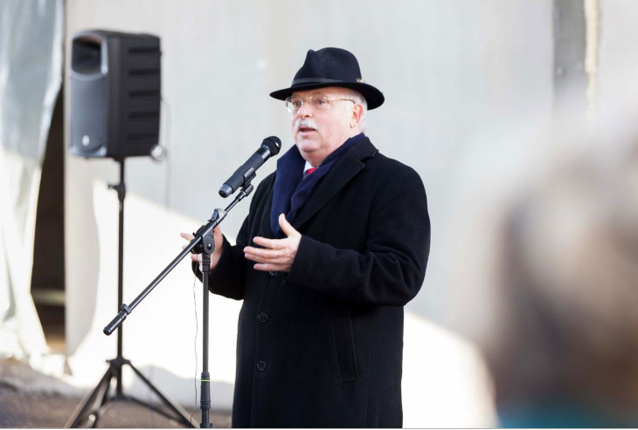

Thomas Kaeser, CEO of Kaeser Kompressoren, was confident that the hall extension would be one of many others.
((Kaeser photo – free for publication))

