Kaeser presents the powerful ASK series
Powerhouses of efficiency
Compact and refined, but with significantly more power than comparable products, Kaeser Compressors is proud to introduce its latest generation of high efficiency ASK series rotary screw compressors. These innovative compressors not only deliver more compressed air for less energy, but also impress with their user- and service-friendly design.
ASK rotary screw compressors are true leaders in their class when it comes to stationary compressed air applications. Thanks to further-refined Sigma Profile airends, an innovative cooling concept and high-efficiency IE3 motors, these cutting-edge air compressors perform up to 20 percent better than many comparable products on the market. ASK models are available for flow rates from 0.79 to 4.65 m³/min, and feature optional frequency control and / or an integrated dryer.
The integrated Sigma Control 2 controller provides efficient and intuitive control, whilst the energy-saving IE3 motor and radial fan (with its own dedicated motor) help keep energy costs to a minimum.
A further important efficiency-enhancing component is the “Sigma Control 2” controller: equipped as standard and assuring maximum communication capability, this advanced system not only enables demand-oriented performance matching and dependable monitoring, but - through its numerous interfaces - also ensures even greater flexibility when it comes to connection to the energy-saving Sigma Air Manager 4.0 master control system. The compressed air system can therefore be seamlessly integrated into Industrie 4.0 environments since the necessary interfaces for connection to the Kaeser Sigma Network are provided as standard. The addition of an integrated RFID reader assures service continuity, increases security and significantly raises service quality.
ASK models also impress with their logical, user-friendly design, which allows all maintenance parts to be conveniently accessed from one side for easy servicing. Moreover, when closed, the enclosure with its sound-dampening insulation ensures quiet and unobtrusive operation.
File: A-ASK-aus
Approved for publication, copy acknowledgement appreciated

Images:
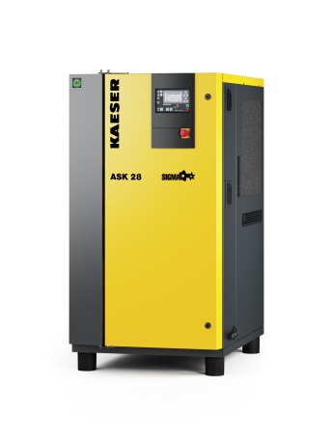
With enhanced specific power, the latest generation ASK models are true powerhouses when it comes to providing quality compressed air at flow rates from 0.79 to 4.65m³/min, at pressures from 5.5 to15 bar.

