Kaeser at Collision Repair Expo 2017
Kaeser Compressors Australia will be exhibiting at the 2017 Collision Repair Expo from 6 to 8 April at the Melbourne Convention & Exhibition Centre. Visitors to stand number AC24 will be able to discover a comprehensive range of compressed air solutions ideally suited to the automotive aftermarket industry. In addition Kaeser will be running two free seminars where delegates can learn how to optimise the efficiency of their compressed air system.
Hosted by the Australian Automotive Aftermarket Association (AAAA), the biennial Collision Repair Expo is the nation’s most comprehensive exhibition of body finishing materials, crash repair equipment and tools.
There are a number of applications within the automotive aftermarket industry sector that require a high quality and dry supply of compressed air. Kaeser Compressors has a number of solutions to meet these requirements, not least the all-in-one Kaeser Aircenter.
The complete and compact Aircenter from Kaeser incorporates a compressor, dryer and air receiver all within a single housing. At the heart of each Aircenter lies a proven Kaeser rotary screw compressor featuring a premium quality screw compressor block with Kaeser Sigma Profile rotors that have been designed for maximum energy efficiency.
All Kaeser rotary screw compressor blocks are powered by premium efficiency IE3-rated drive motors (that comply with, and exceed, prevailing Australian GEMS regulations for 3 phase electric motors), for maximum performance and reliability.
The inclusion of a thermally shielded refrigeration dryer further ensures a dependable supply of dry and clean air. Along with a number of energy saving compressed air solutions, visitors to stand number AC24 will be able to see a Kaeser Aircenter in action.
Crash Course in Compressed Air
A reliable and high quality supply of compressed air is essential when it comes to re-finishing. An inefficient compressed air system - whether due to pressure drops, restricted air flow or inadequate compressed air treatment - can all lead to flawed product finishes. The result for a business is more cost - from rework requirements to increased compressed air consumption and maintenance needs.
Operating a well-designed and high quality compressed air system is even more important where waterborne paints are being used. Many users may not realise however, that flash-off and curing times can actually be significantly reduced when a correctly designed and high quality compressed air system is in place. Coupled with heightened electricity costs, operating an energy efficient compressed air system has therefore never been so important.
Kaeser Compressors will be running two free seminars at the Collision Repair Expo and compressed air users wanting to learn more about the energy savings potential that may be hiding in their compressed air system, and how they can achieve high quality compressed air by opting for a well-designed system with the right compressed air treatment and filtration, are invited to attend. These 45 minute seminars will be running on Friday 8th April at 10.45 am and 2.30 pm. Registration is essential and can be completed by clicking here
Visit Kaeser Compressors at the 2017 Collision Repair Expo on stand number AC24 and discover your energy efficient compressed air solution! 6 – 8 April at the Melbourne Convention & Exhibition Centre.

File: o-Collision Repair-aus
Approved for publication, copy acknowledgement appreciated
Image:

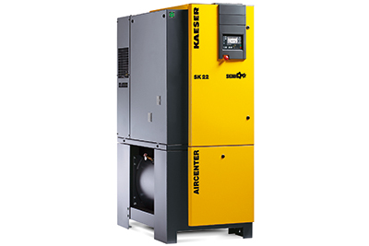
The complete and compact Kaeser Aircenter will be in action on stand AC24 at the 2017 Collision Repair Expo

Kaeser Compressors is running two free Compressed Air Seminars at the 2017 Collision Repair.

