Energy efficiency shines Bright
Bright Print Group, an award winning printer based in NSW, recently underwent a comprehensive Air Demand Analysis with Kaeser Compressors which assisted them in selecting the most energy efficient compressed air system configuration to meet their current demand for compressed air.
Bright Print Group (Bright) is a family owned and managed national printer with operations in Sydney and Newcastle. Full colour printing, digital print, binding and finishing are just some of the superior printing services that Bright has to offer.
Using the latest technology and sustainable printing practices, they are able to deliver a broad spectrum of end products to their customers, such as: business cards and magazines, to posters, point of sale materials, books and brochures. At Bright’s purpose built factory in Wetherill, NSW, compressed air is used extensively in the manufacture of these products. From the printing presses, laser cutters and guillotines to the laminating and the stitching and trimming machines, compressed air plays an integral role.
In recent months, Bright has expanded its operations by introducing wide format printing, as well as through the acquisition of a commercial print and promotional item company. Both of these developments have not only changed their demand for compressed air, but the company acquisition also meant that they inherited an additional compressed air system.
Operating an energy efficient and lean manufacturing facility
In light of these changes, it was clear to Debbie Burgess, joint Managing Director and fourth generation Bright printer, that in order to continue to operate an efficient manufacturing facility, the compressed air system needed to be assessed.
As an ISO9001:2015 and ISO14001:2015 accredited company (the international quality and environmental standards respectively), operating an efficient facility is of paramount importance to Bright. So much so that the company has also implemented a number of further environmental initiatives over the years. Most recently all employees underwent training to achieve Level III Lean Manufacturing certification. This initiative assisted the company in developing a super-efficient manufacturing facility.
It is no surprise then that the first step they took in order to assess their compressed air requirements, was to undergo a comprehensive compressed air demand analysis audit. As Burgess said; ‘we decided to have an audit done so we could better understand what we needed in order to efficiently operate the compressed air system’. Long standing compressed air supplier - Kaeser Compressors – was therefore invited to perform a complete Air Demand Analysis (ADA) on the existing compressed air system that would then be analysed using the Kaeser Energy Savings System (KESS).
Saving energy and money with ADA and KESS
The first stage when planning any compressed air system is to determine the actual air demand in order to meet this as efficiently as possible. The computer-aided ADA from Kaeser, allows meaningful and accurate data to be gathered regarding compressed air system performance. By simply wiring the ADA logging equipment to the existing compressors electrical cabinet, Kaeser is able to pick up various digital signals for load and motor running, as well as logging the pressure. From this information, the true compressor performance can be established.
The resulting air consumption profiles gathered from the ADA are then analysed using the KESS. This advanced software developed by Kaeser Compressors, doesn’t simply come up with one solution, but offers the most efficient and economical one from several possibilities. The ADA and KESS together can provide a realistic forecast of the energy savings that can be expected from a proposed compressed air system.
An effective compressed air system should provide maximum availability at all times. Particular attention is therefore given to ensure that the system solutions presented are designed to deliver outstanding dependability and performance.
In Bright’s case, precise data - which showed the actual power consumption and energy efficiency of their existing compressed air systems - was therefore gathered from the ADA, and then analysed using the KESS in order to simulate system options. As a result, Kaeser was able to present two configurations with an efficiency comparison. This information assisted Bright in selecting the right compressed air system design to efficiently meet their compressed air and budget requirements.
Bright chose to keep their existing Kaeser Aircenter 15 and to replace the ageing and inherited compressor with a new Kaeser Aircenter 25.
The Aircenter from Kaeser is an all-in-one compressed air system, incorporating a high efficiency rotary screw compressor, refrigeration dryer and air receiver, all in one compact package. At the heart of every compressor lies a premium quality Kaeser rotary screw compressor block and energy saving Sigma Profile rotors. Designed for maximum energy efficiency, the Kaeser Sigma Profile can achieve power savings of up to 15 percent compared to conventional screw compressor block rotor profiles. In addition, these compressors are equipped with a premium efficiency IE3 class drive motor which complies with and exceeds prevailing Australian GEMS regulations for 3 phase electric motors. For Bright this would translate into more compressed air for less energy consumption. Ideal at point of use, the sound adsorbing compressor enclosure additionally keep operational sound levels to a minimum ensuring a pleasant work environment.
The result of undergoing the ADA and KESS for Bright was reduced energy costs and considerable environmental benefits. Burgess commented ‘With the recent developments to our business that are now taking us into new markets and increasing the depth of services we offer, it was important that we found a compressed air solution that would be able to meet our new requirements now and for the next 5 to 10 years.
By undergoing the ADA and KESS with Kaeser we were able to graphically and monetarily see – in terms of investment and energy costs - what the best options were. Kaeser has always delivered the best solution to us, and we are certainly pleased with the final configuration which is already proving to be reliable in operation.’

File: Q-Bright-Print-Group-aus
Approved for publication, copy acknowledgement appreciated
Images: (contact the press office for high res copies of the following images)

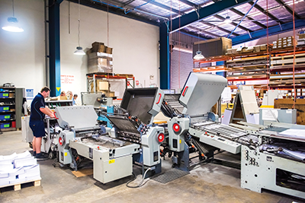

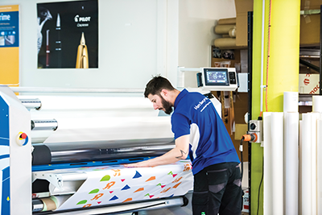

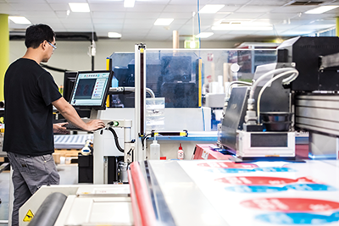

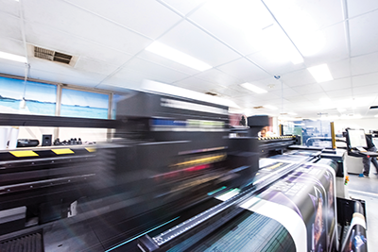

Caption: Compressed air is used extensively at Bright, from the; printing presses, laser cutters and guillotines to the wide format printers.

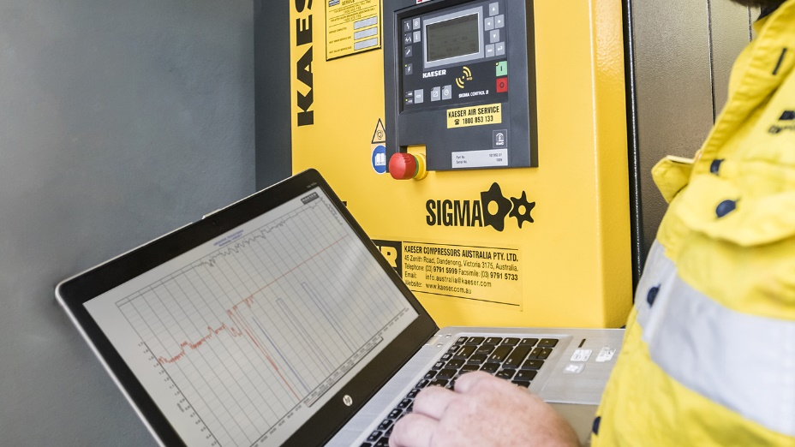
Caption: Kaeser was invited to perform a complete Air Demand Analysis (ADA) on the existing compressed air system

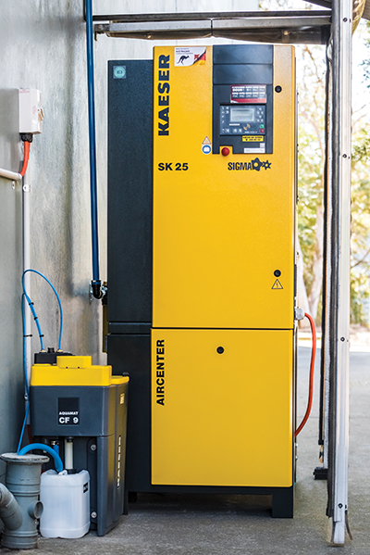

Caption: Bright chose to replace an ageing compressor with a new Kaeser Aircenter 25

