Kaeser launches dry-running screw compressor range featuring integrated i.HOC rotating dryer
Kaeser Compressors has launched a new version of its highly successful DSG-2 dry-running rotary screw compressor range. Energy and space saving, the Kaeser DSG-2 RD series include an integrated i.HOC rotating dryer, able to efficiently and reliably achieve pressure dew points as low as -40ºC.
The DSG-2 series dry-running rotary screw compressors from Kaeser are now available with an i.HOC rotation dryer, or 'integrated heat of compression' dryer. Innovative, integrated and intelligent, the new i.HOC rotation dryer that can be found in the DSG-2 RD series machines provide a dependable source of quality compressed air with pressure dew points as low as -40ºC.
Where absolutely dry and clean compressed air is required, such as in the medical, pharmaceutical and food sectors, the DSG-2 RD series models really come into their own.
With the i.HOC rotating dryer, the heat which is a by-product of air compression, is used to regenerate the desiccant. The heat is essentially available for free, as no additional energy is required to power the drying process. The result is reliable air drying with maximum efficiency and lower energy costs - even for varying quantities of air.
Compared to systems already on the market, i.HOC takes advantage of the entire quantity of available heat. As a result low pressure dew points can be reliably achieved even in challenging conditions, such as low pressure, high temperature or low load operation.
This is made possible by a high-efficiency radial blower with variable control, which serves two main purposes: to compensate for the pressure lost in the drying process and automatically adapt the drying process to changing operating conditions. Full-flow regeneration, together with an additional patented process, ensures dependable drying, without additional electrical heat sources or coolers, even at ambient temperatures as high as 45ºC.
The integrated Sigma Control 2 compressor controller perfectly manages the entire process, controlling the radial blower and drum drive of the i.HOC integrated rotation dryer. Regardless of the operating conditions or the required air delivery volume, the controller automatically adjusts accordingly to ensure reliable and consistent production of pressure dew points down to -20ºC, and under special conditions down to as low as -40ºC.
A compact design further ensures that installation is not only easy and cost-saving, but it also means that only a relatively small footprint is required. Maintenance is also made easy thanks to excellent component accessibility.
The DSG-2 RD series dry-running rotary screw compressors with i.HOC from Kaeser are available air- or water- cooled, with drive powers ranging from 90 to 200 kW, and provide free air deliveries for the complete package at working pressure 13.1 to 28.6 m³/min. Variable speed models are also available with drive motors 110 to 200 kW and free air deliveries for the complete package at working pressure 8.5 to 30 m³/min. For more information phone 1800 640 611.

File: A-iHOC-aus
Approved for publication, copy acknowledgement appreciated
Image:

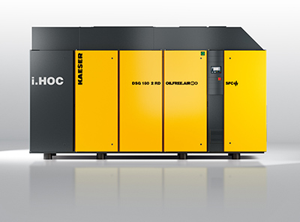
The energy and space saving Kaeser DSG-2 RD series deliver a reliable and dependable supply of quality compressed air with pressure dew points to minus 40 degrees Celsius.
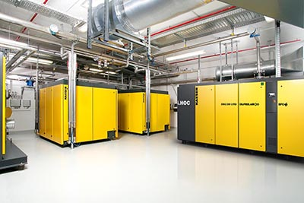
A compact design ensures that installation is not only easy and cost-saving, but is also means that only a relatively small footprint is required.

